**NODE JS**

1.

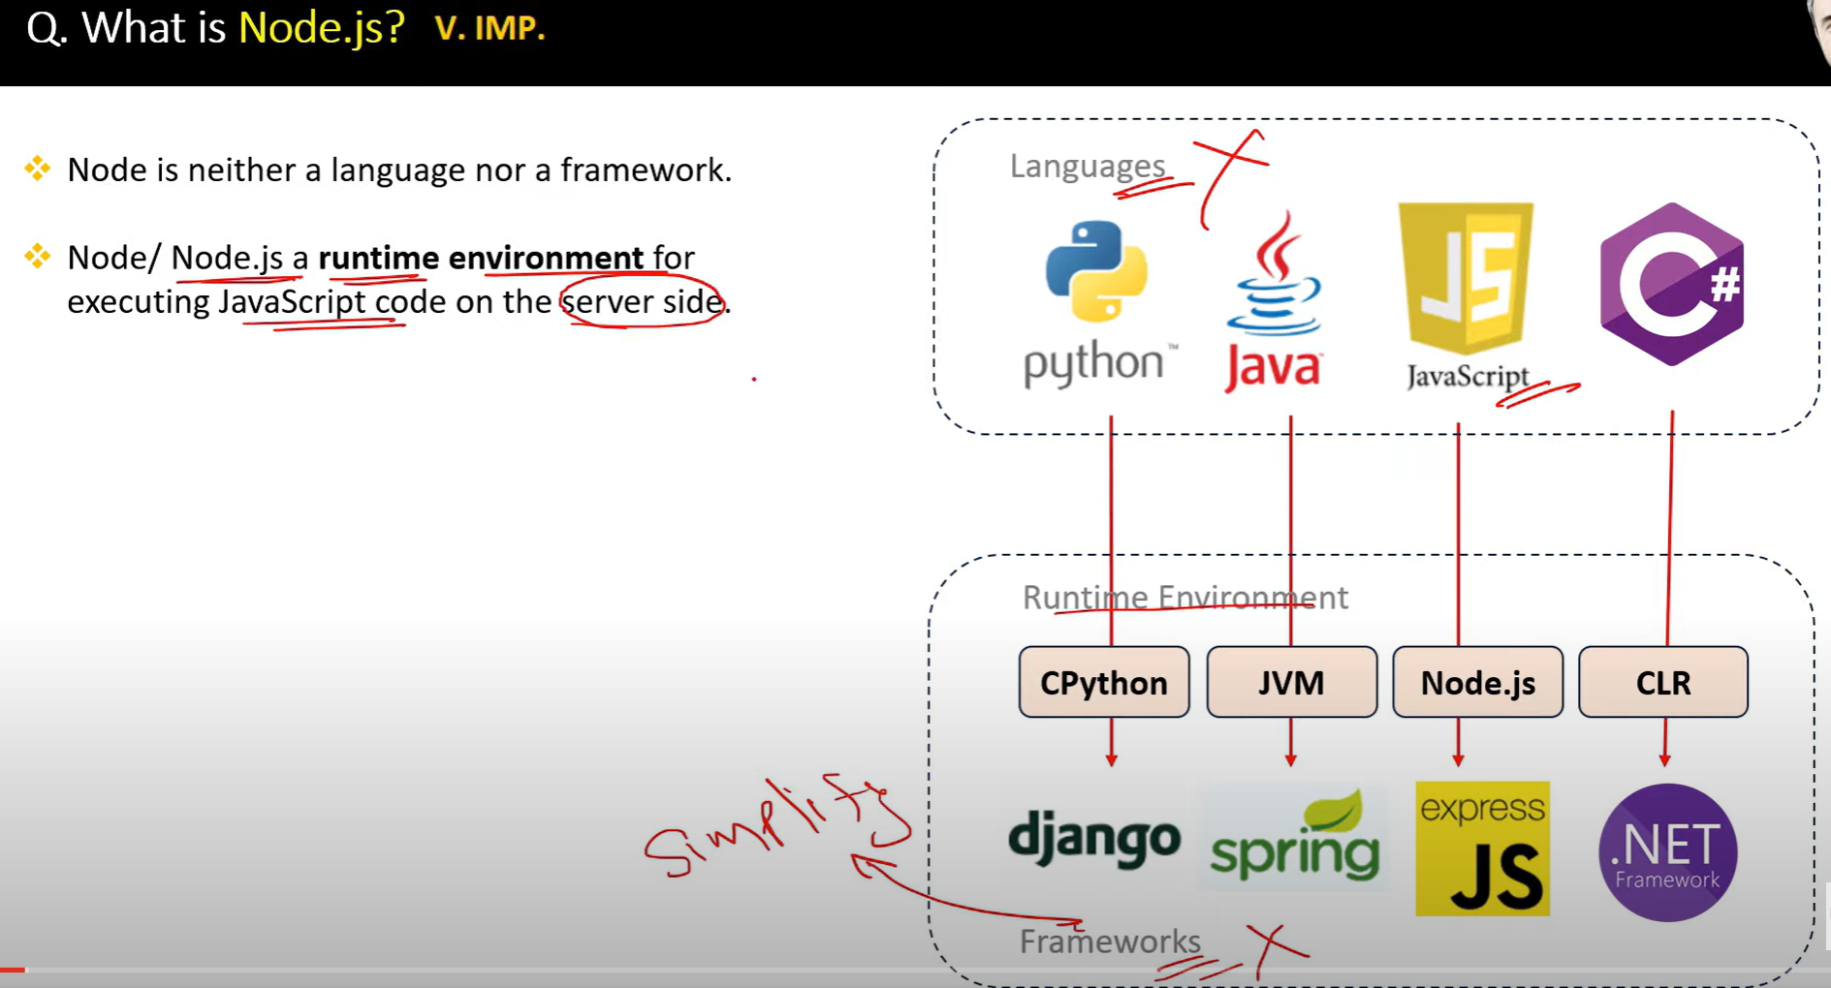

Node.js is a JavaScript runtime built on Chrome's V8 engine, allowing developers to run JavaScript on the server-side. It uses an event-driven, non-blocking I/O model, making it lightweight and efficient.

In Node.js, the I/O (Input/Output) model refers to how the runtime handles interactions with external systems, such as file systems, databases, and network requests.

2.

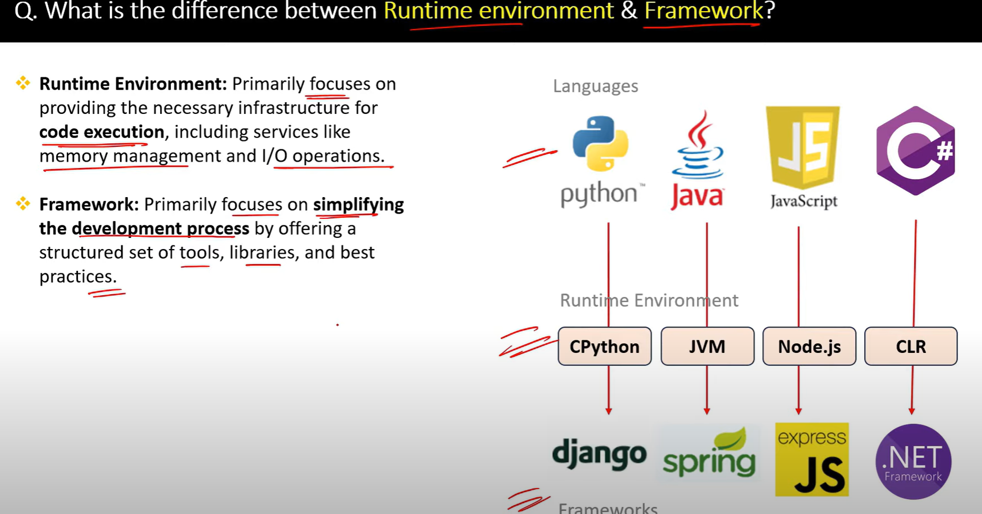

3.

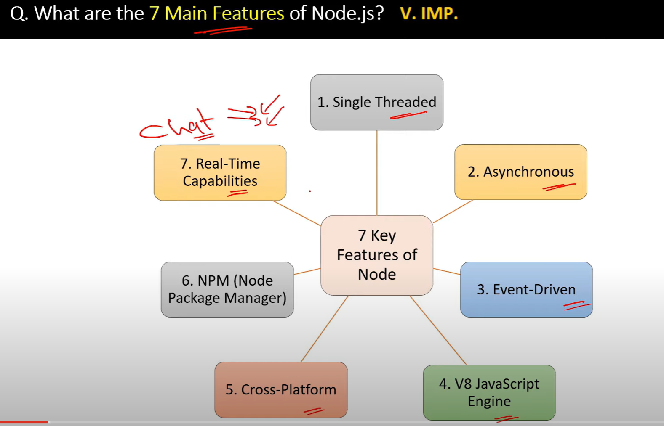

4.

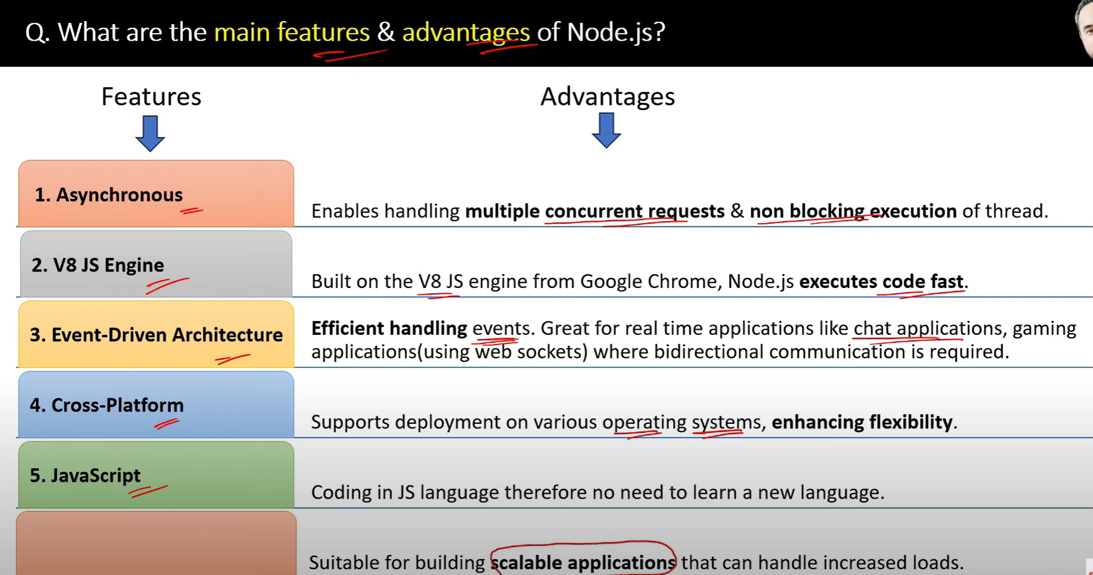

5.

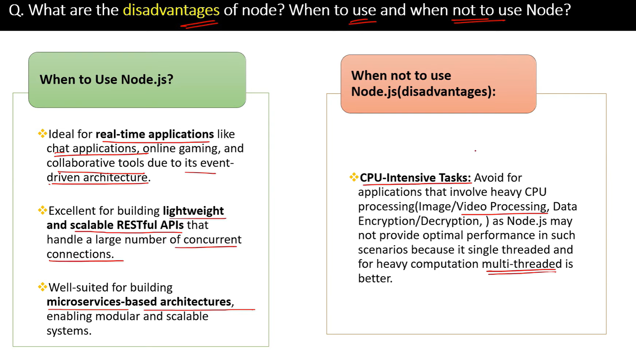

6. Is javascript Single Threaded programming?

1. javascript is a single threaded language. Only one thing can happen at a time.Not multiple things can happen at a time.
2. Event loop is a mechanism that allows javascript to perform non-blocking operations.
3. CallStack is a mechanism that allows javascript to perform synchronous operations. Which executes the code line by line.

[**https://www.youtube.com/watch?v=UXWBl77dq3A**](https://www.youtube.com/watch?v=UXWBl77dq3A)

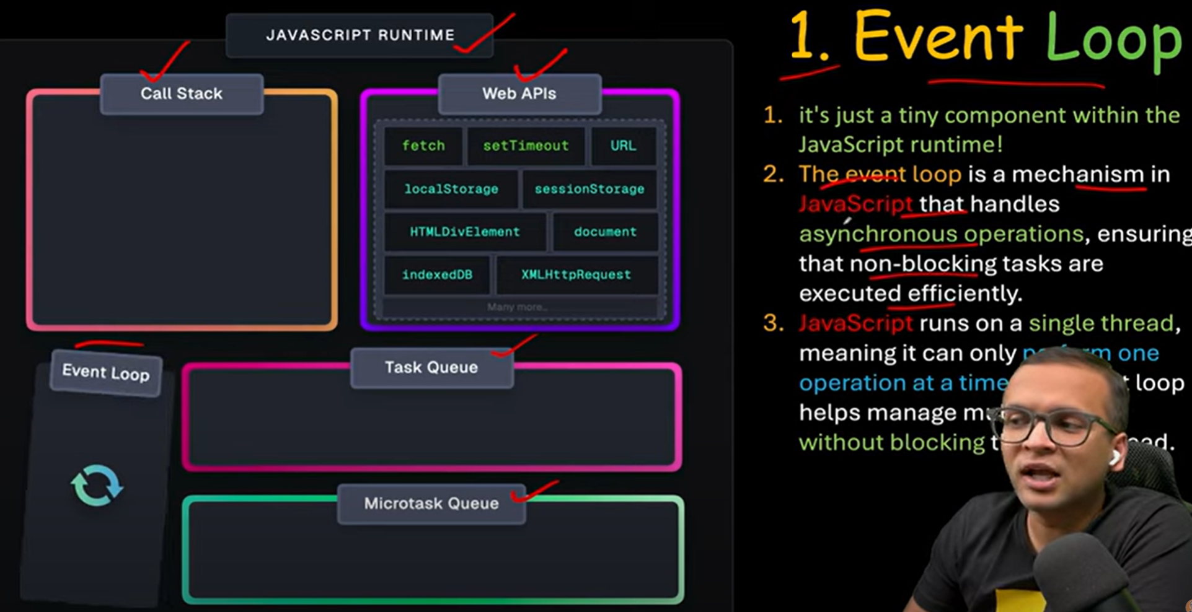

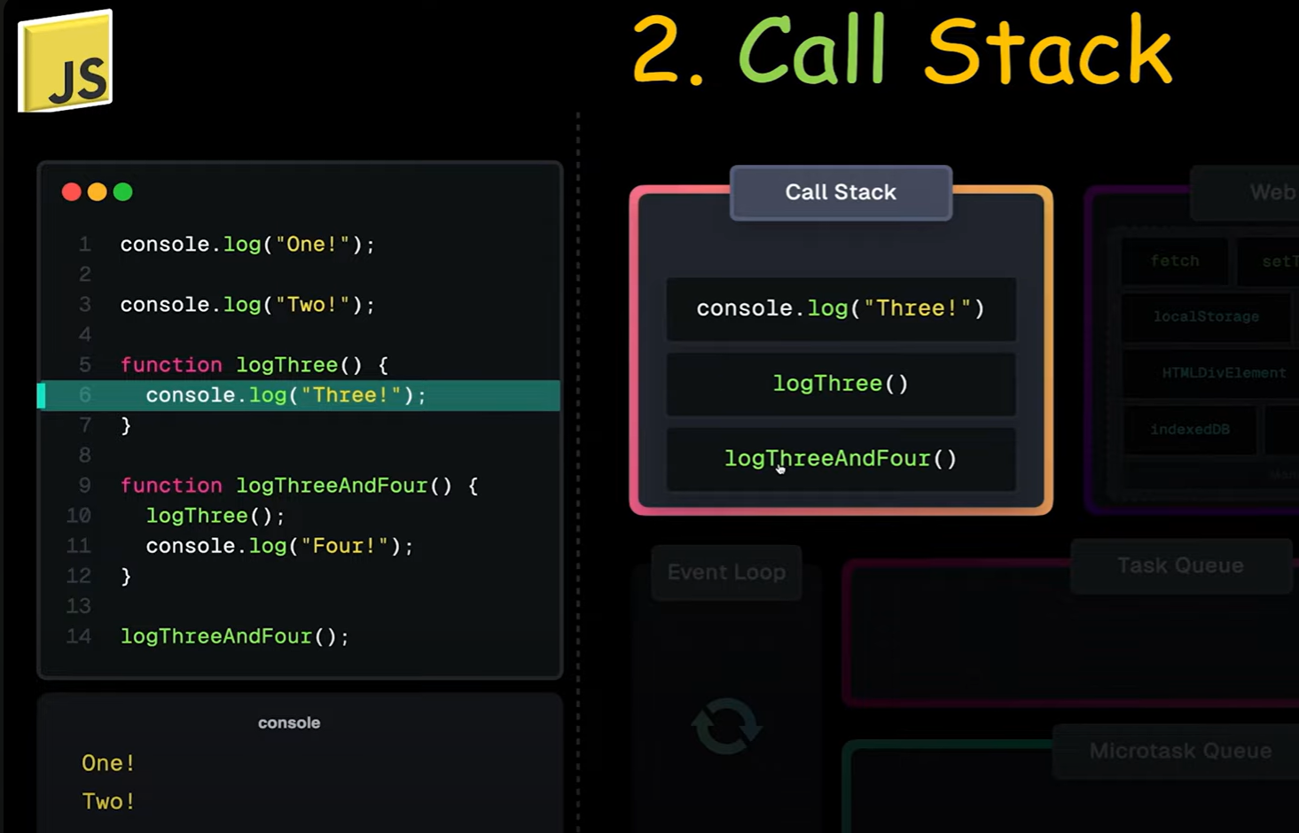

Call stack will run the basic operation in console and normal function

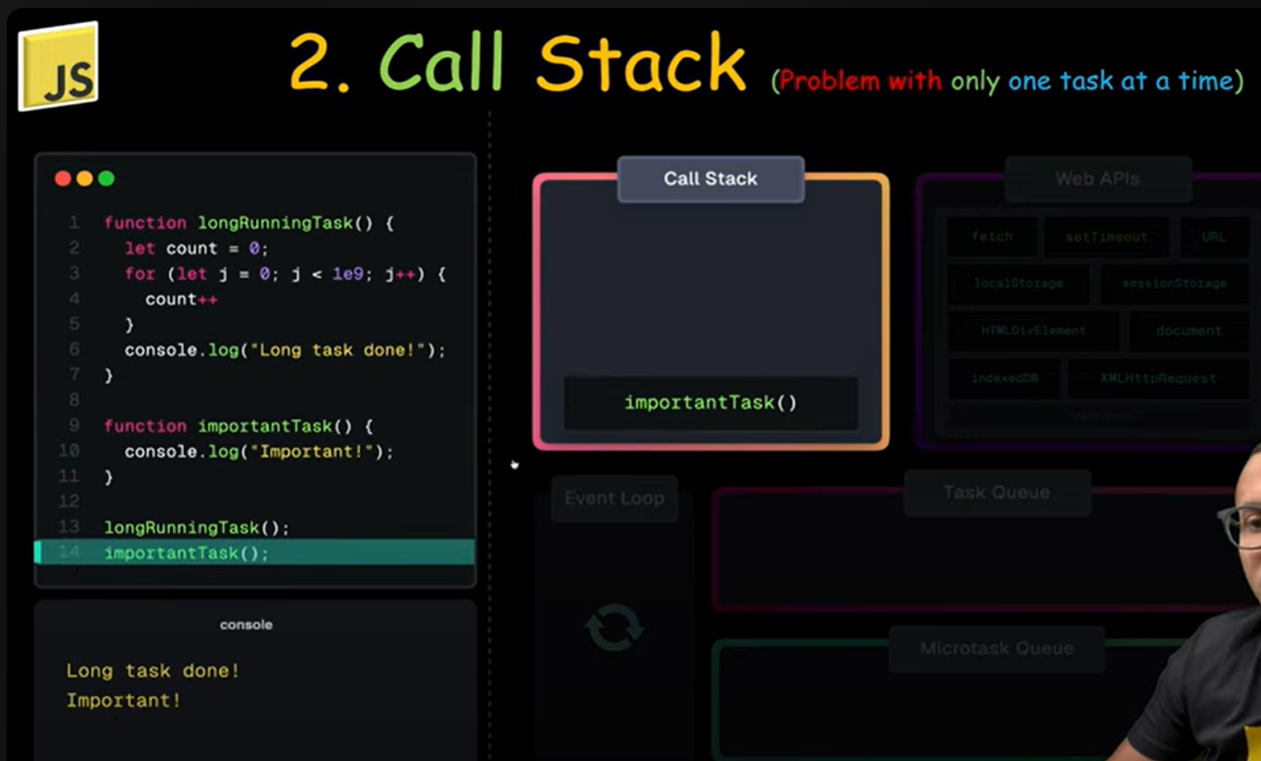

Problem with thr callstack is if there is one function which takes too much time and then the second function will be waiting until first function finishes execution because js is single threaded

1. Web APIs are provided by the browser. They are not part of javascript. They are used to perform non-blocking operations.

   web api is a bridge to use all the features of the browser.

   Types of web APIs:

   -Fetch Api : It is used to make network requests.

   -TimersApi : It is used to delay the execution of a function.Like setTimeout, setInterval, etc.

   - Geolocation Api : It is used to get the location of the user.

   - WebStorage Api : It is used to store data in the browser.Like localStorage, sessionStorage, etc.

   - File Api : It is used to read and write files in the browser.

   - Performance Api : It is used to get the performance of the browser.

   - Html Dom Api : It is used to manipulate the DOM.

   - Url Api : It is used to handle urls.

   - Canvas Api : It is used to draw graphics on a webpage.

   - Audio/Video Api : It is used to play audio and video on a webpage.

   - Image Api : It is used to manipulate images on a webpage.

   - WebSocket Api : It is used to create a two-way communication channel between the browser and the server.

   - Notification Api : It is used to display notifications on a webpage.

   - Web Workers Api : It is used to run javascript in the background.

   - Sensor Api : It is used to access the sensors of the browser.

   - Gpu Api : It is used to access the gpu of the browser.

   many more.

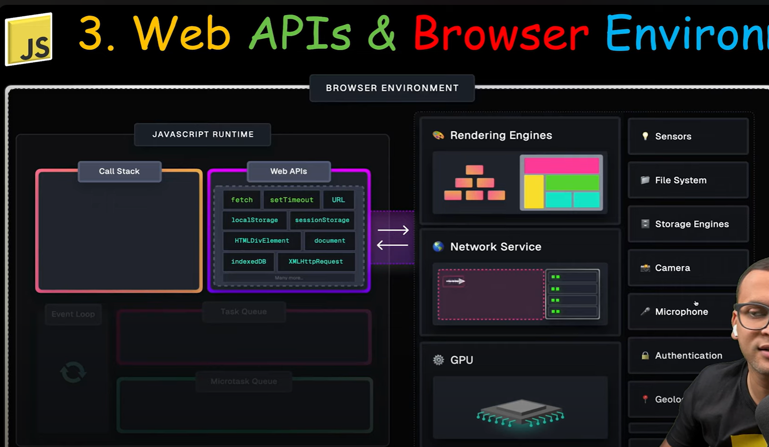

1. Event Loop: It is a loop that continuously checks the call stack and the callback queue.
2. If the call stack is empty, it takes the first item from the callback queue and pushes it to the call stack.

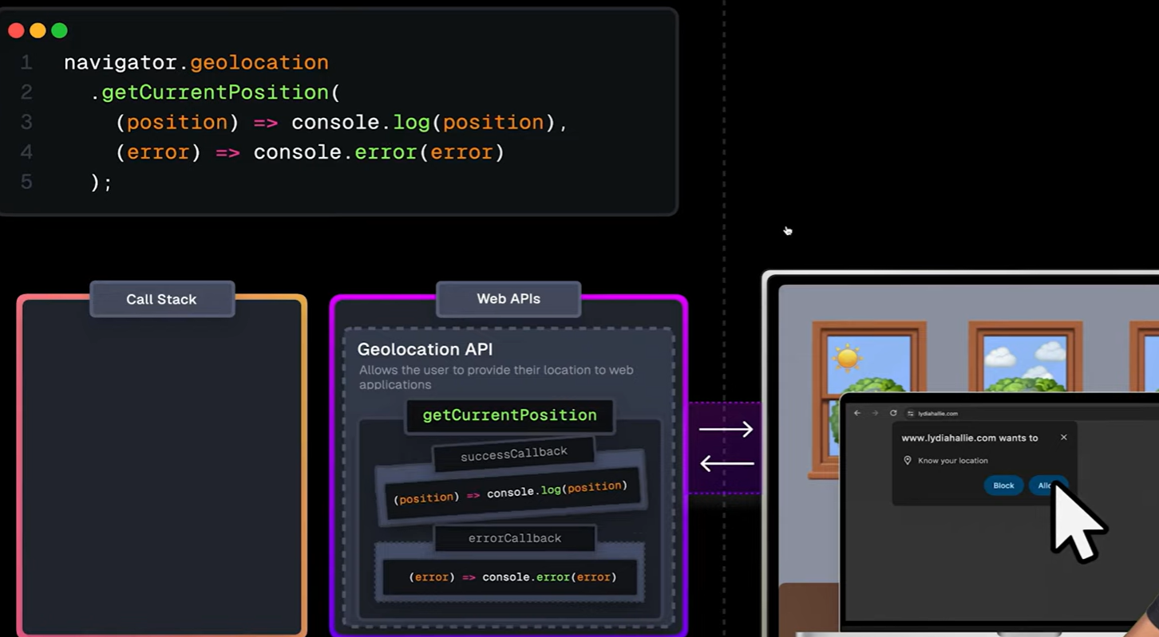

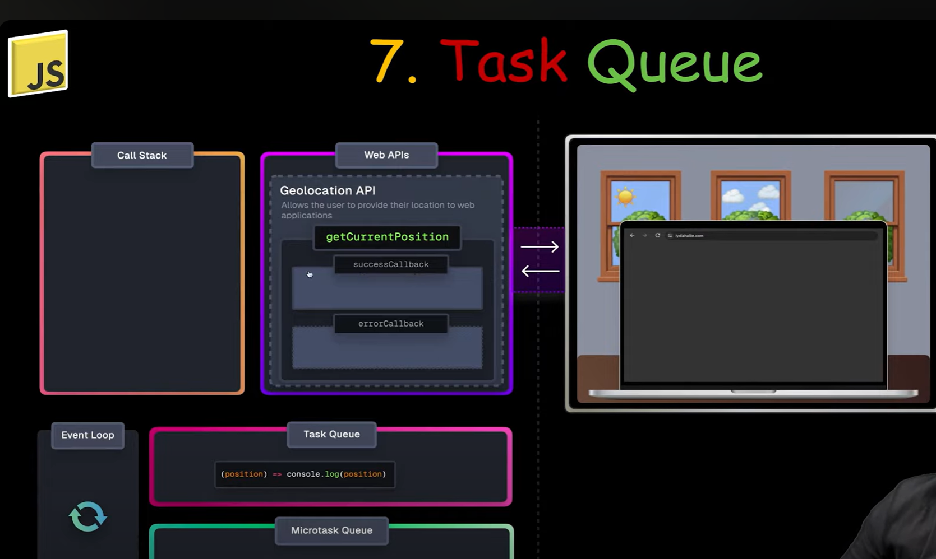

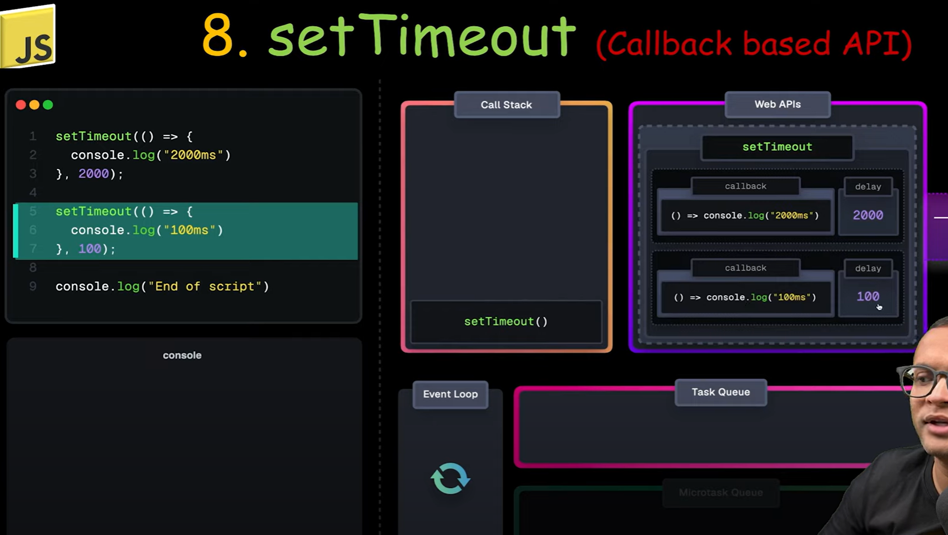

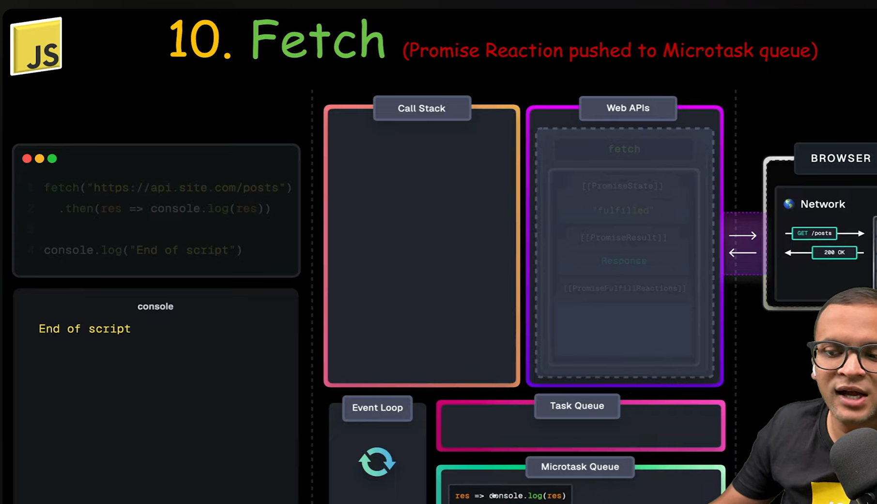

1. Task Queue: It is a queue that stores the callbacks that are ready to be executed. Which are finshed by web apis.
2. Microtask Queue: It is priority queue that stores the callbacks that are ready to be executed. Which are finshed by web apis.
3. Callback Queue: It is another queue in the runtime with lower priority than Microtask Queue. manly promises callbacks are pushed here.

5.

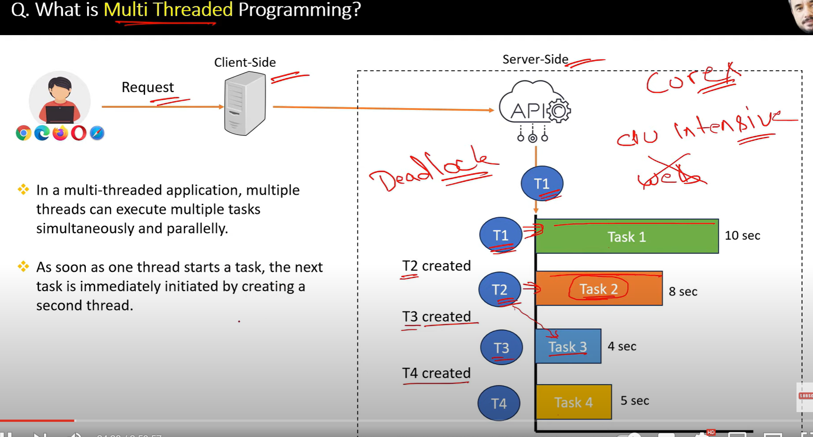

6.

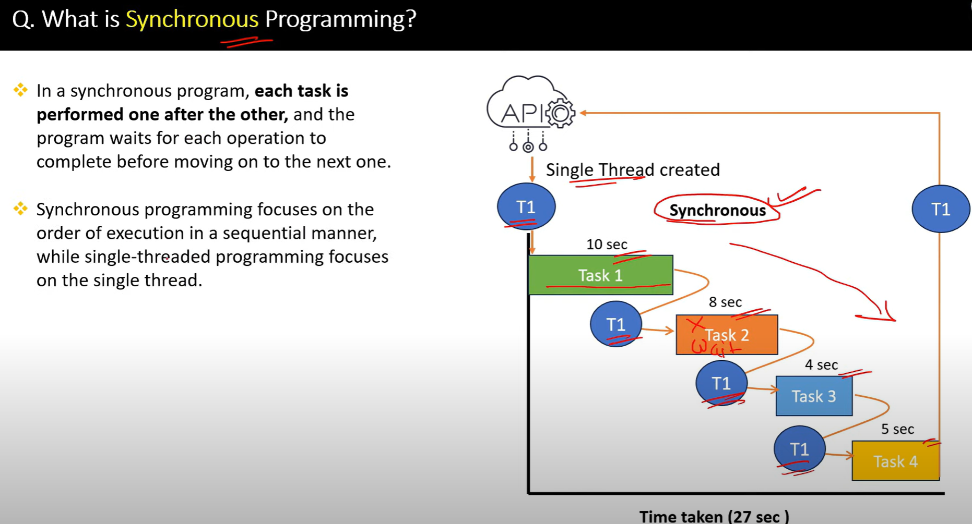

7.

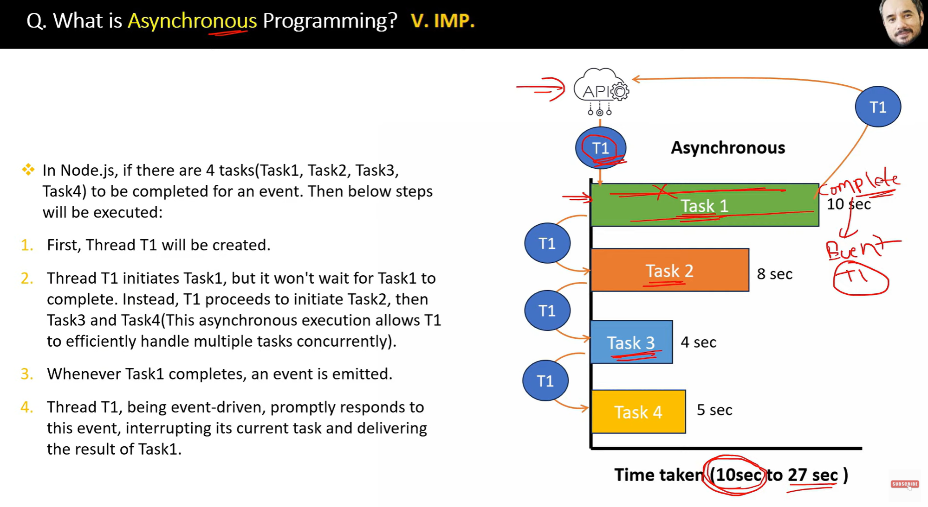

8.

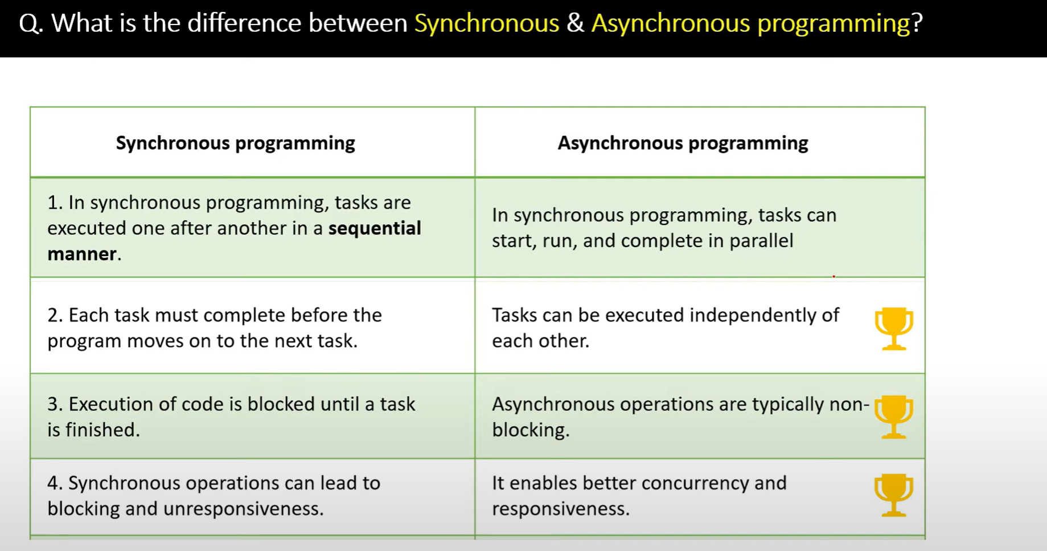

9.

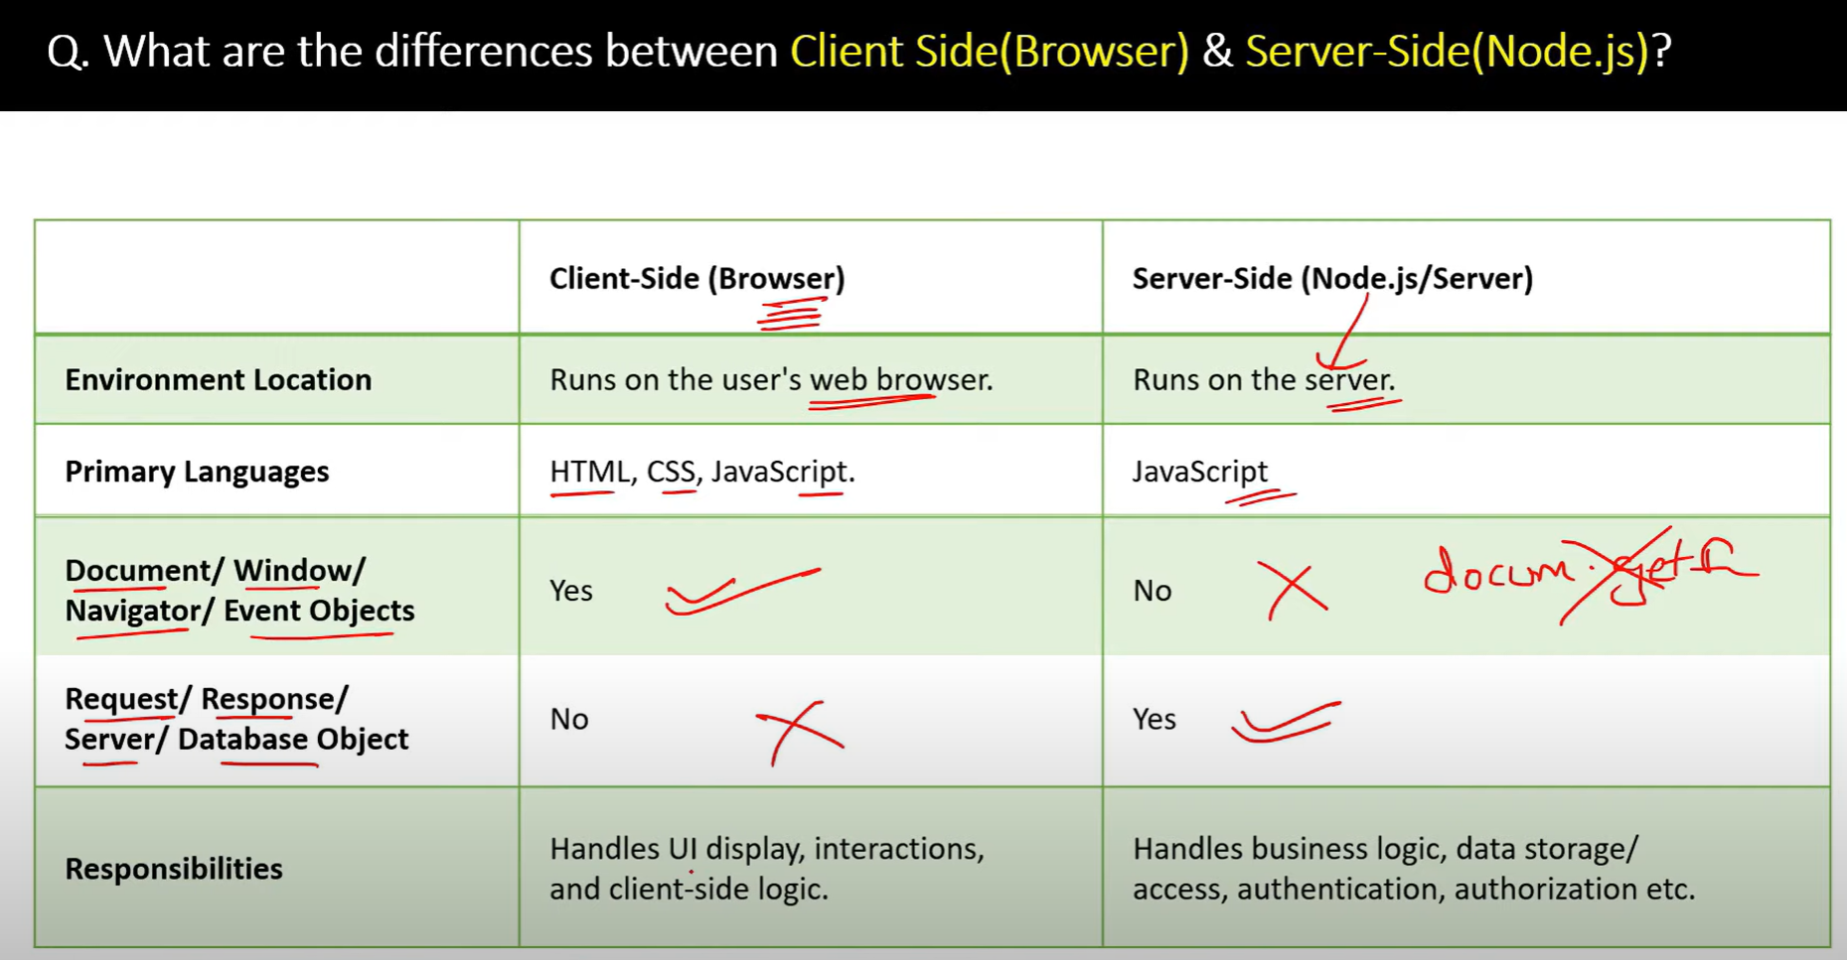

10.

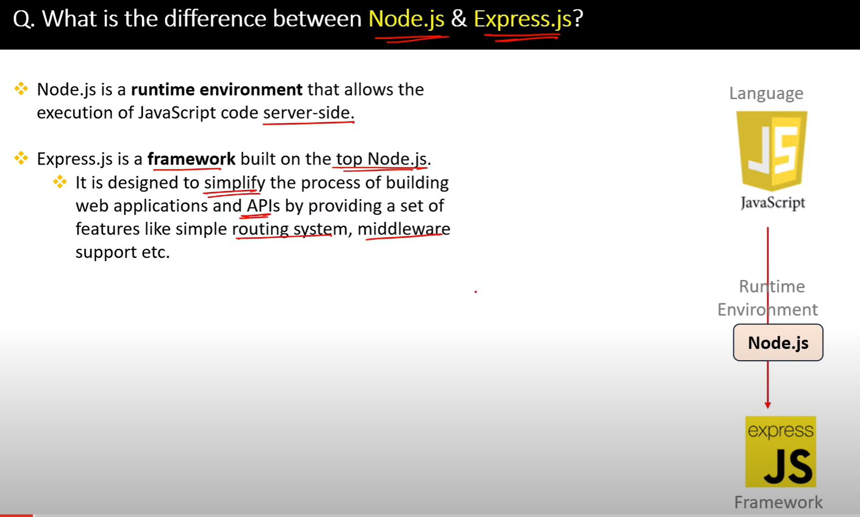

11.

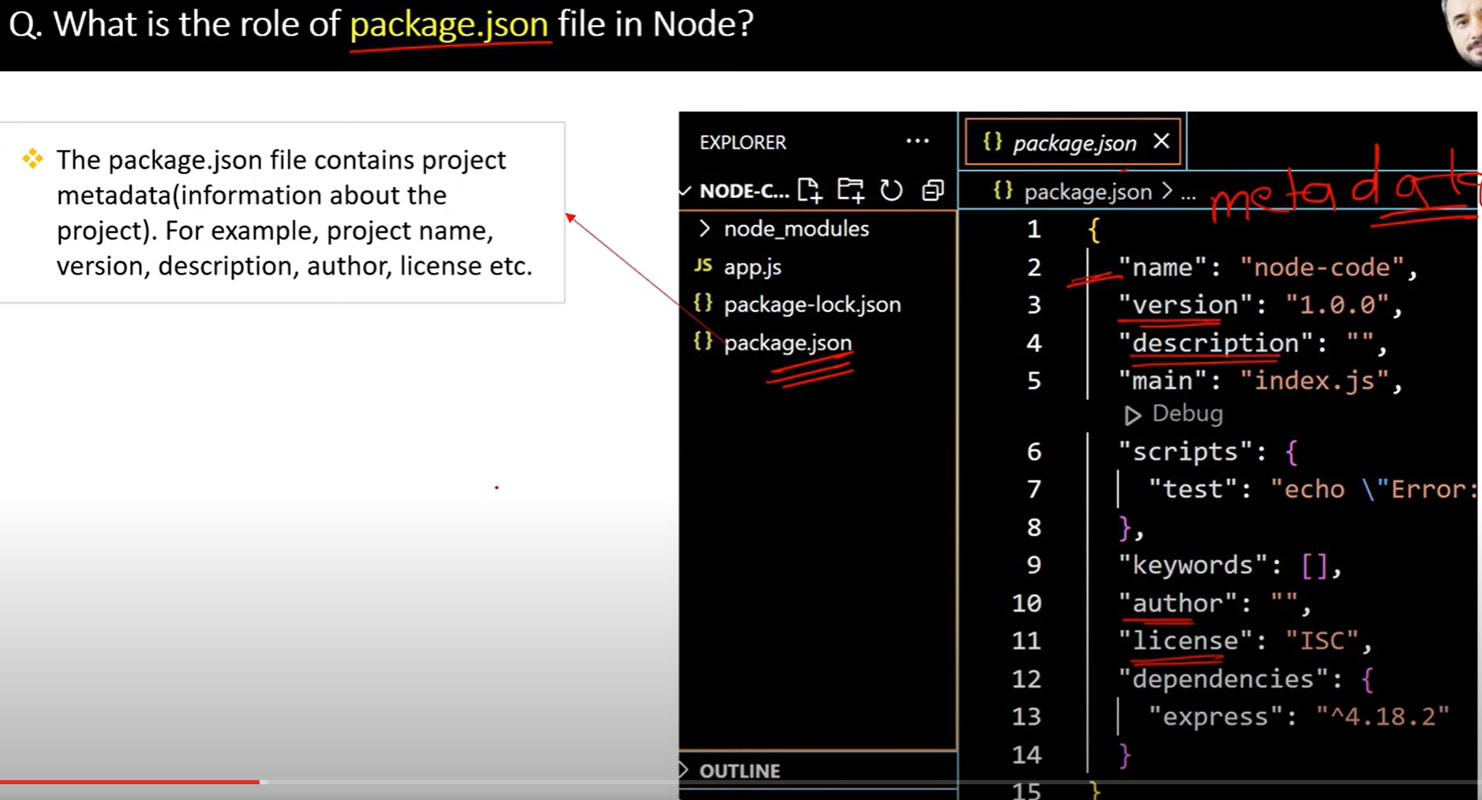

12.

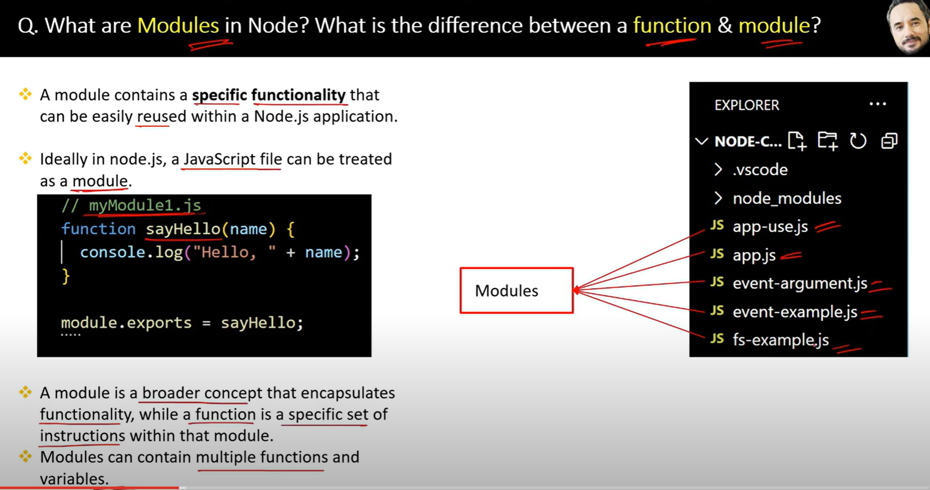

13.

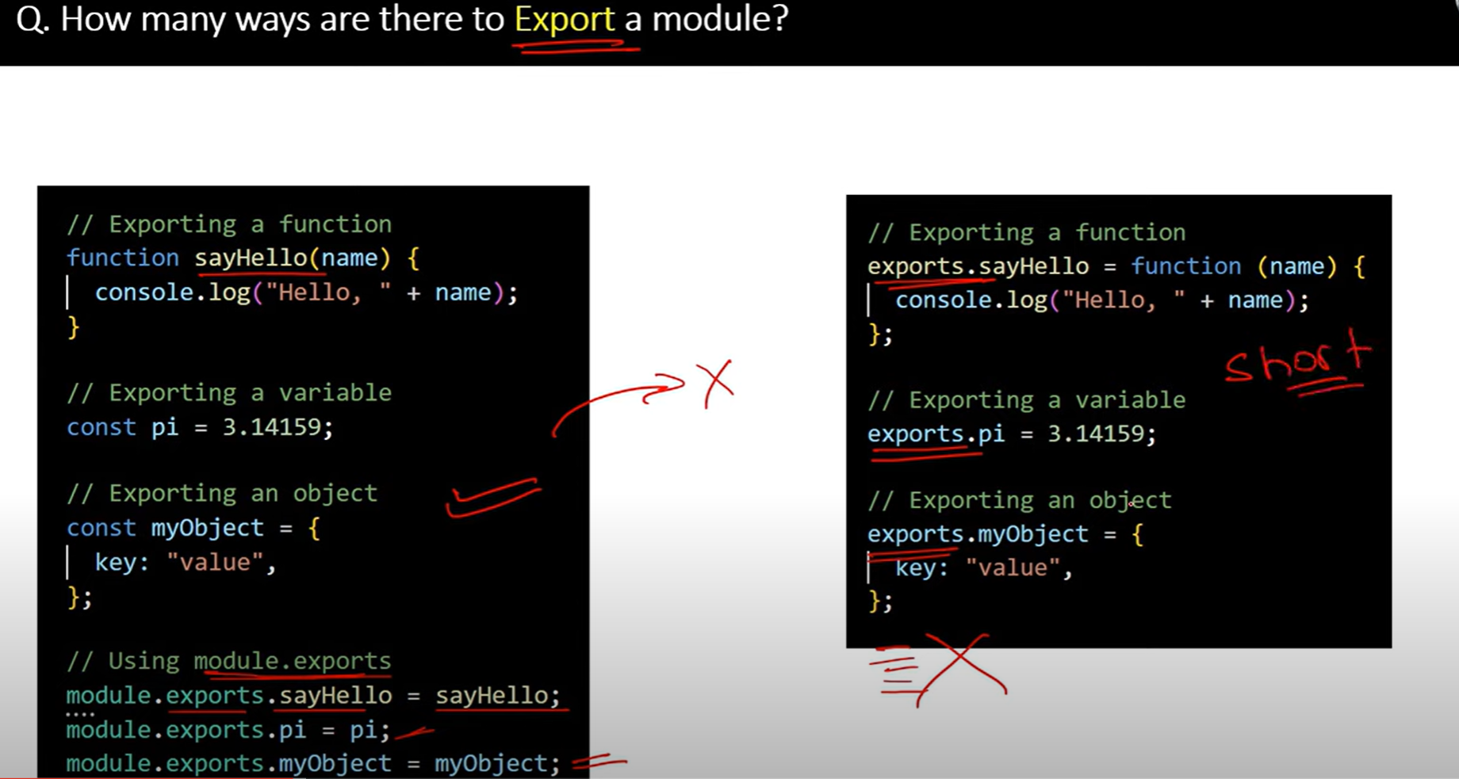

14.

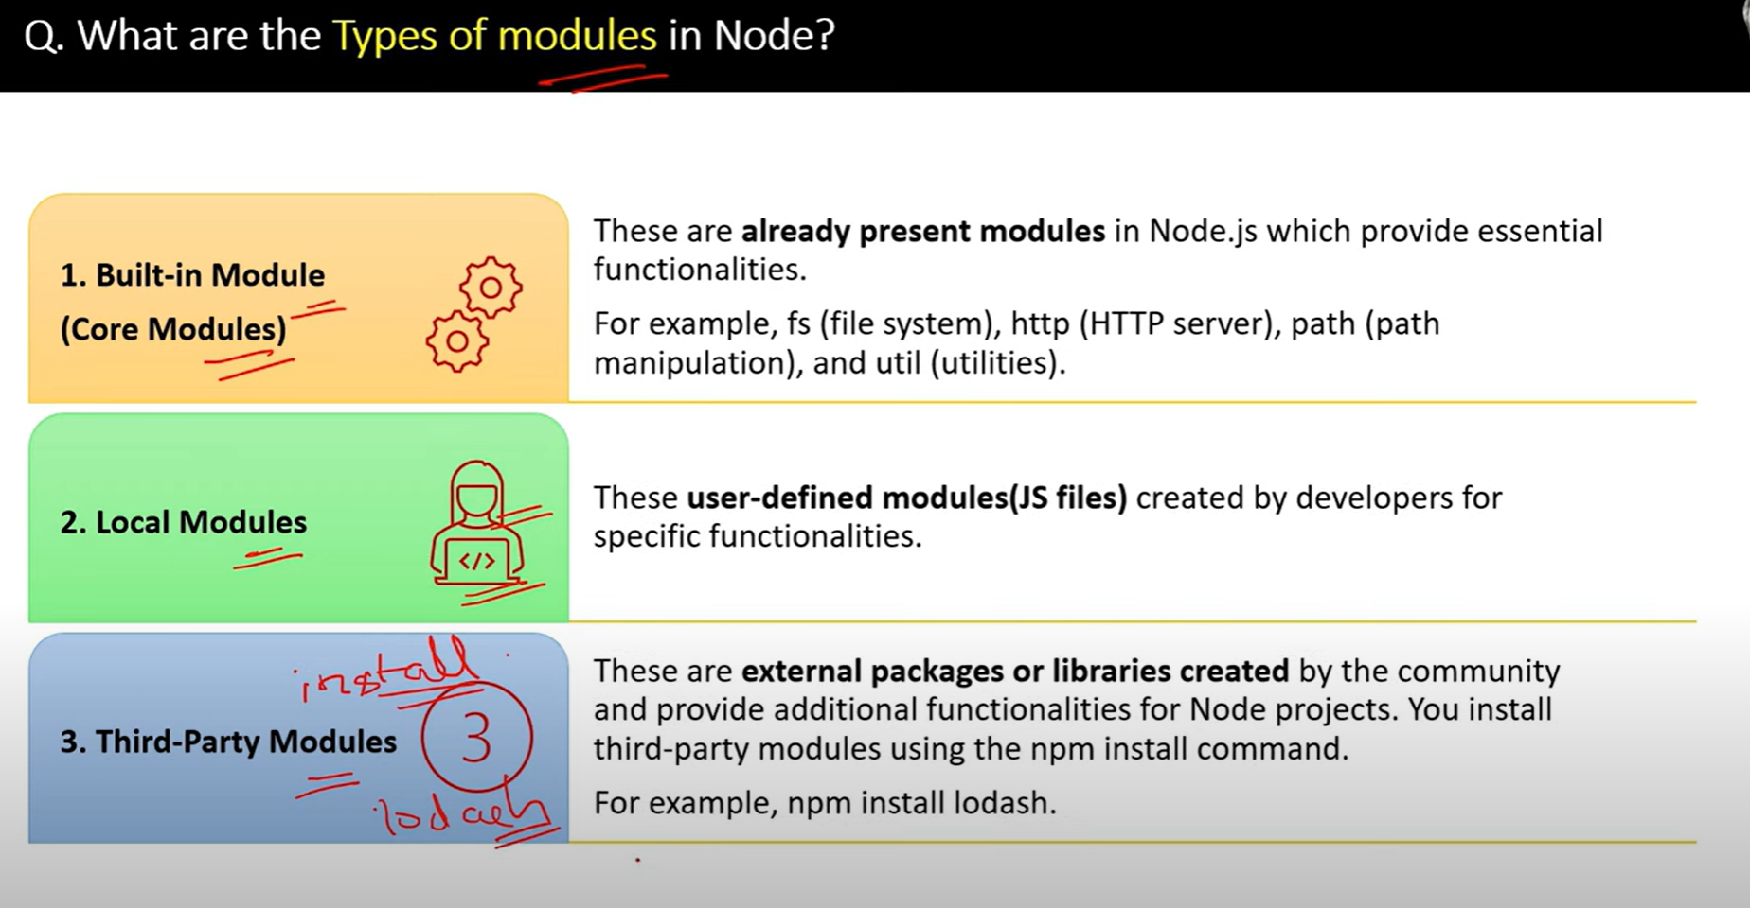

15.

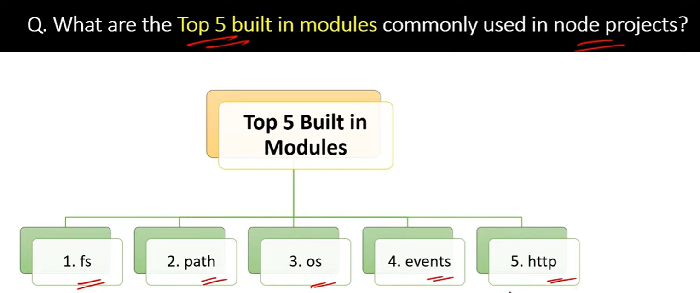

16.

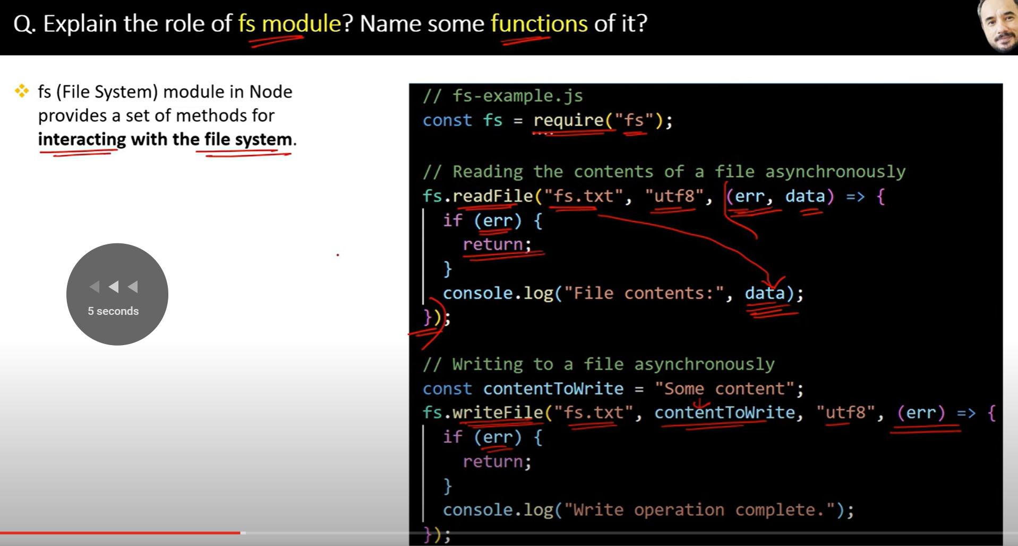

17.

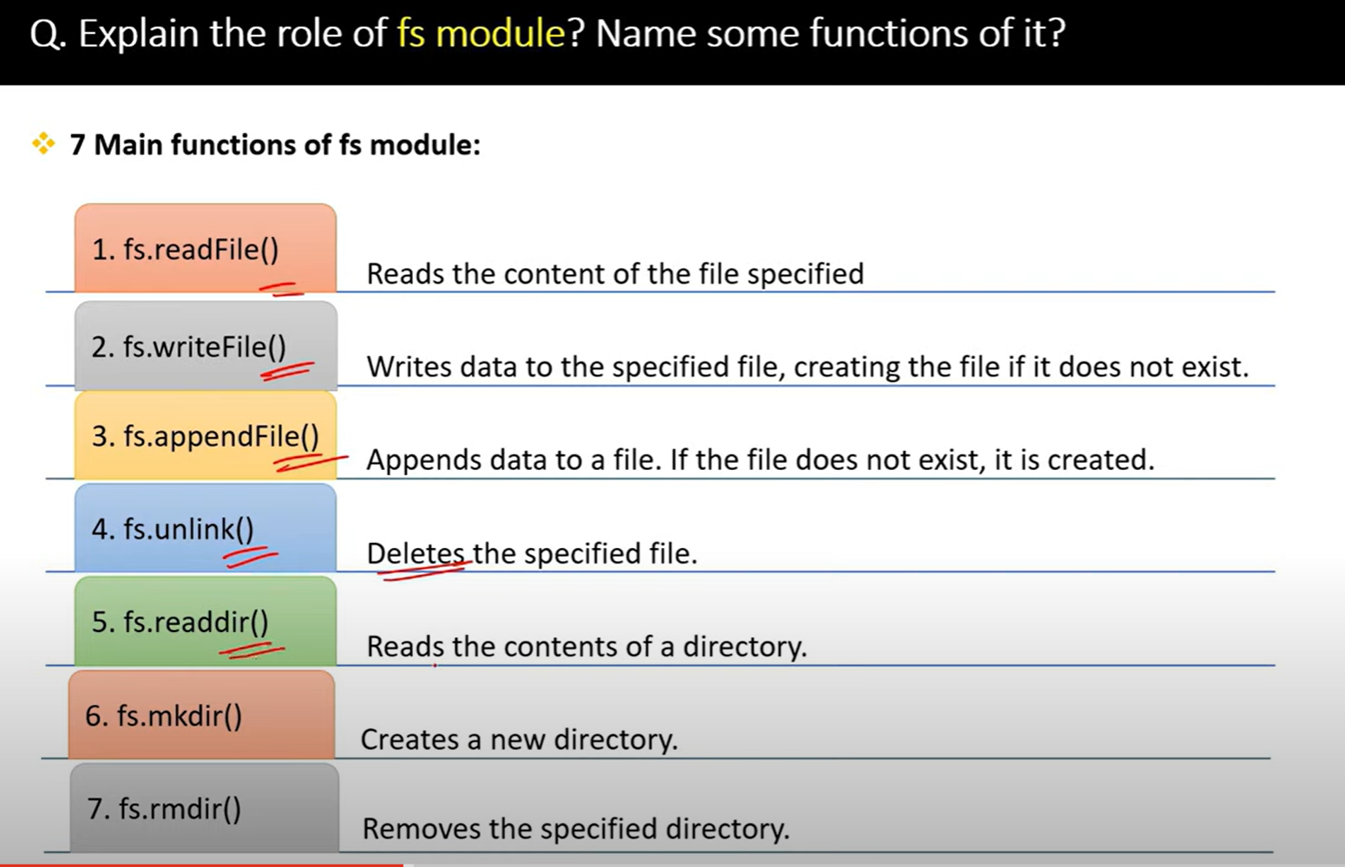

18.

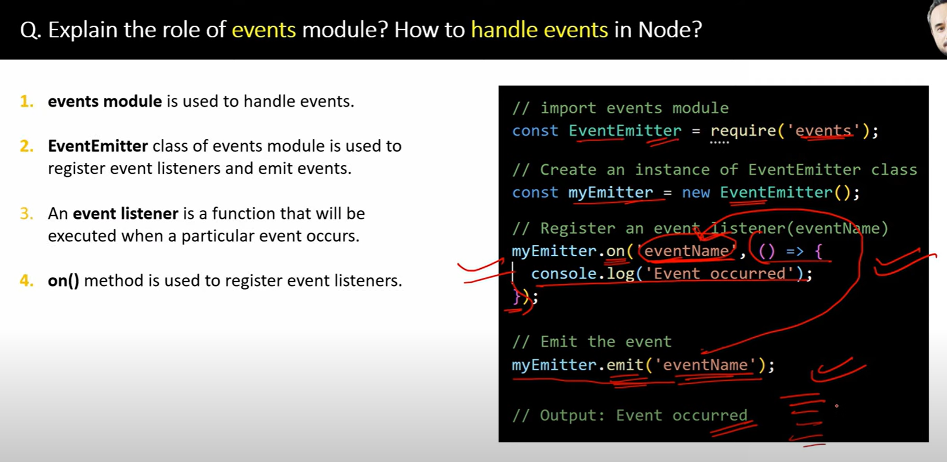

19.

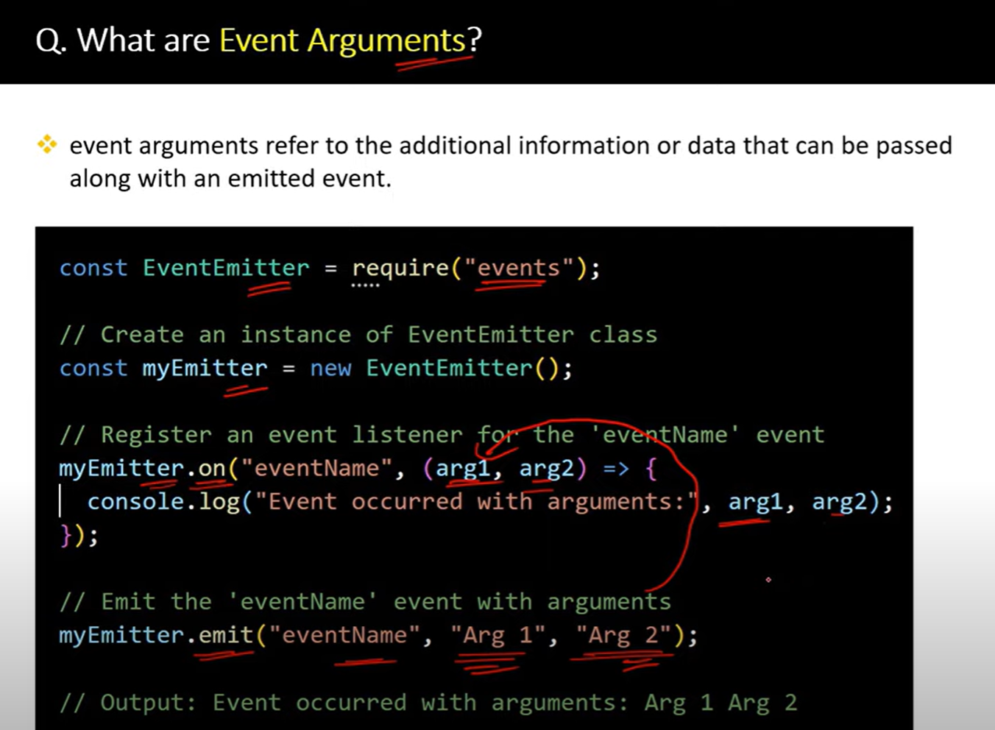

20.

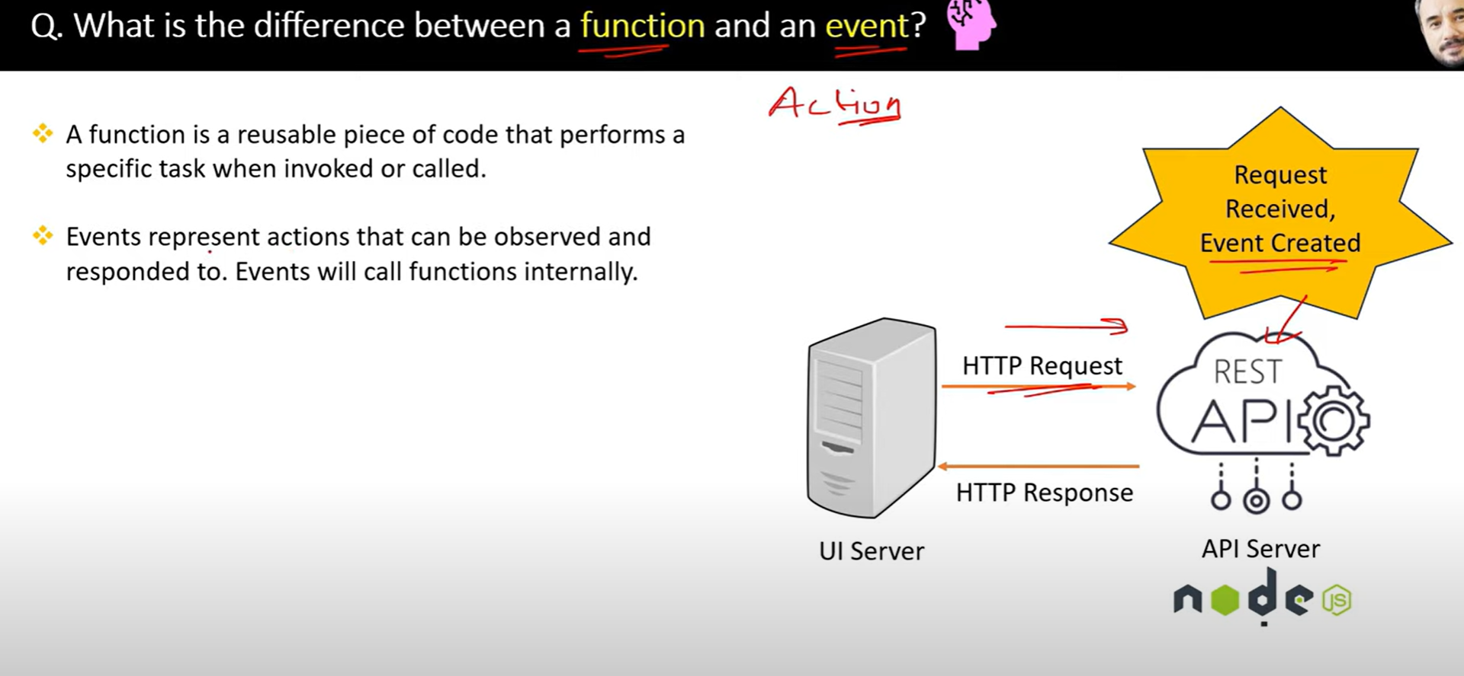

21.

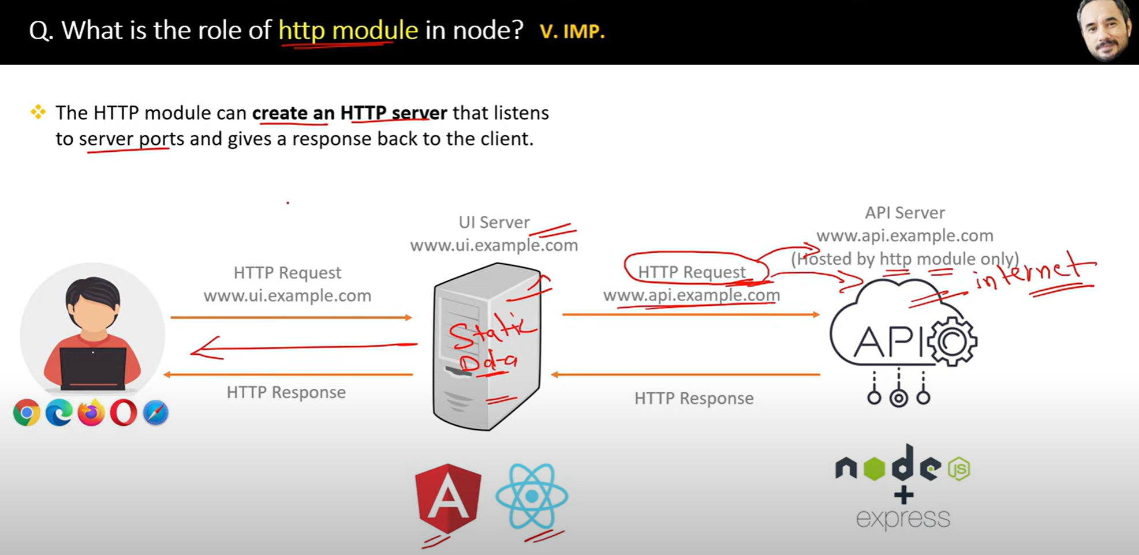

Http modules handles request and response of the server

22.

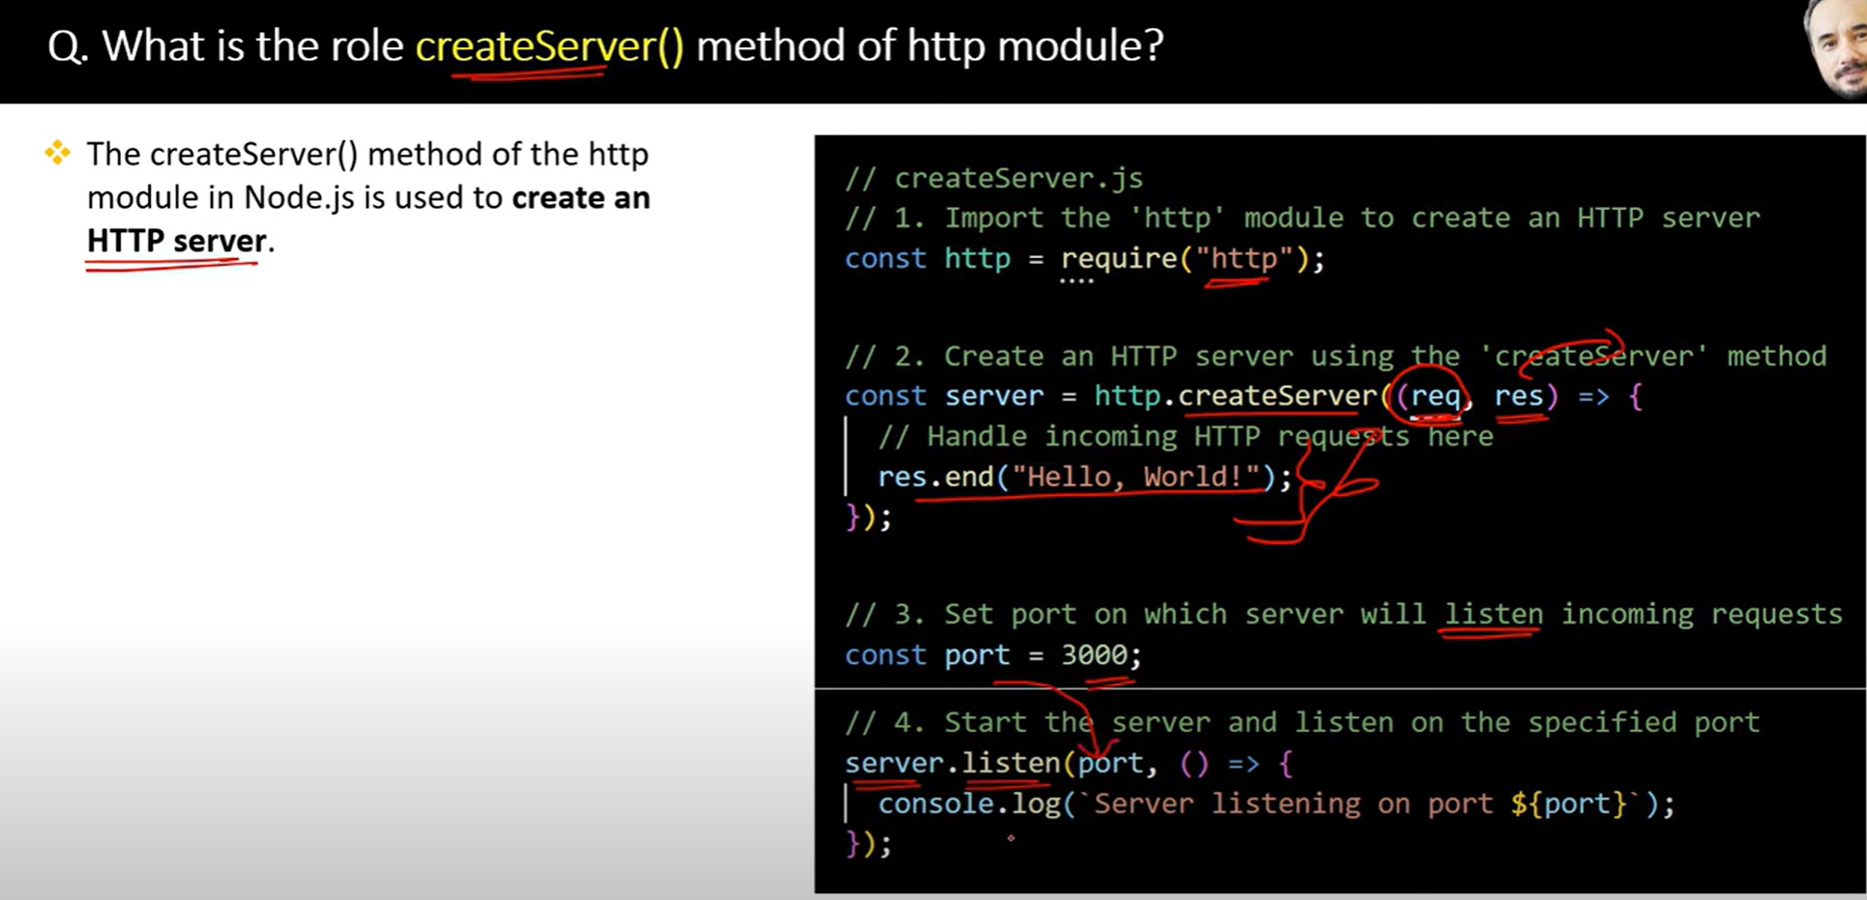

23.

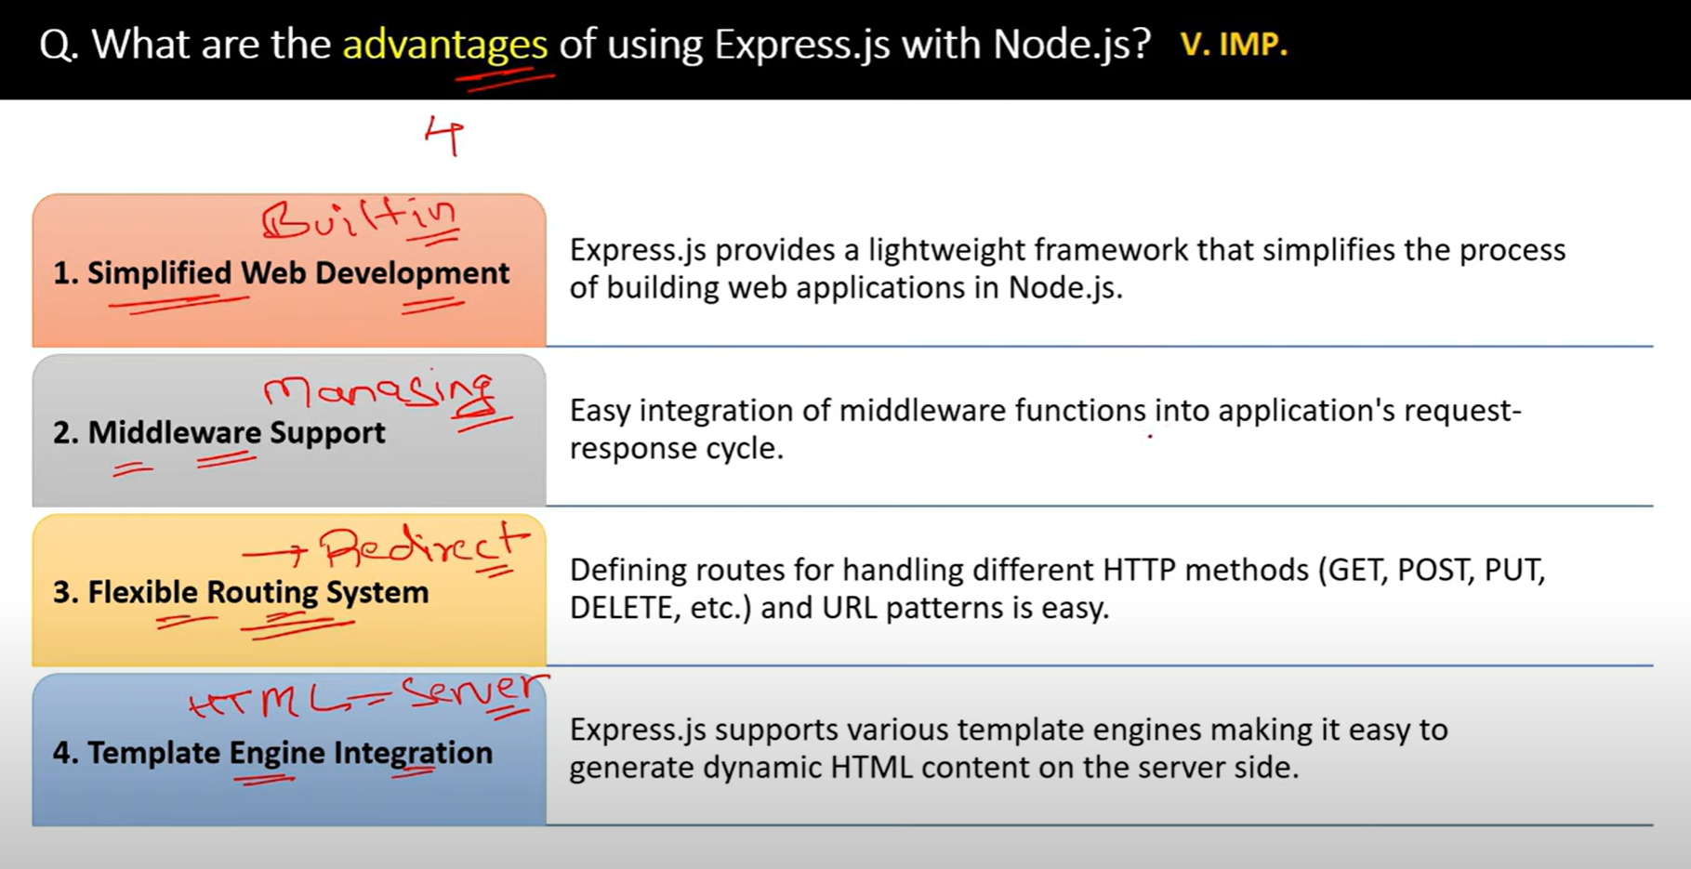

24.

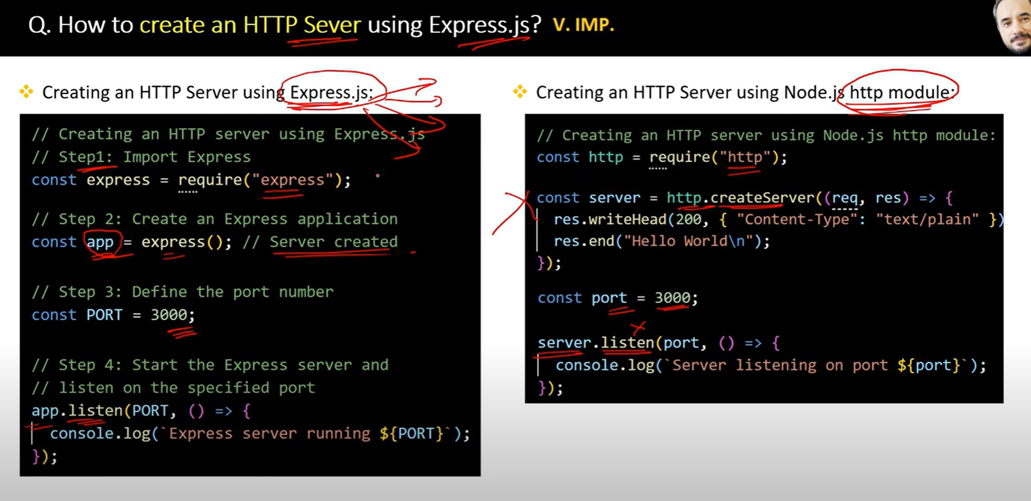

25.

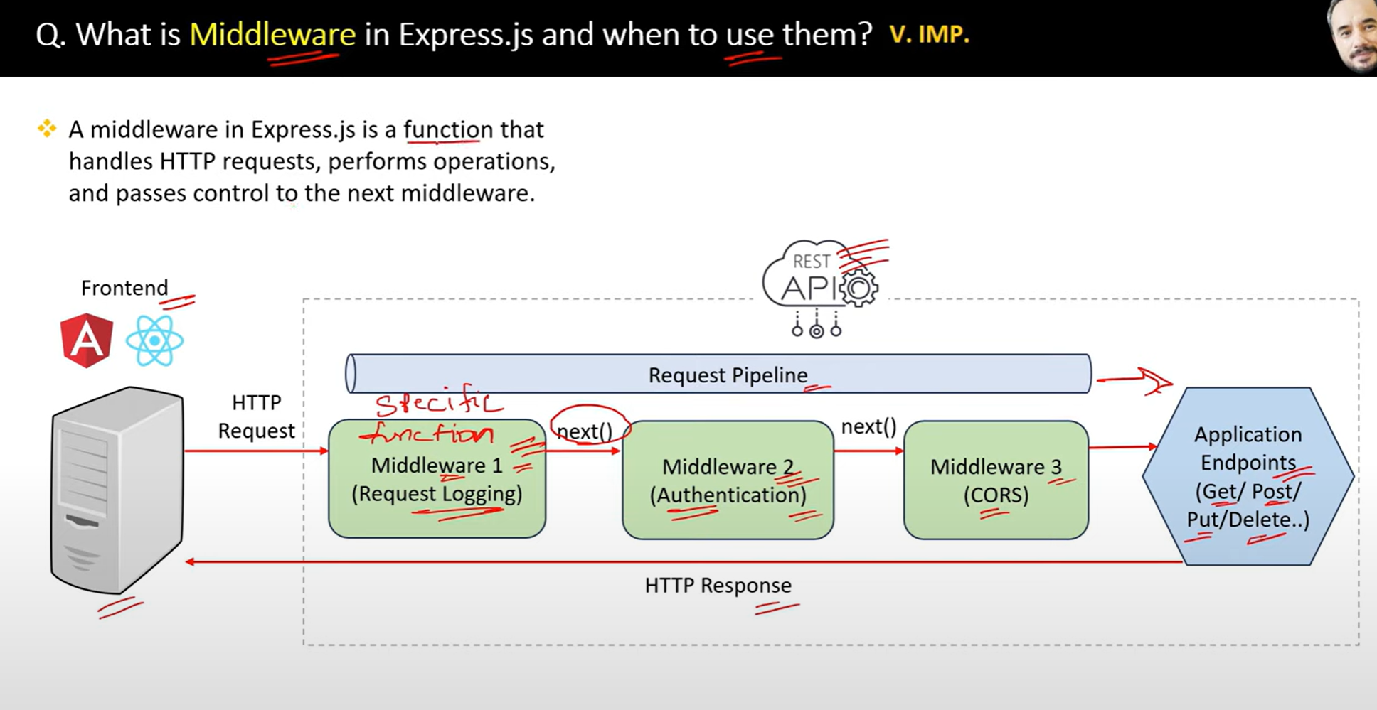

26.

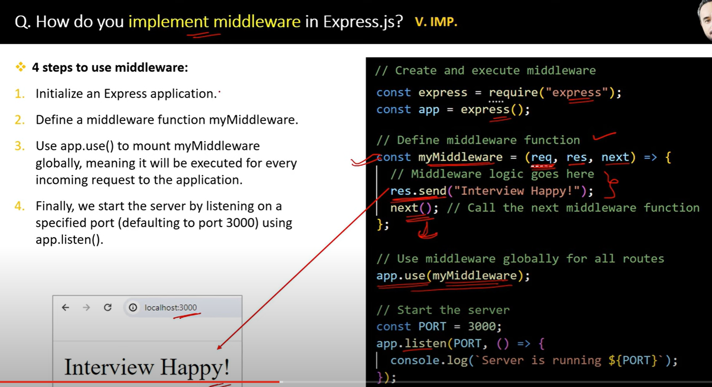

27.

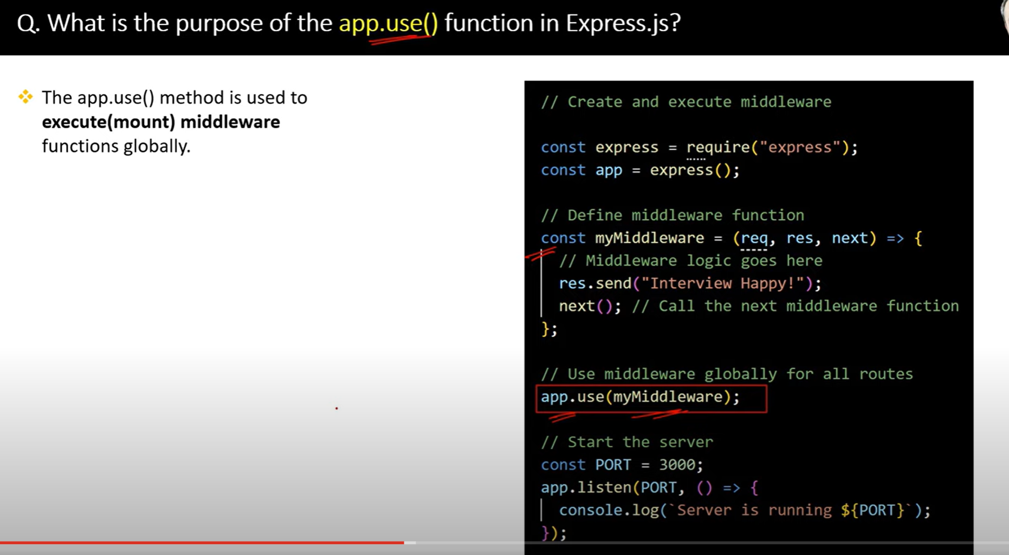

28.

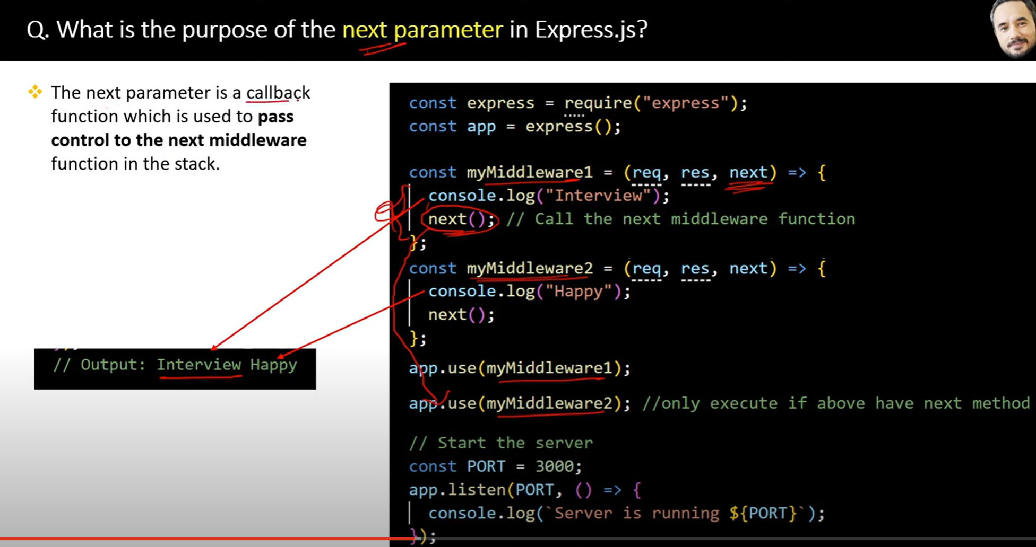

29.

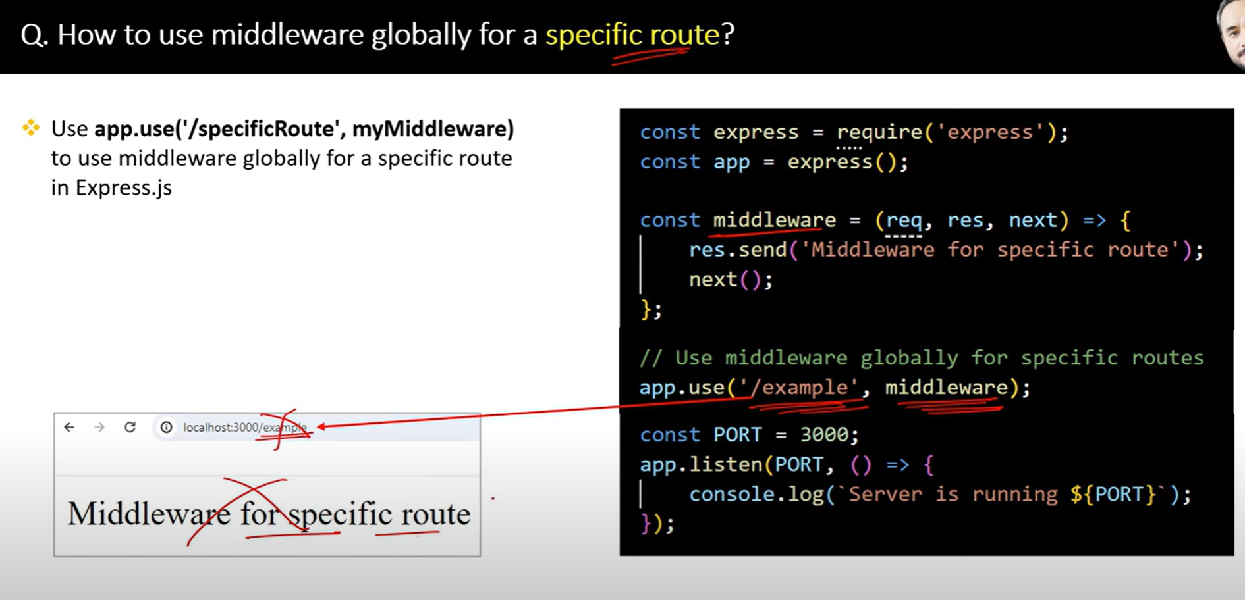

30

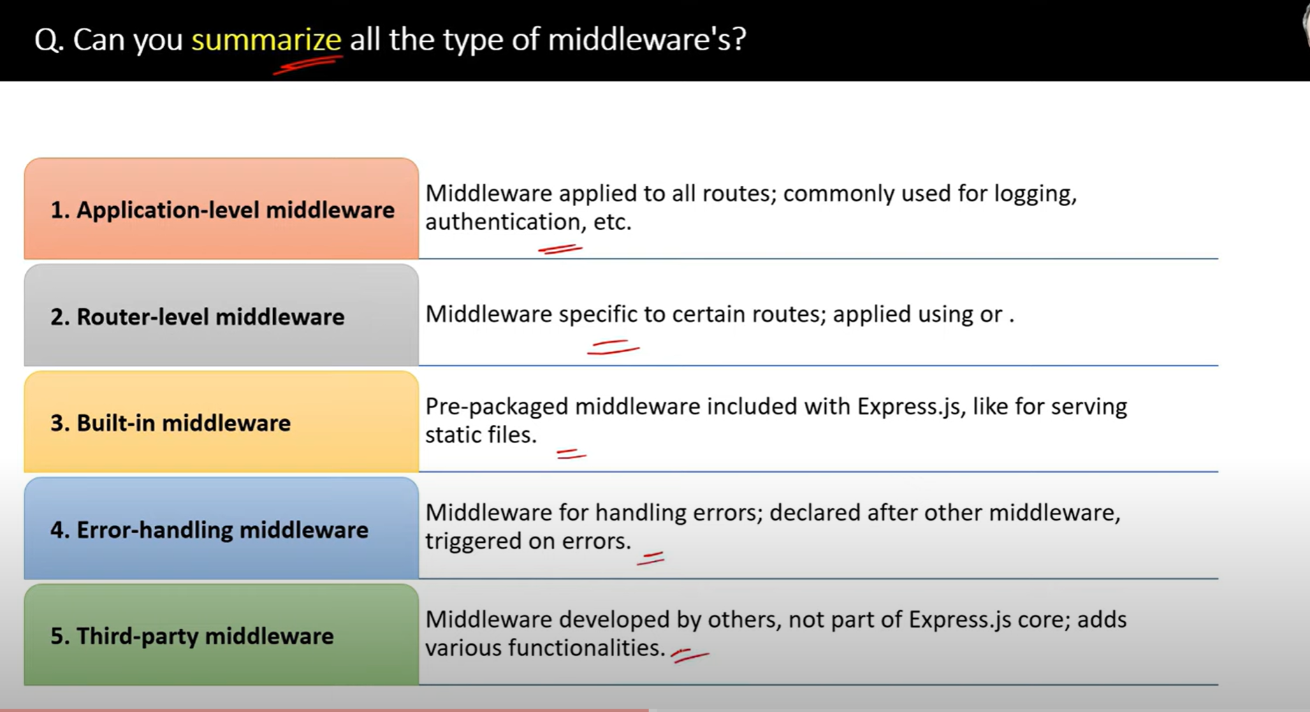

31.

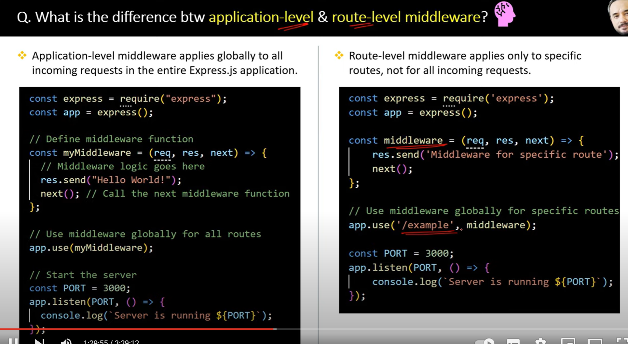

32.

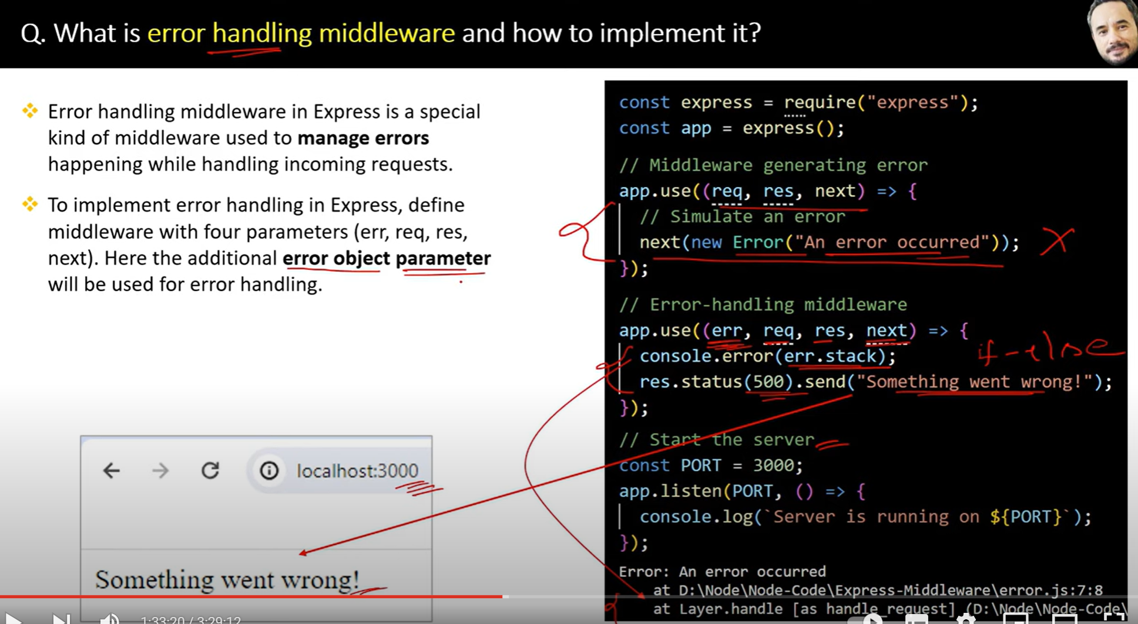

32.

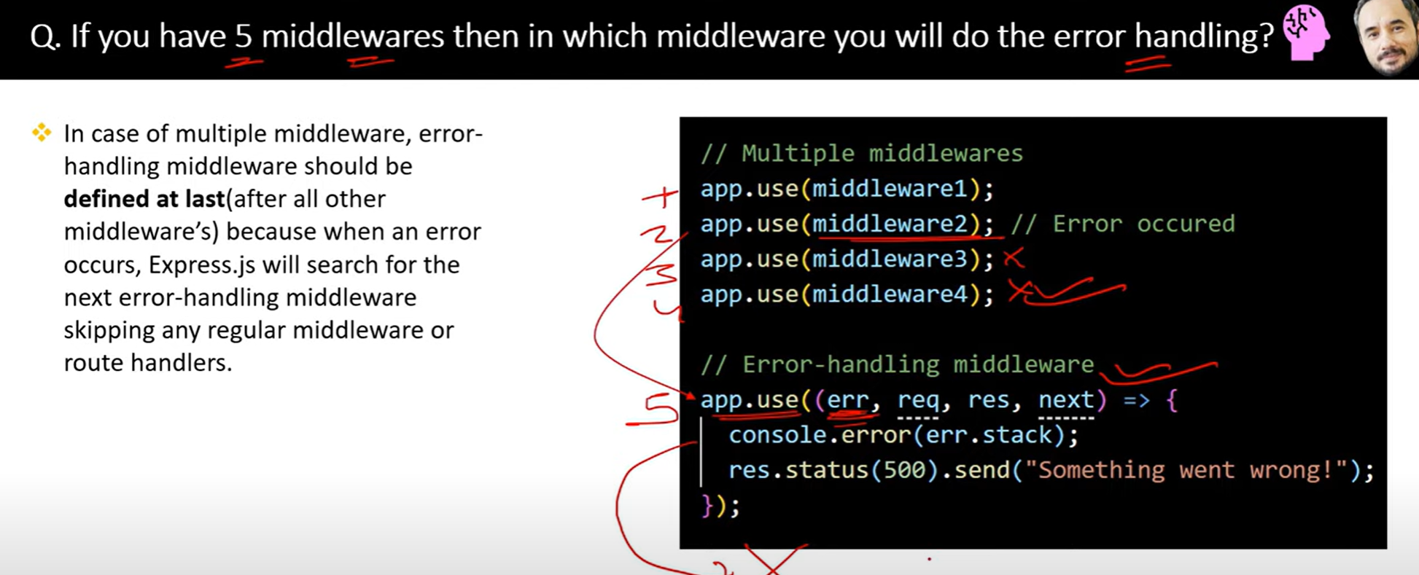

33.

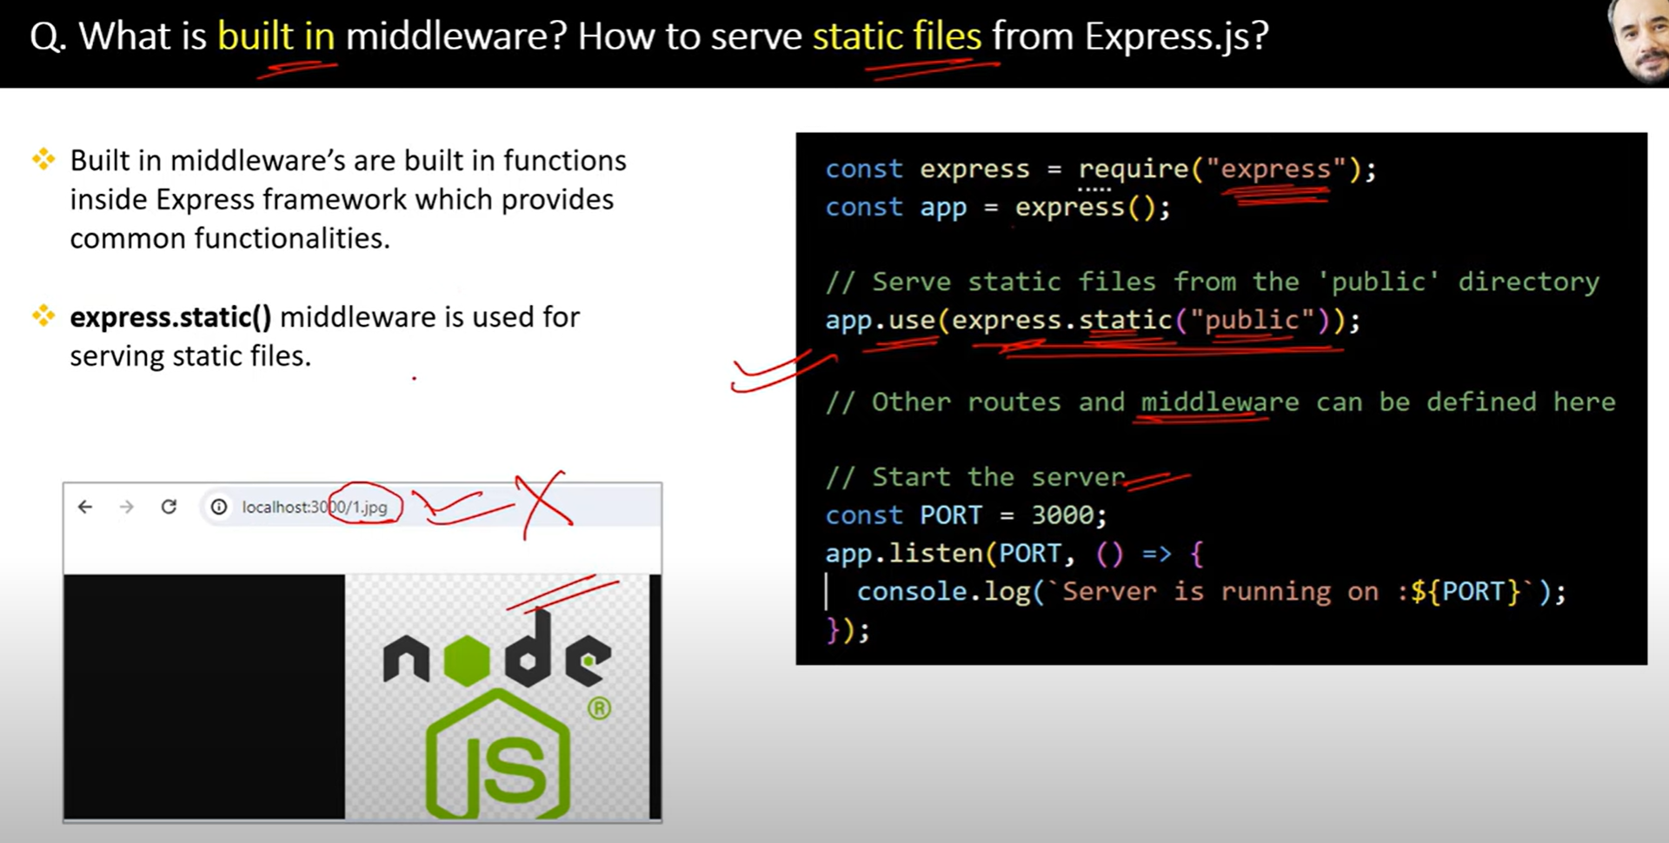

34.

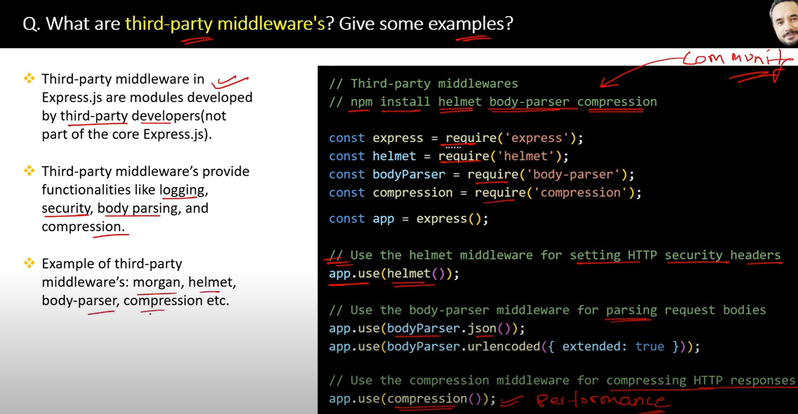

35.

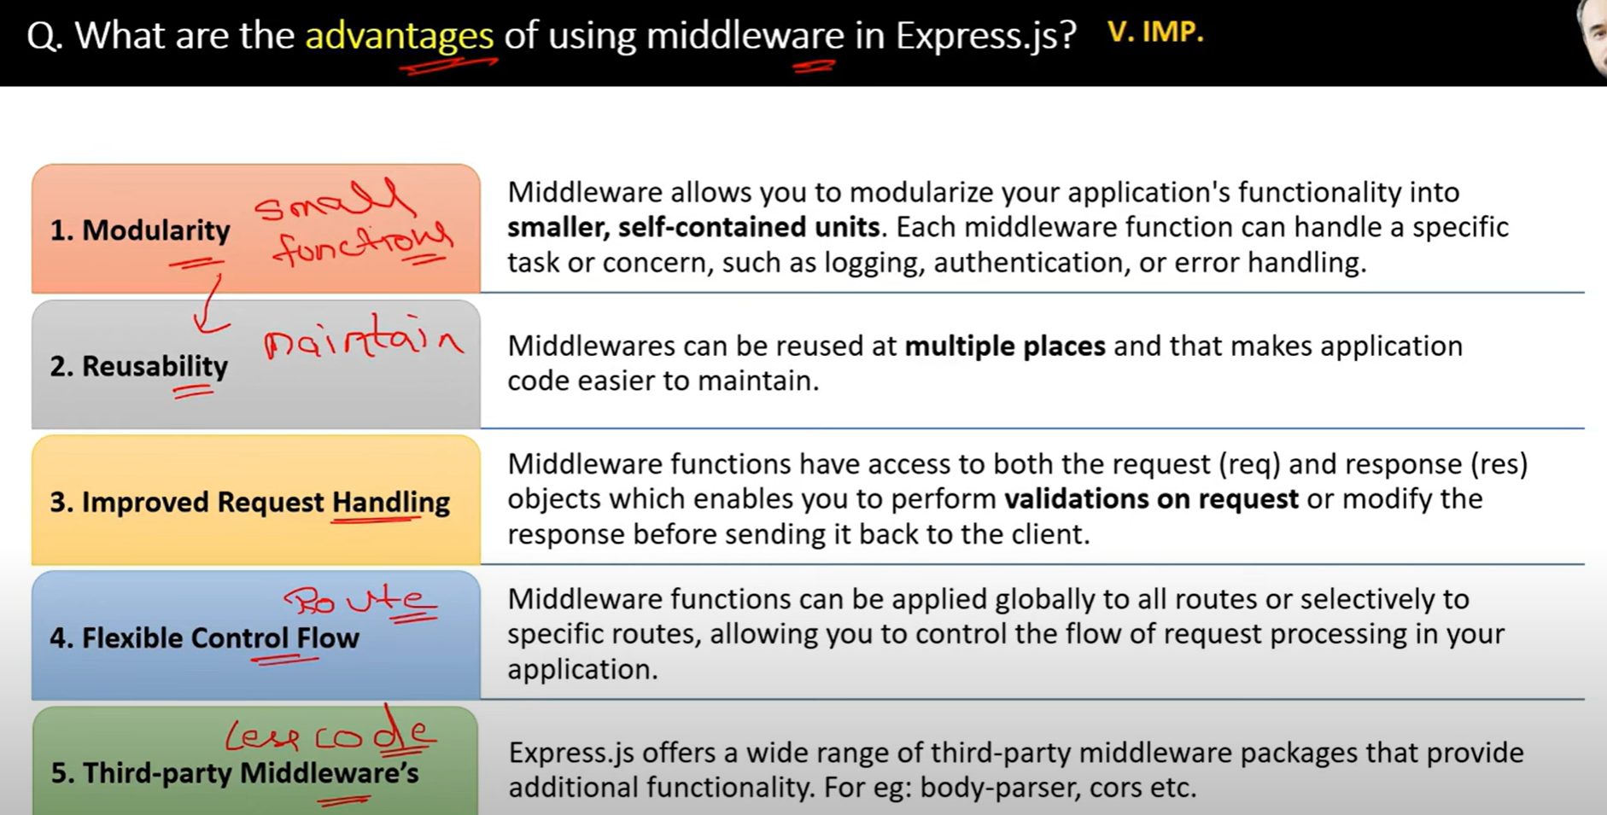

36.

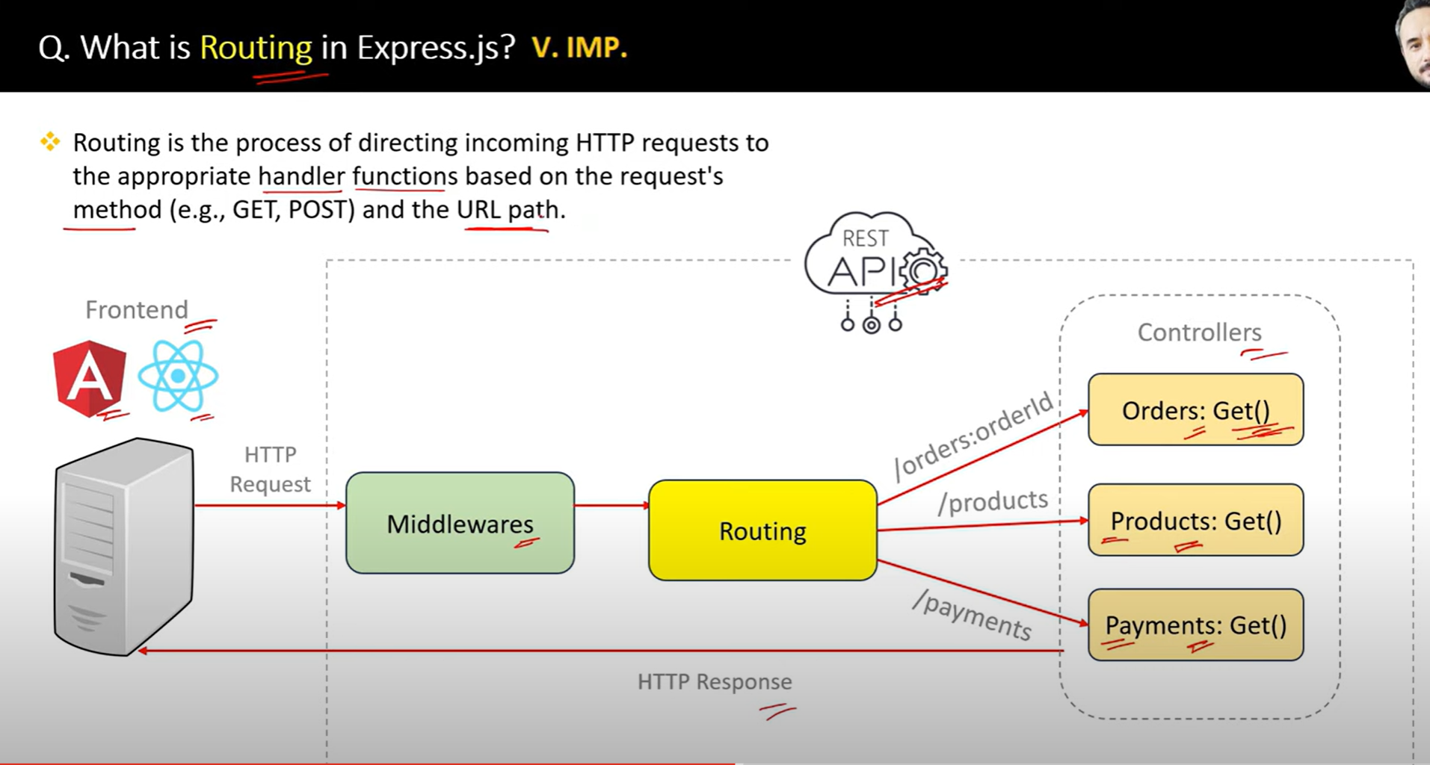

37.

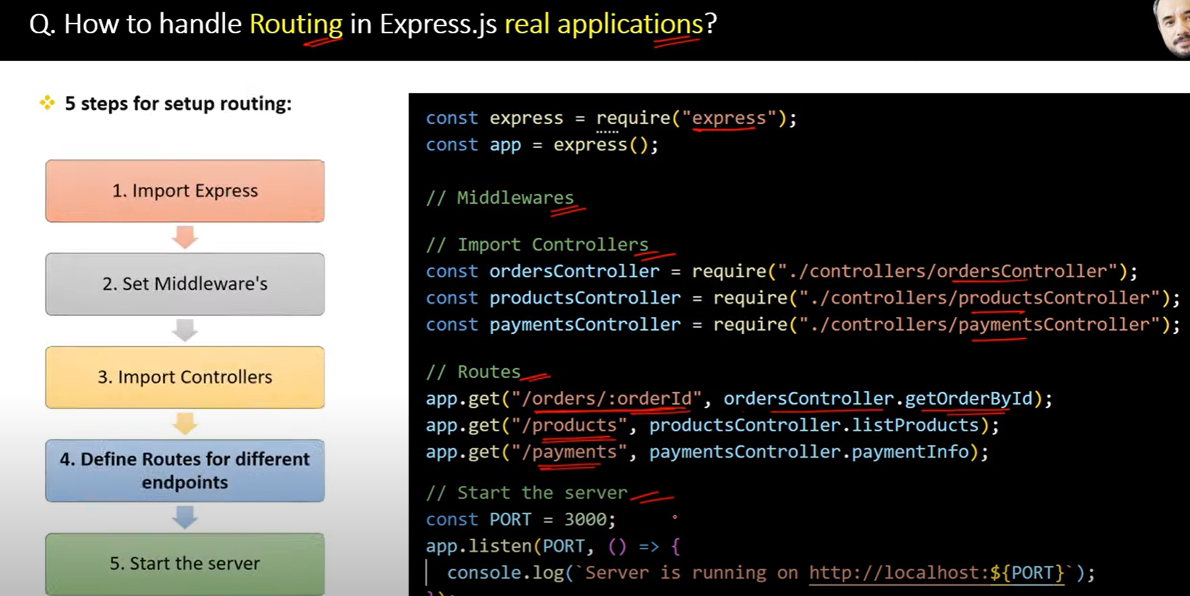

38.

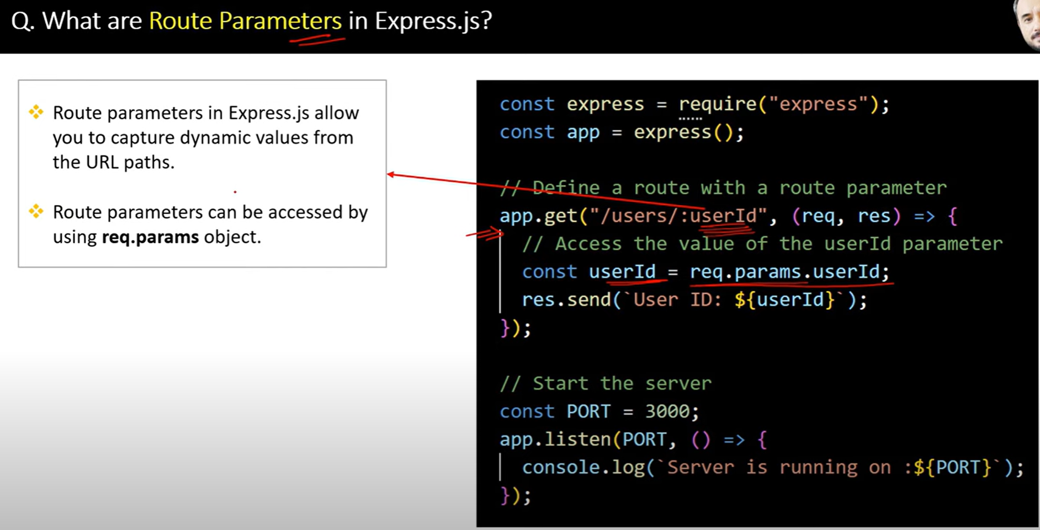

39.

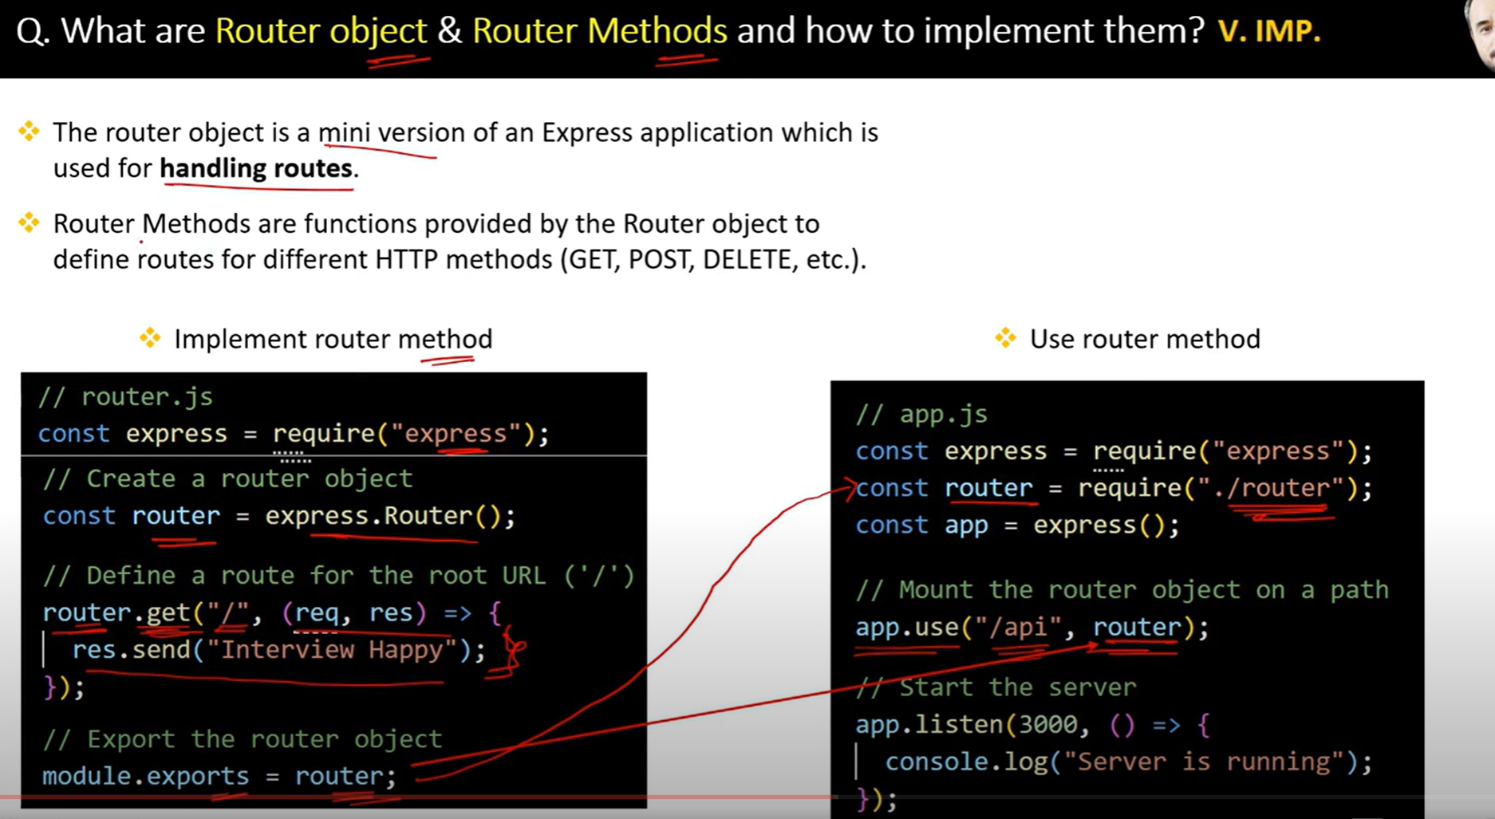

40.

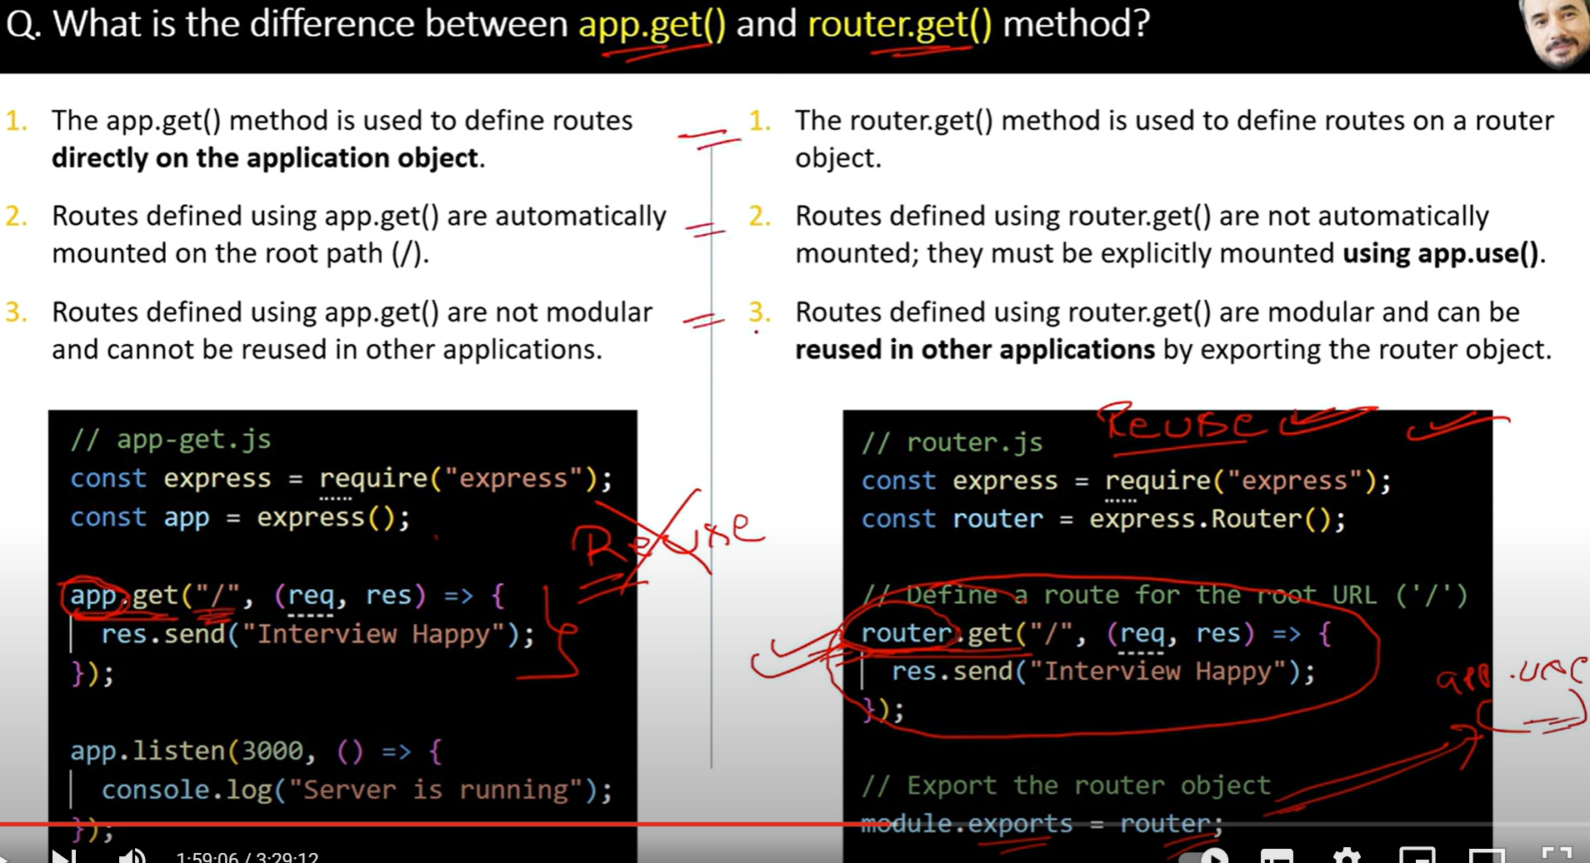

41.

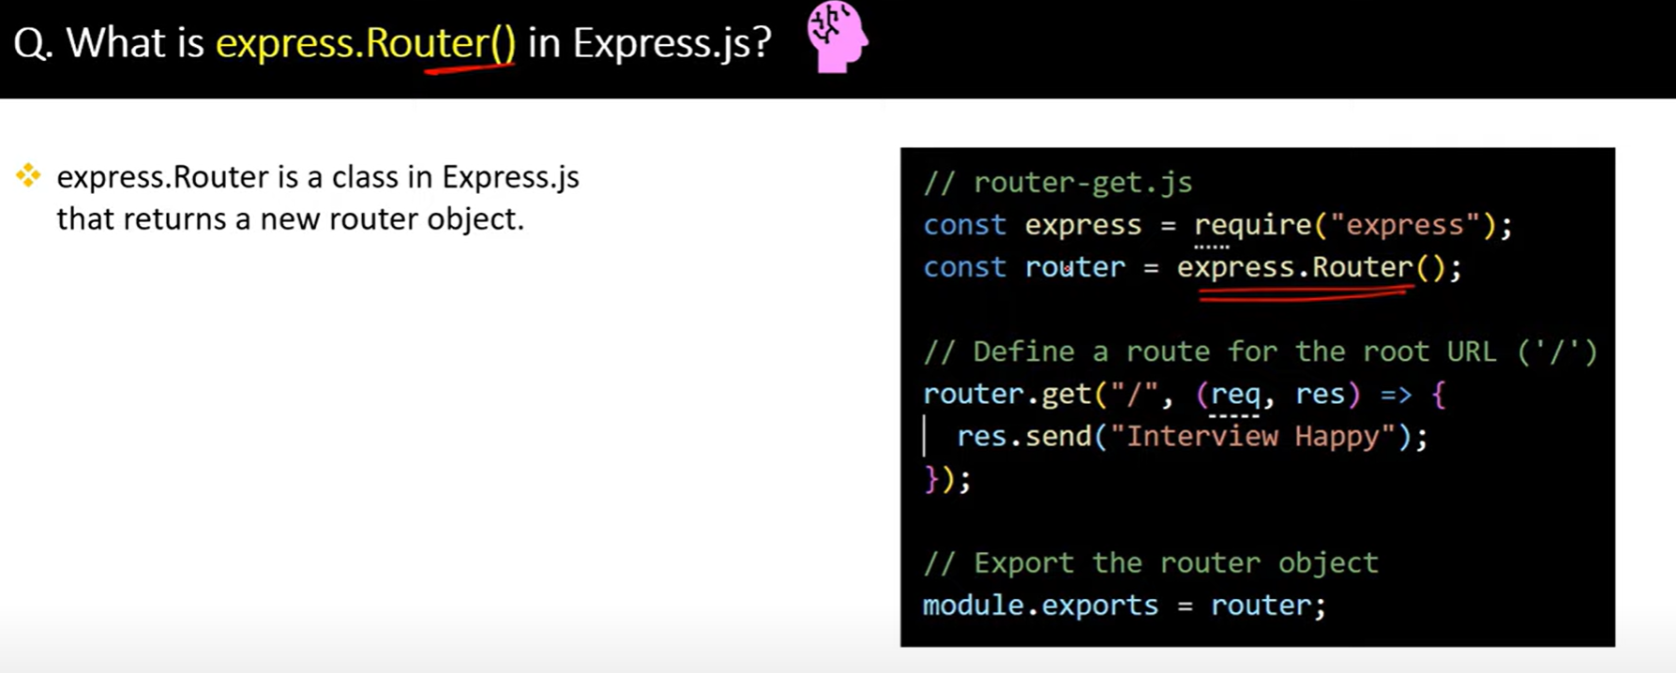

42.

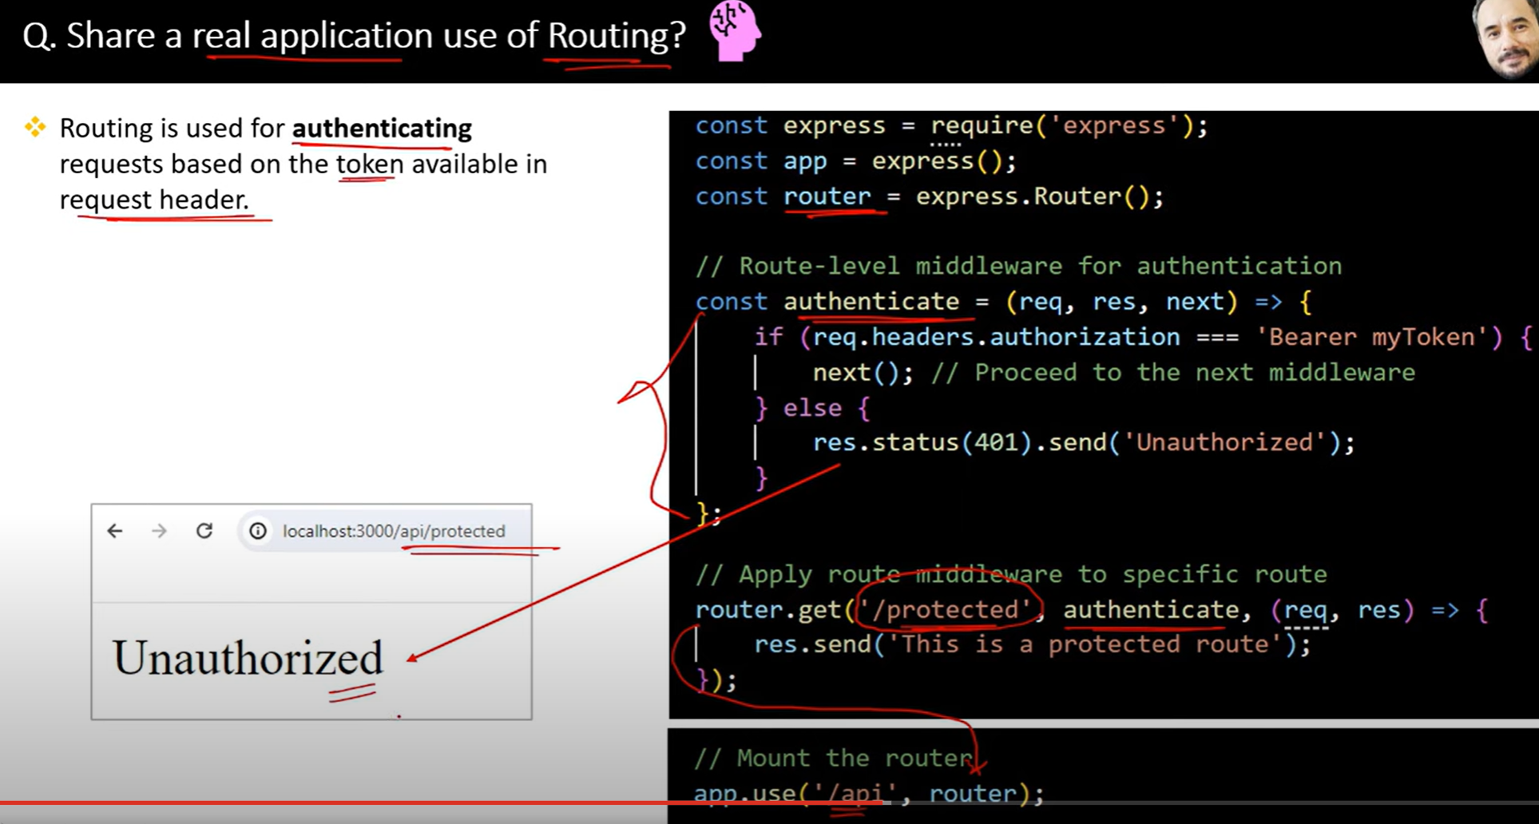

43.

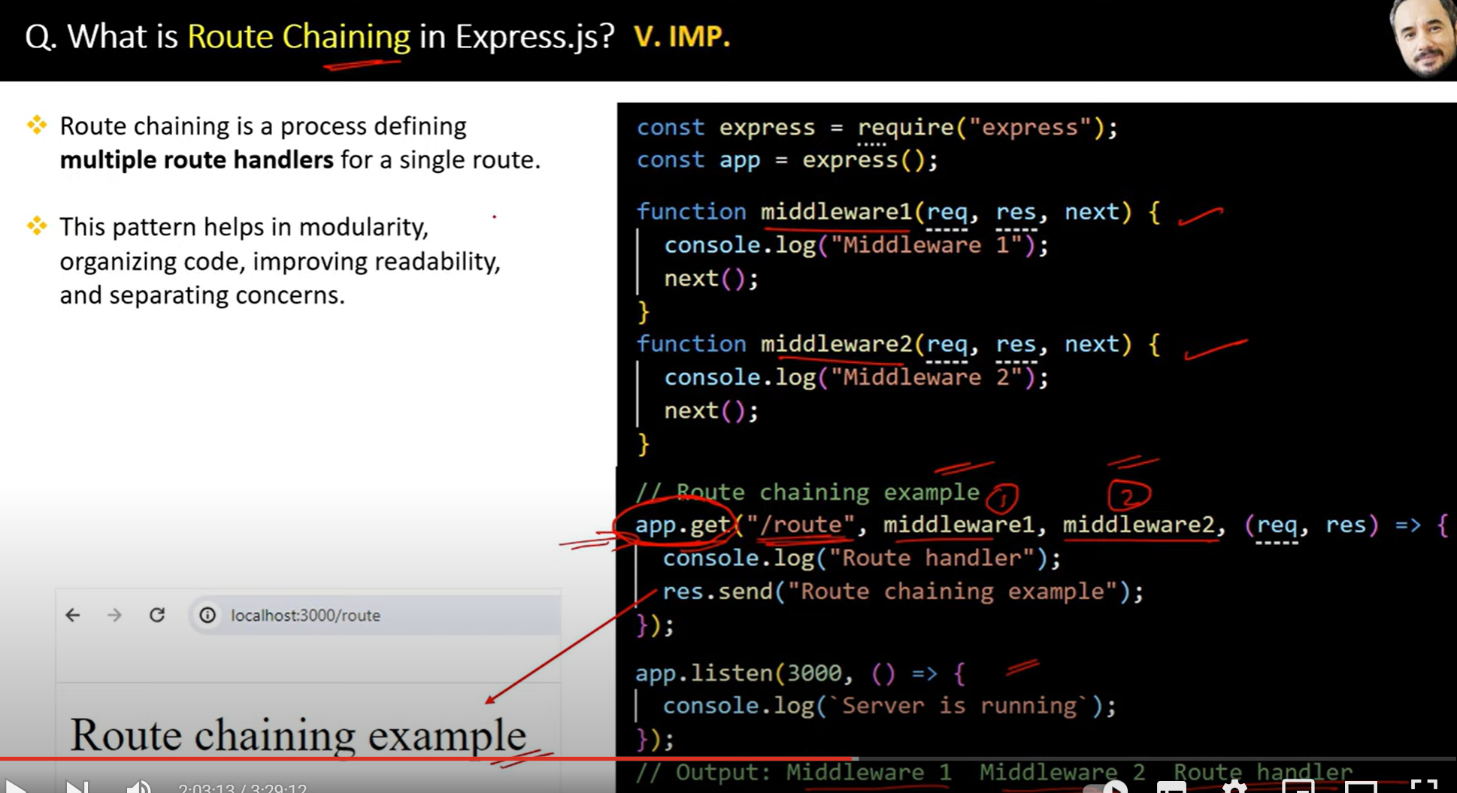

44.

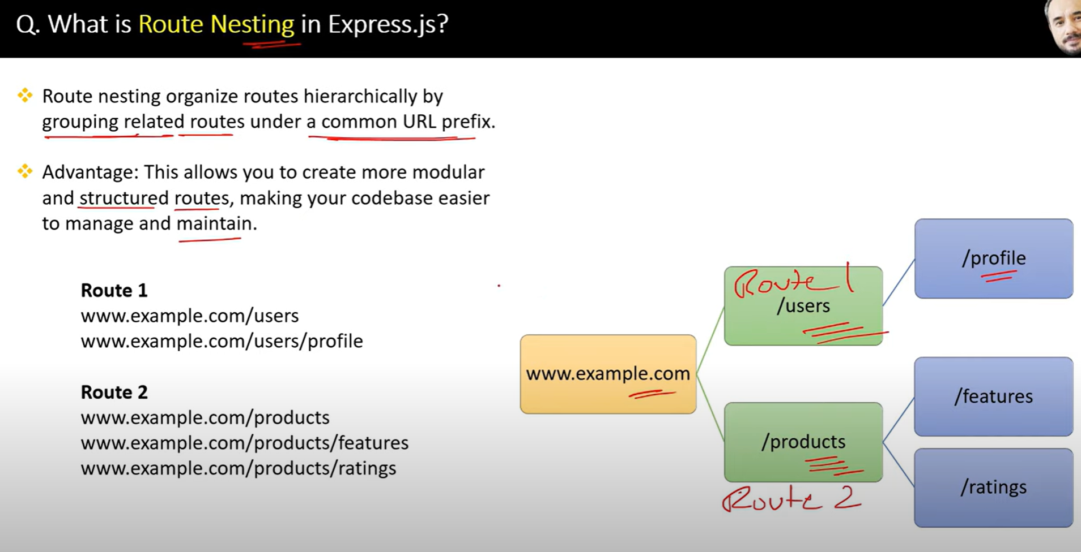

45.

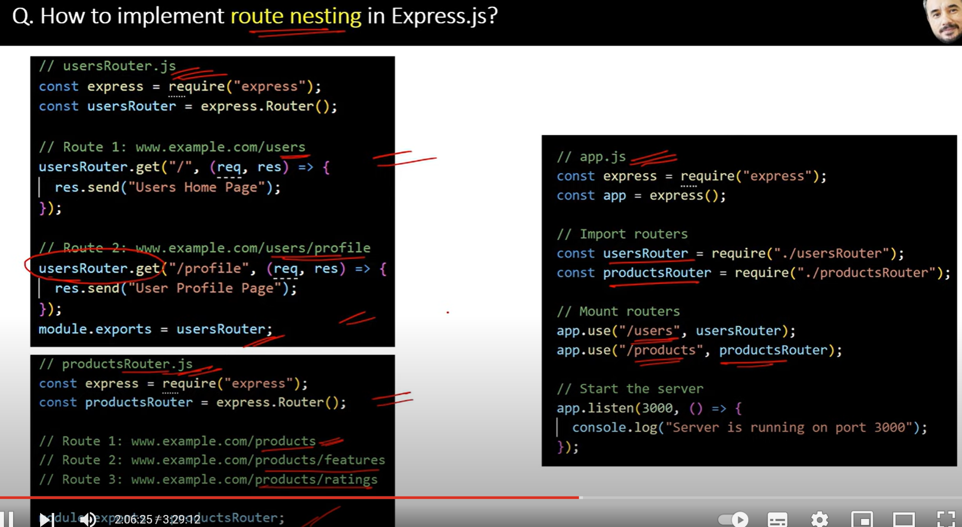

46.

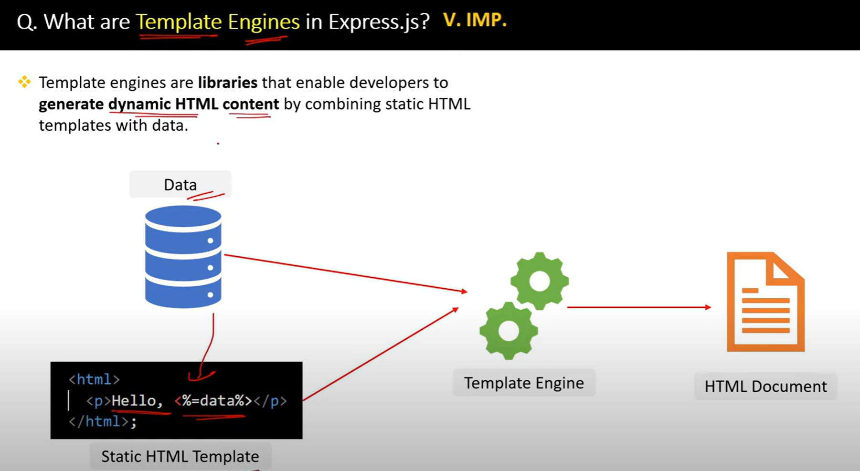

47.

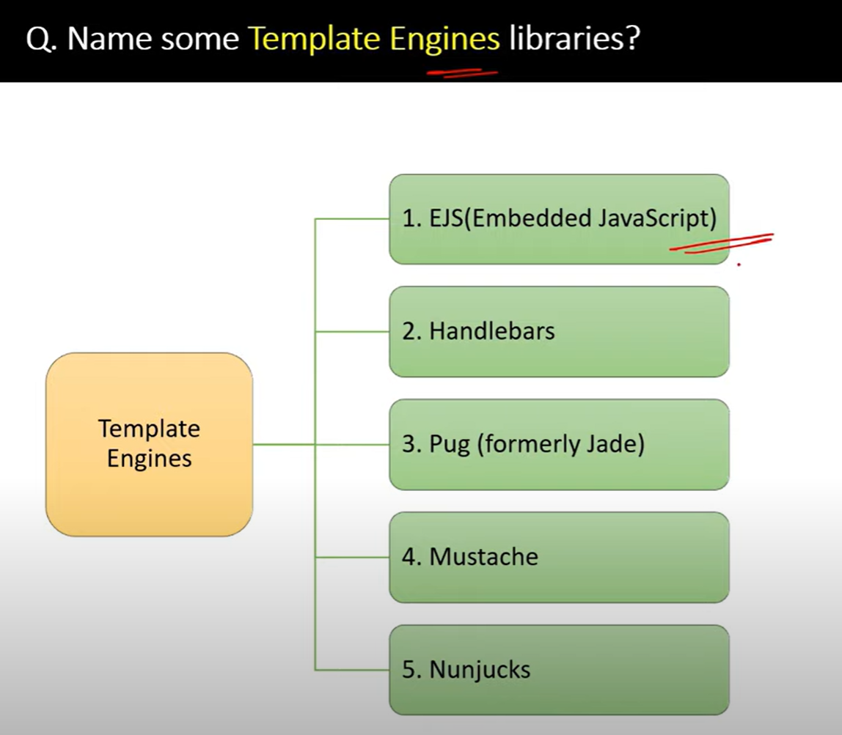

48.

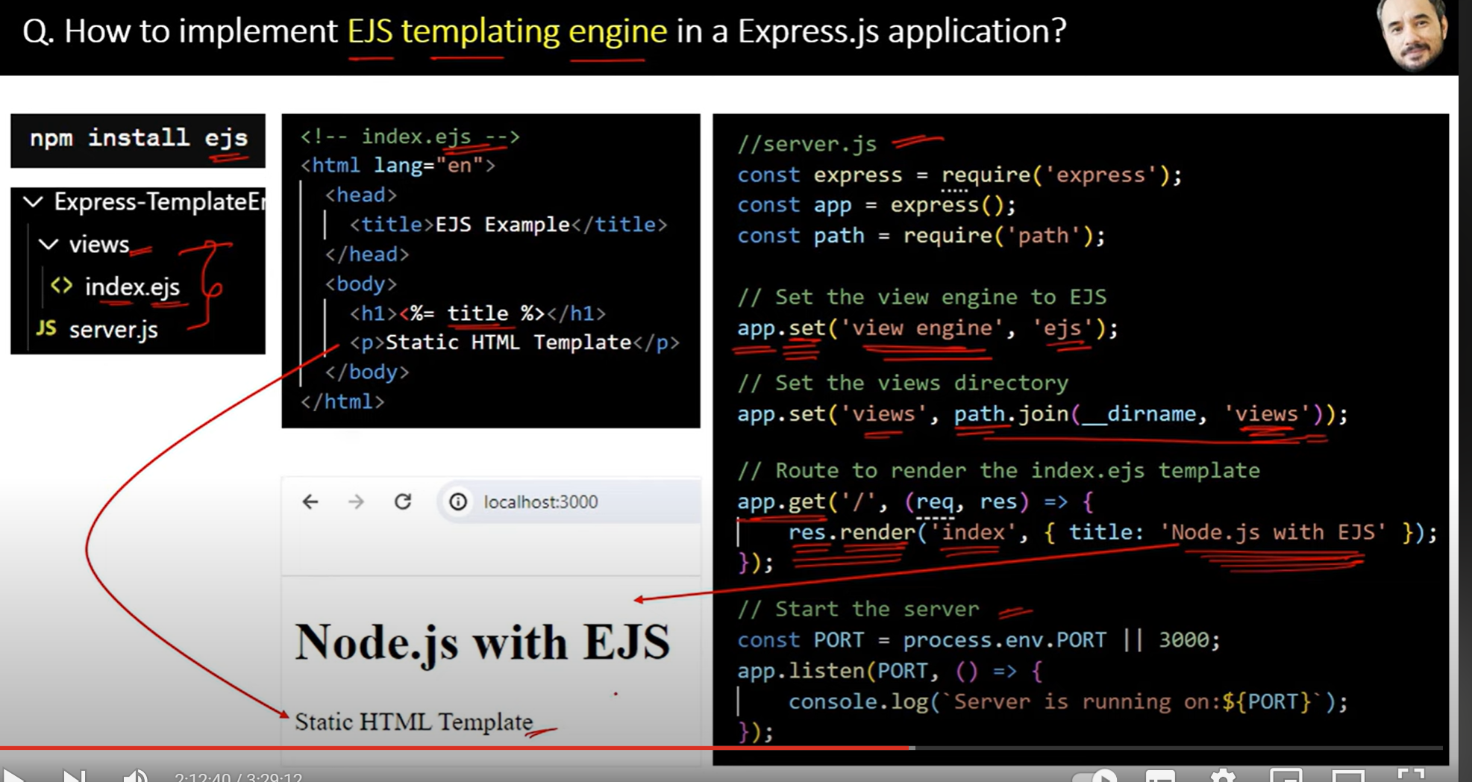

49.

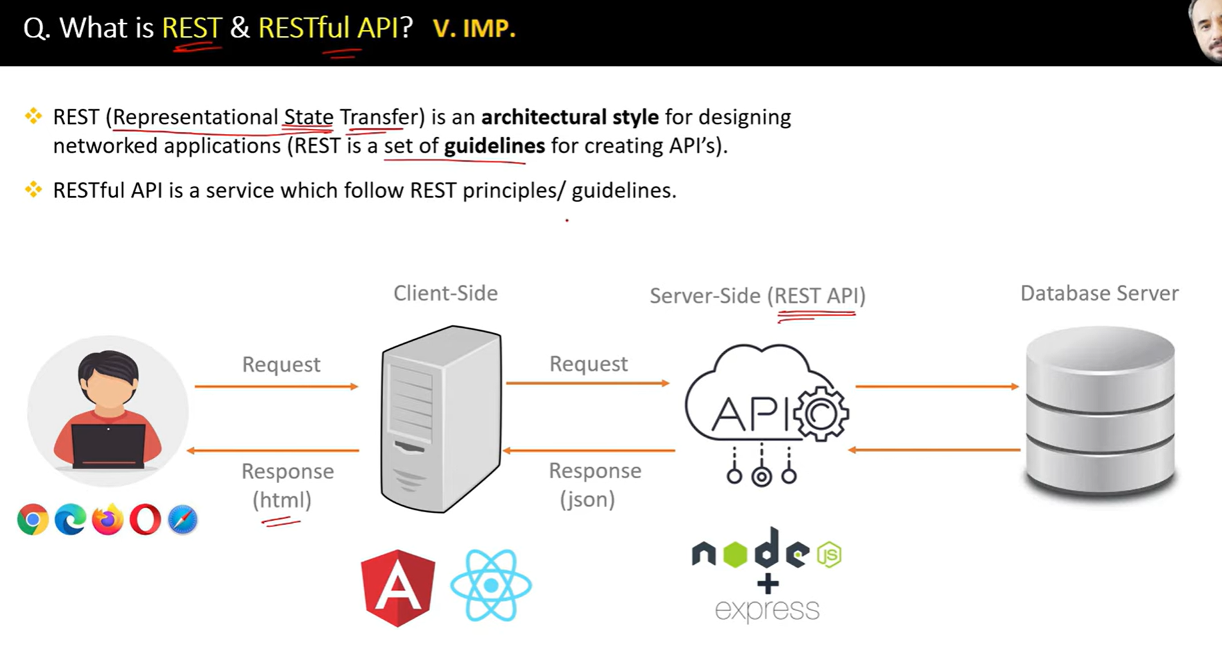

A **REST API** (Representational State Transfer Application Programming Interface) is a set of rules and conventions for building web services that allow communication between systems over the HTTP protocol. REST APIs are designed to be lightweight, stateless, and scalable,

50.

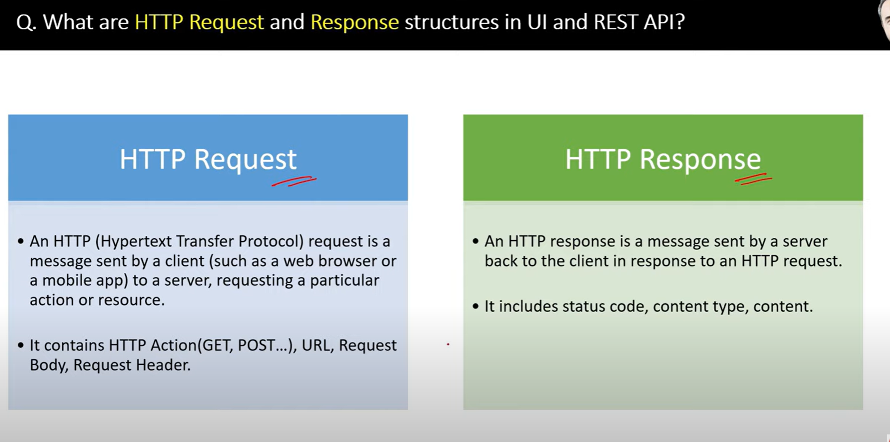

51.

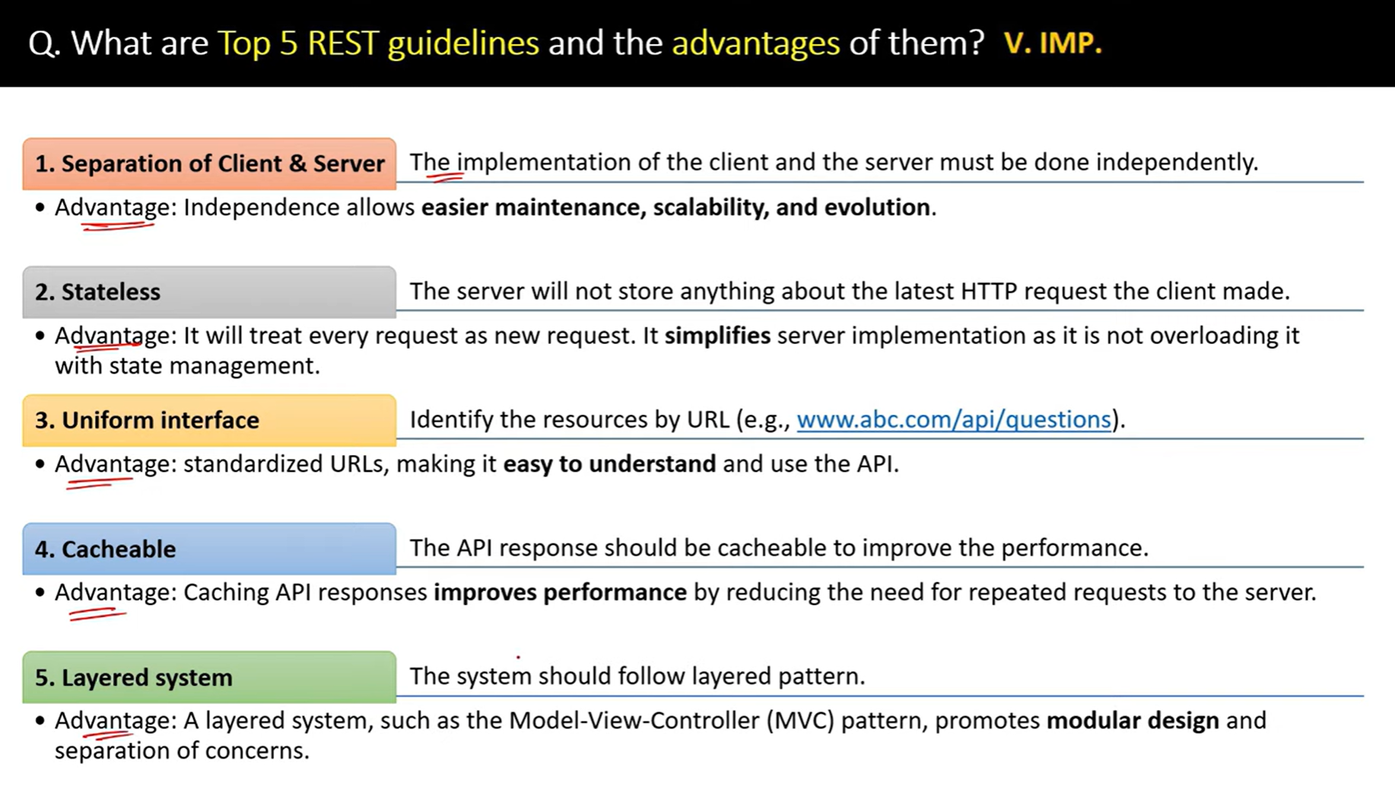

52.

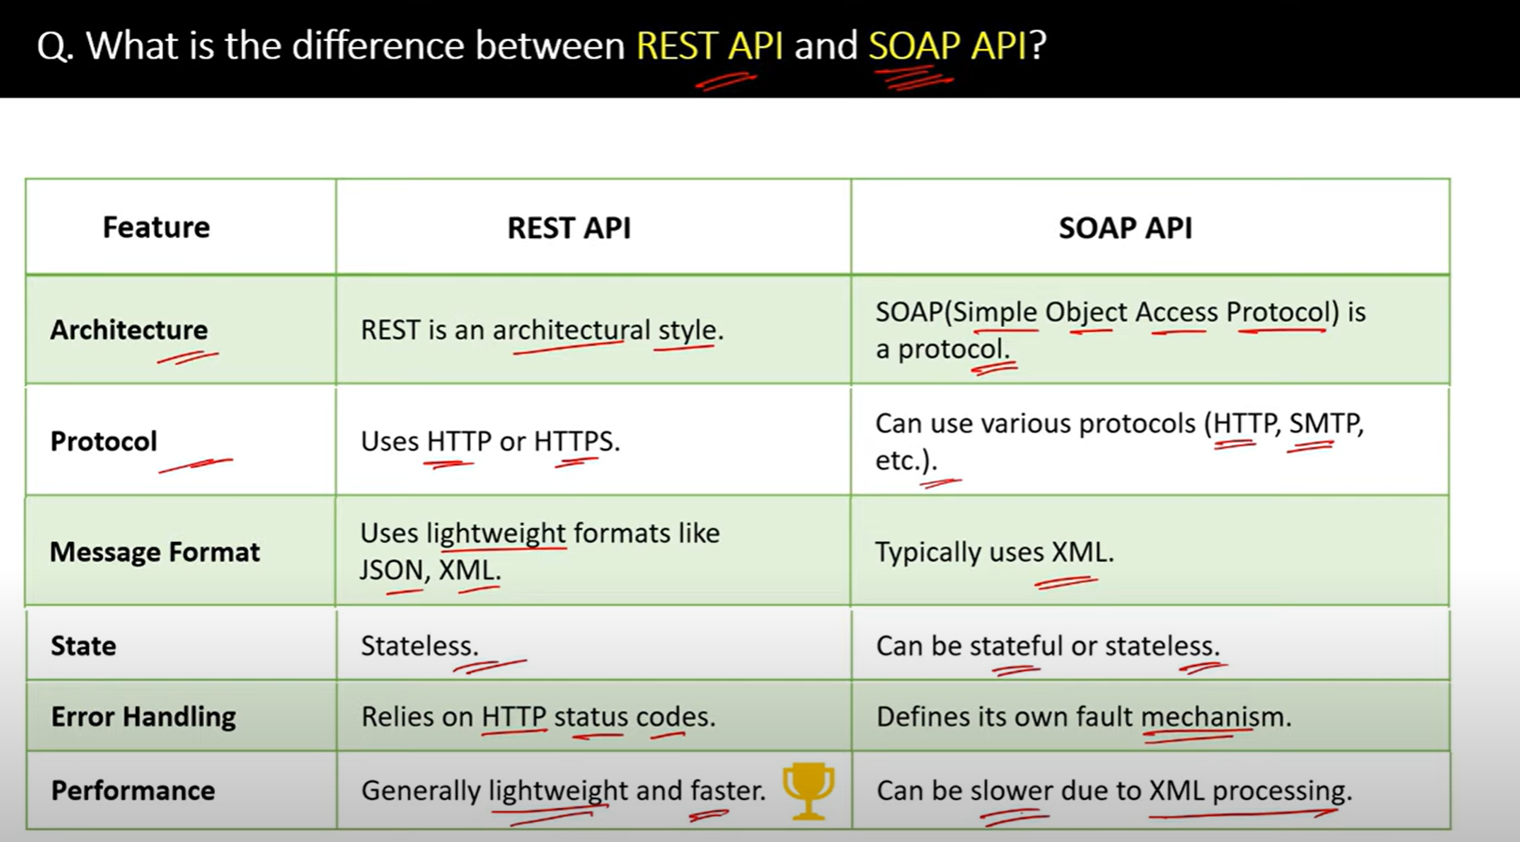

53.

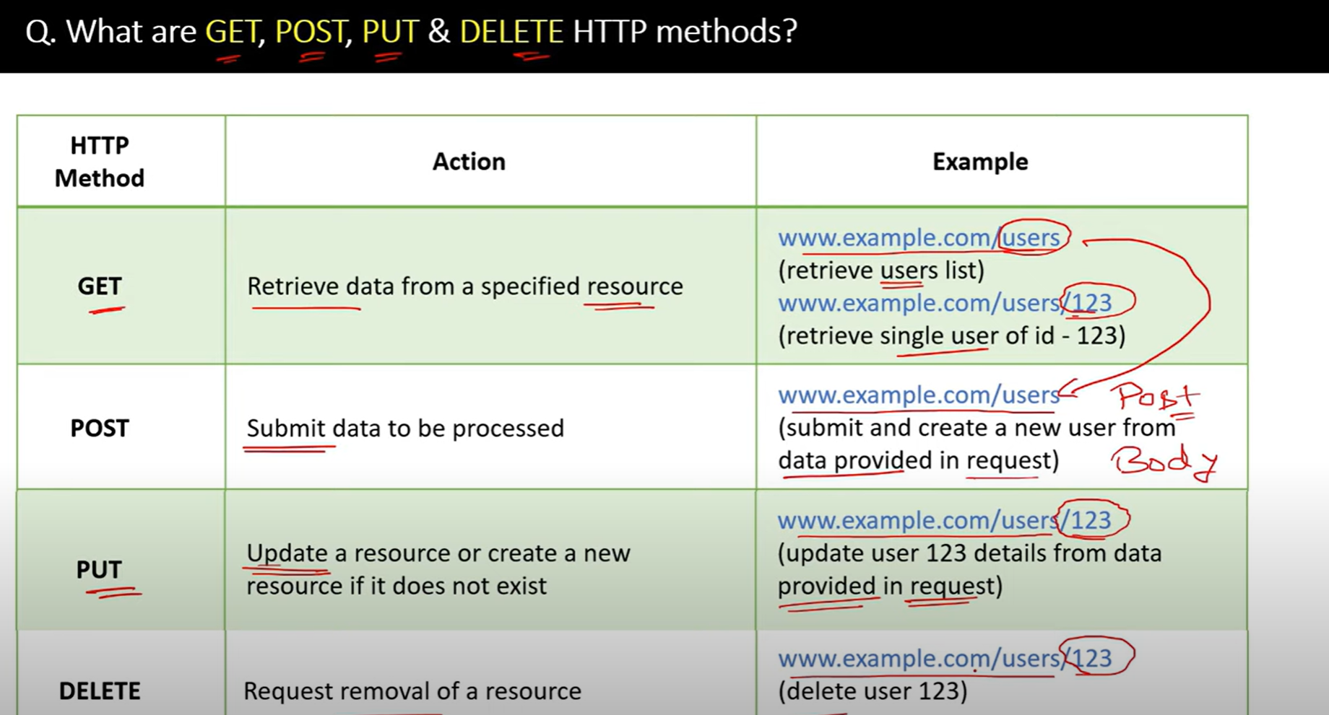

54.

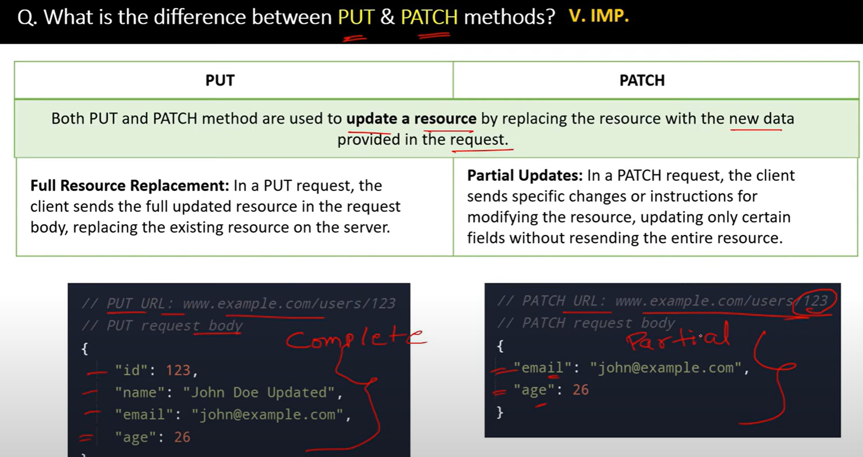

55.

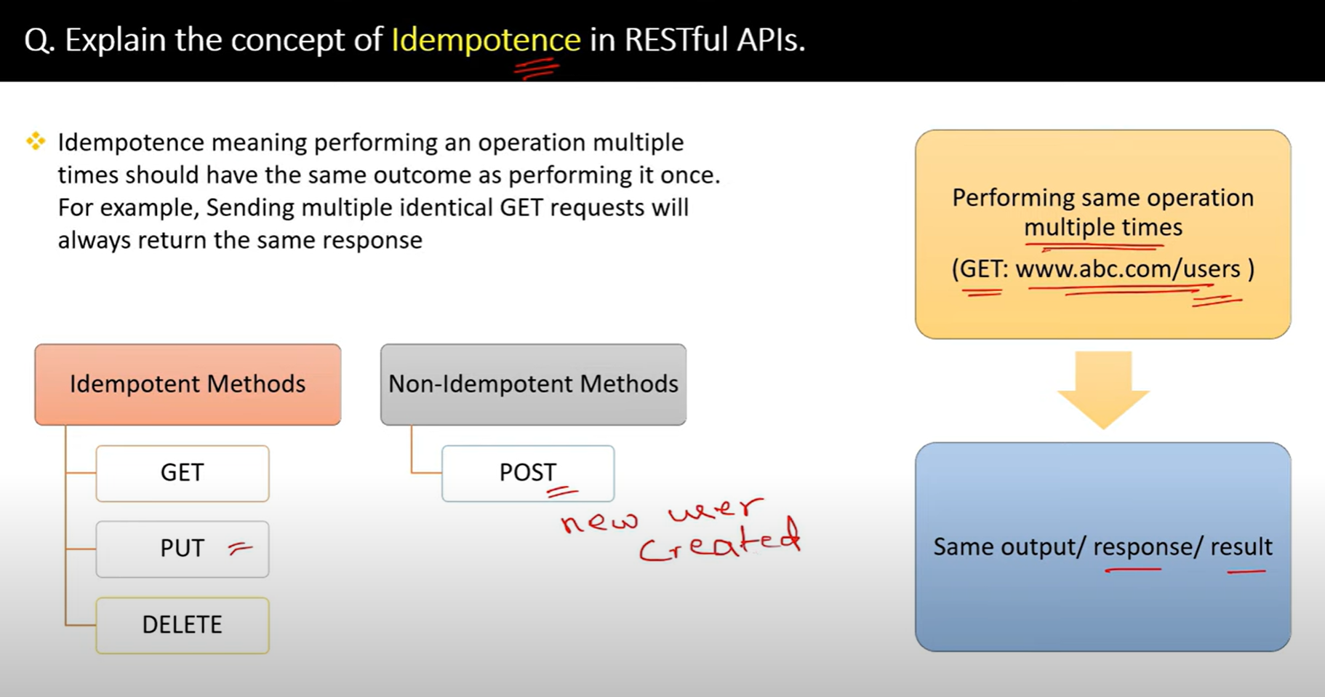

56.

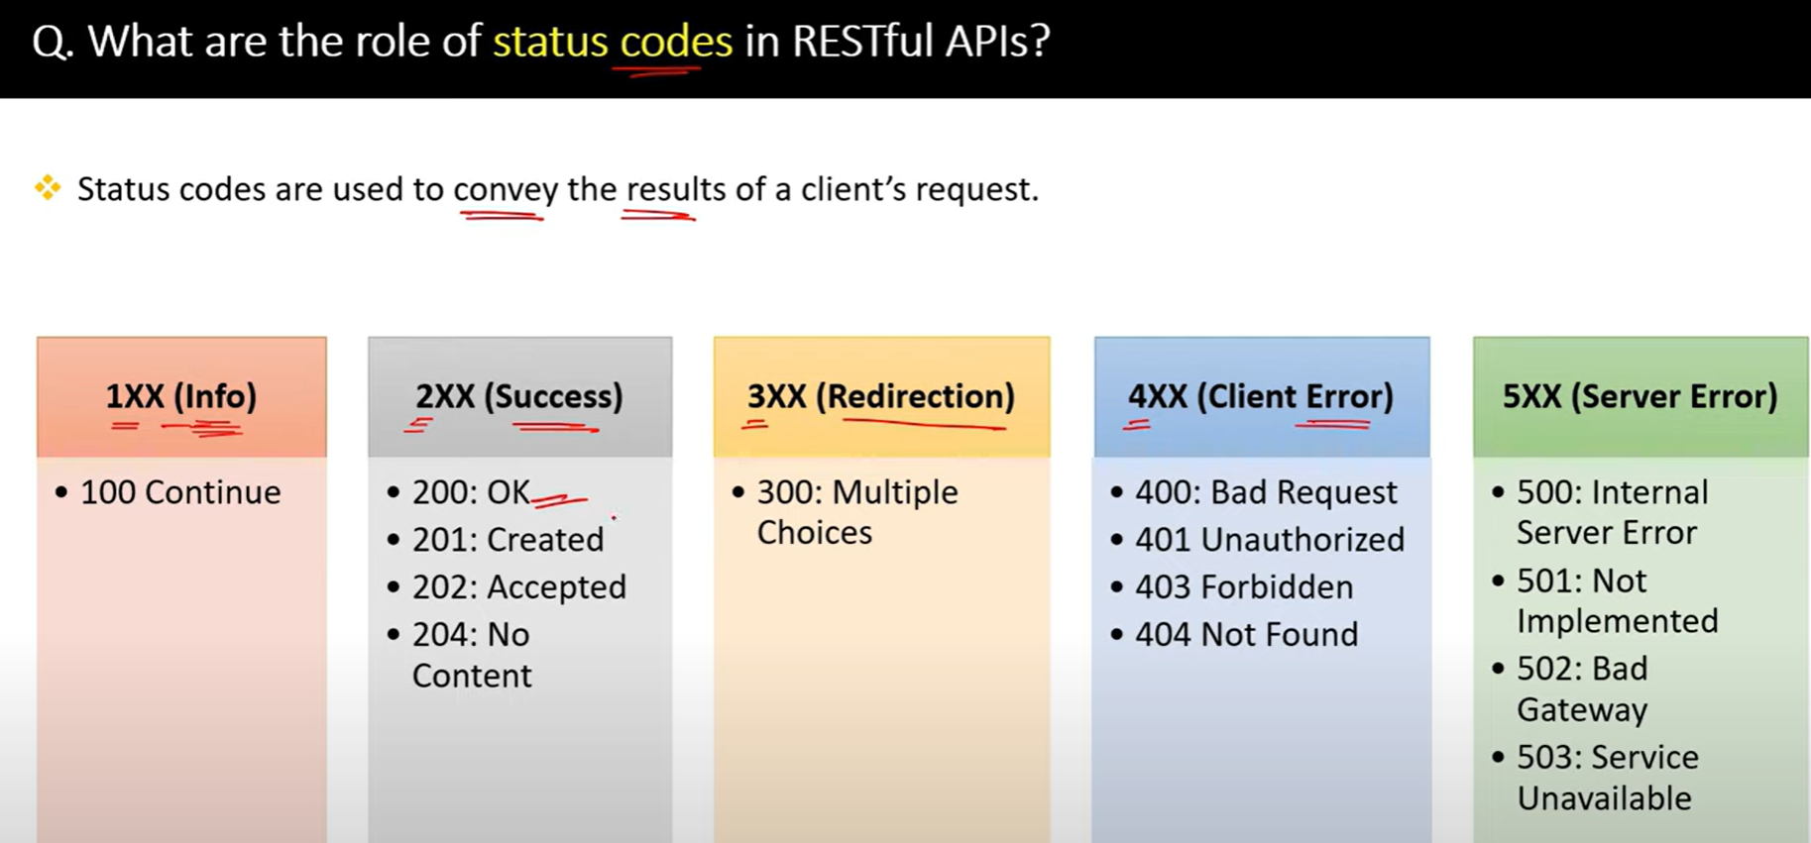

57.

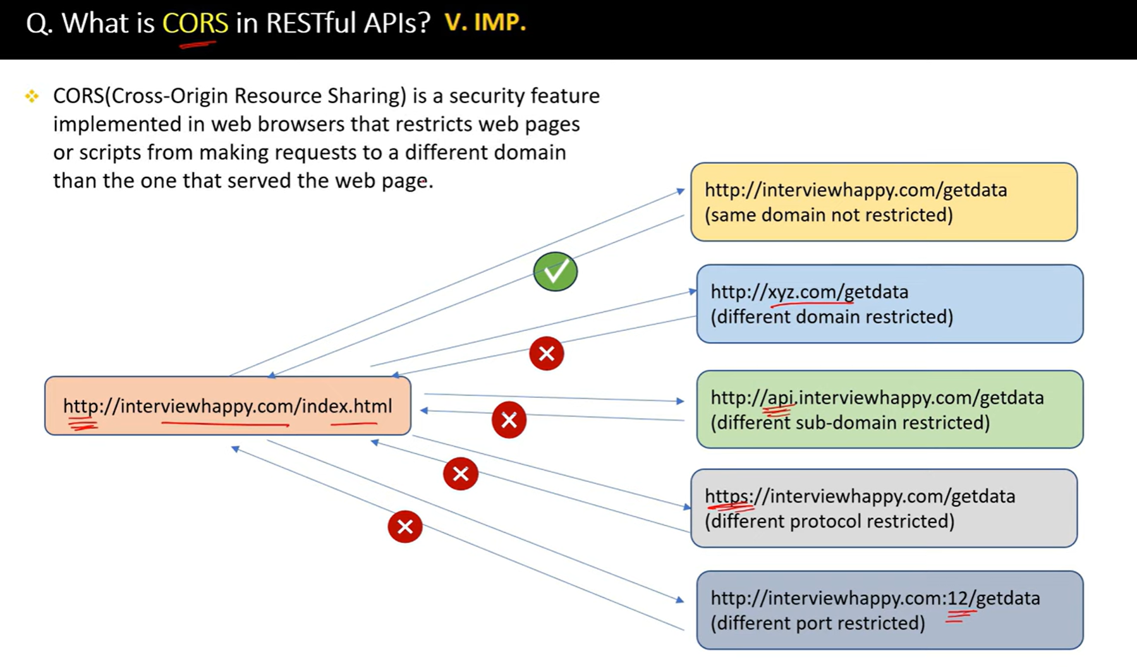

58.

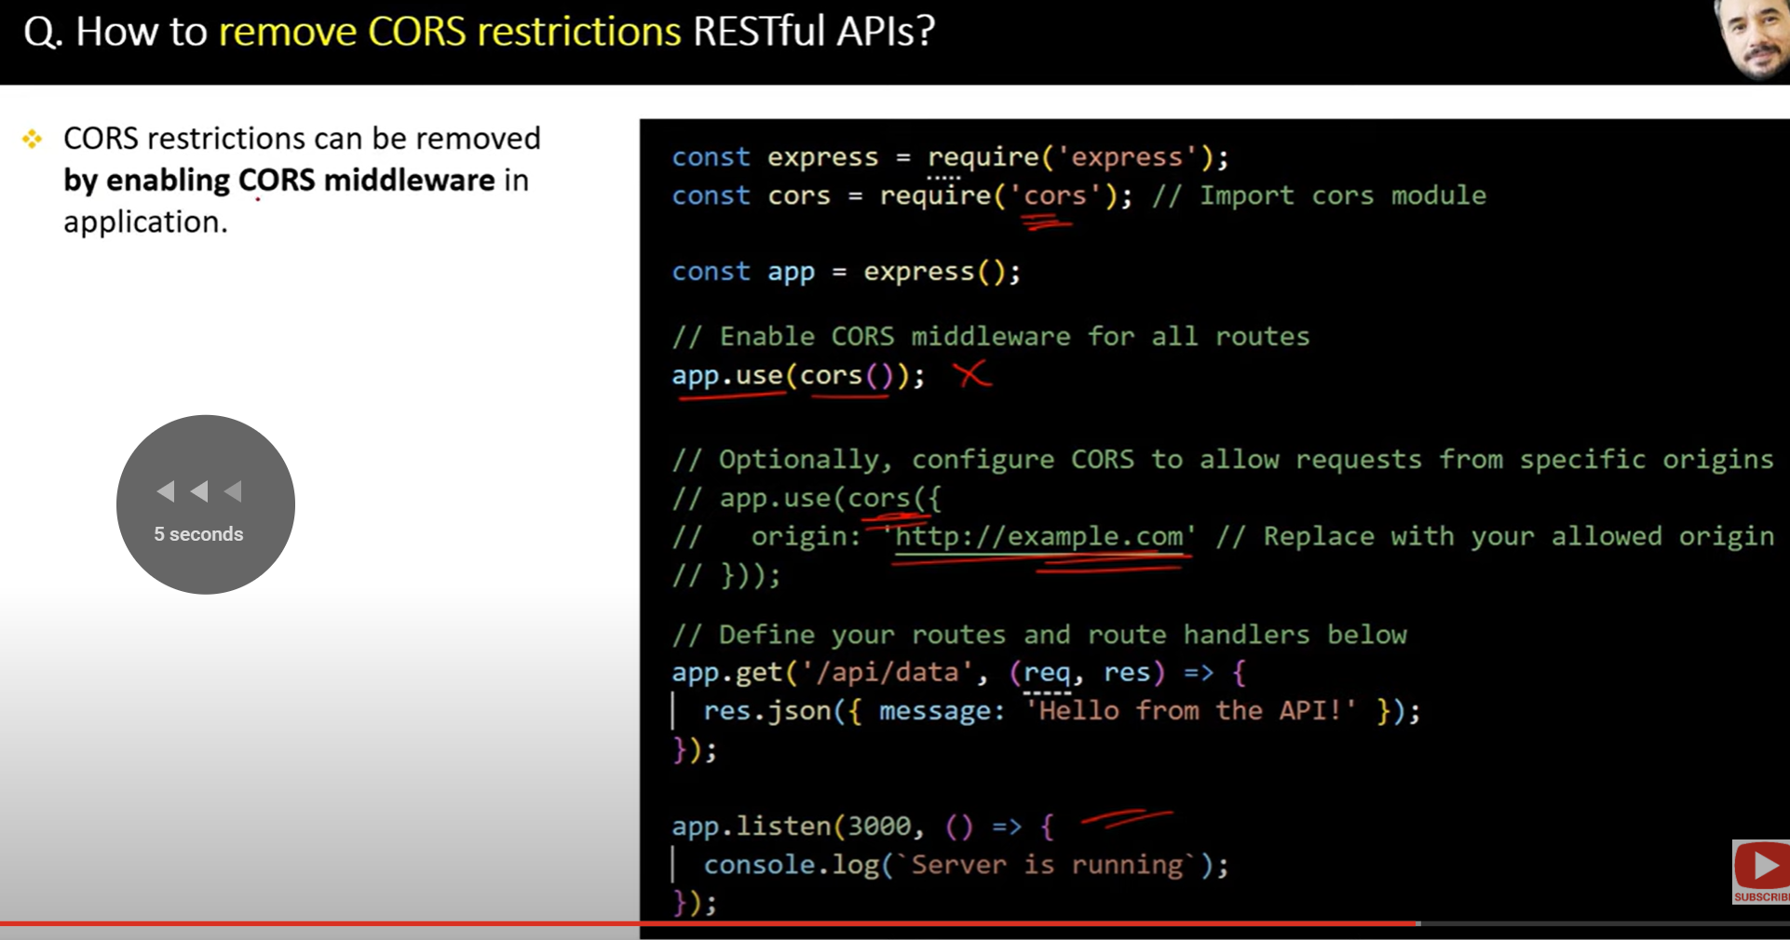

59.

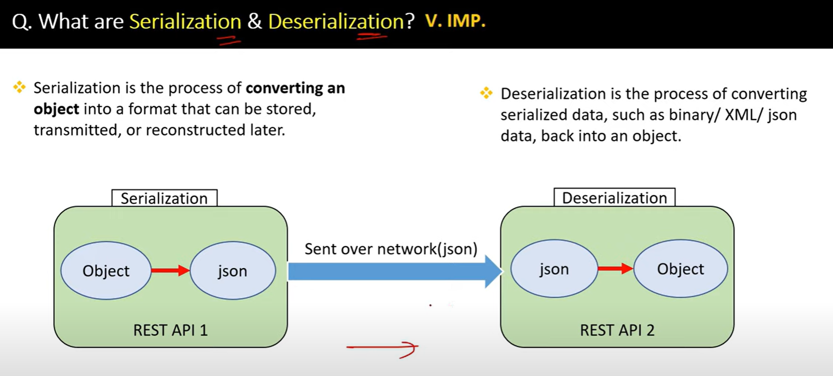

60.

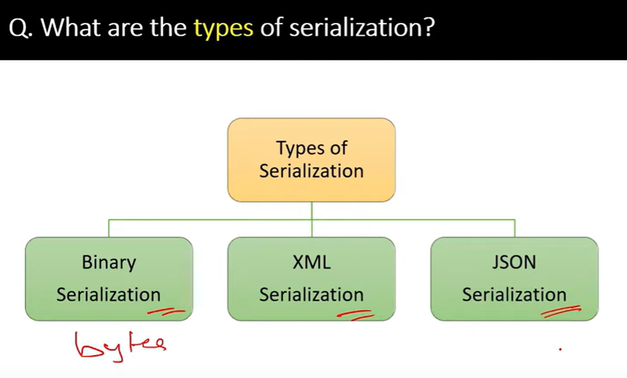

61.

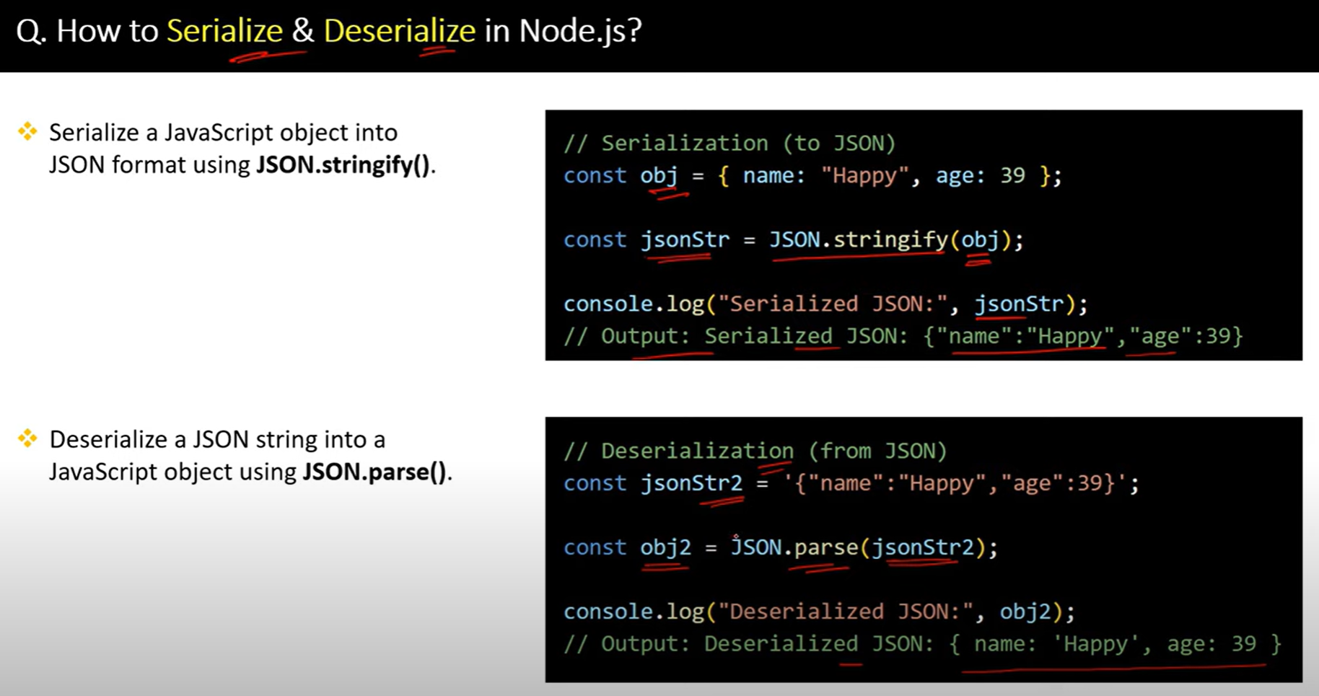

62.

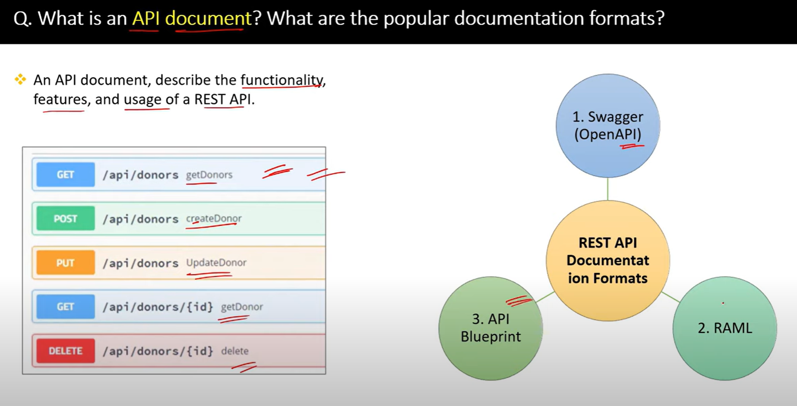

63.

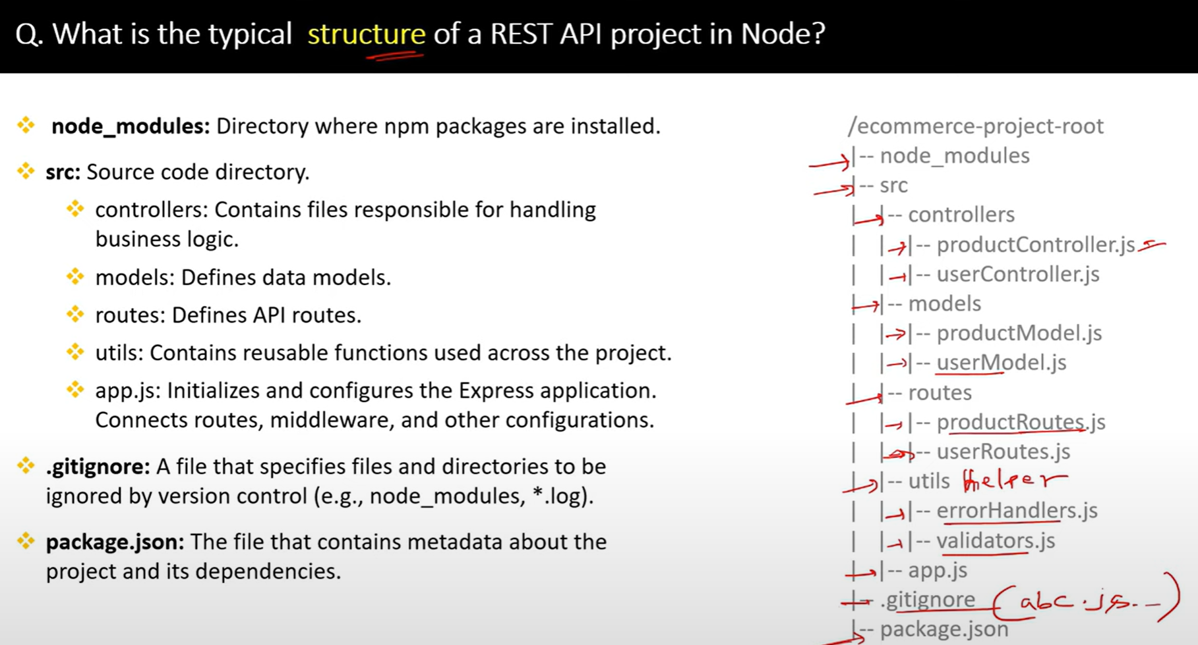

64.

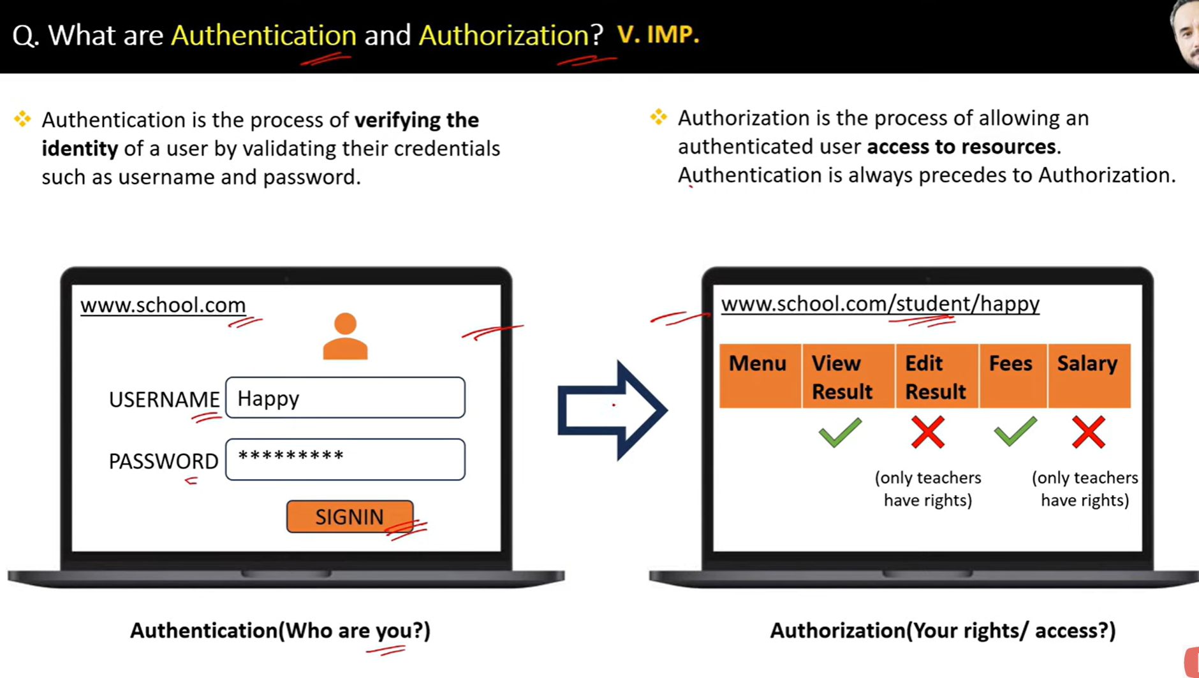

65.

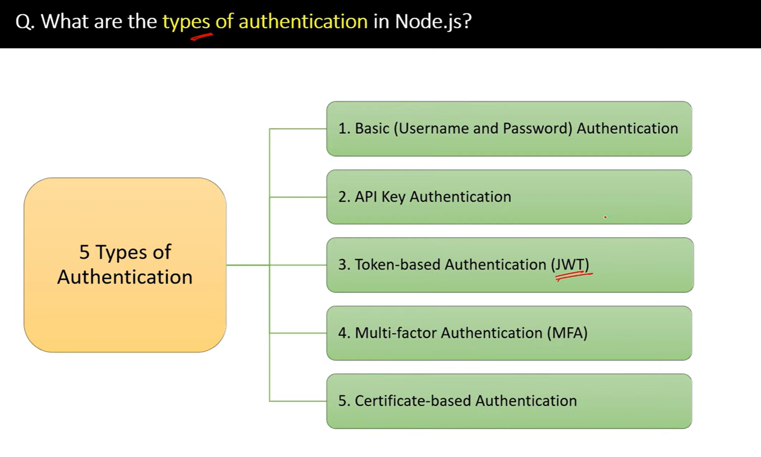

66.

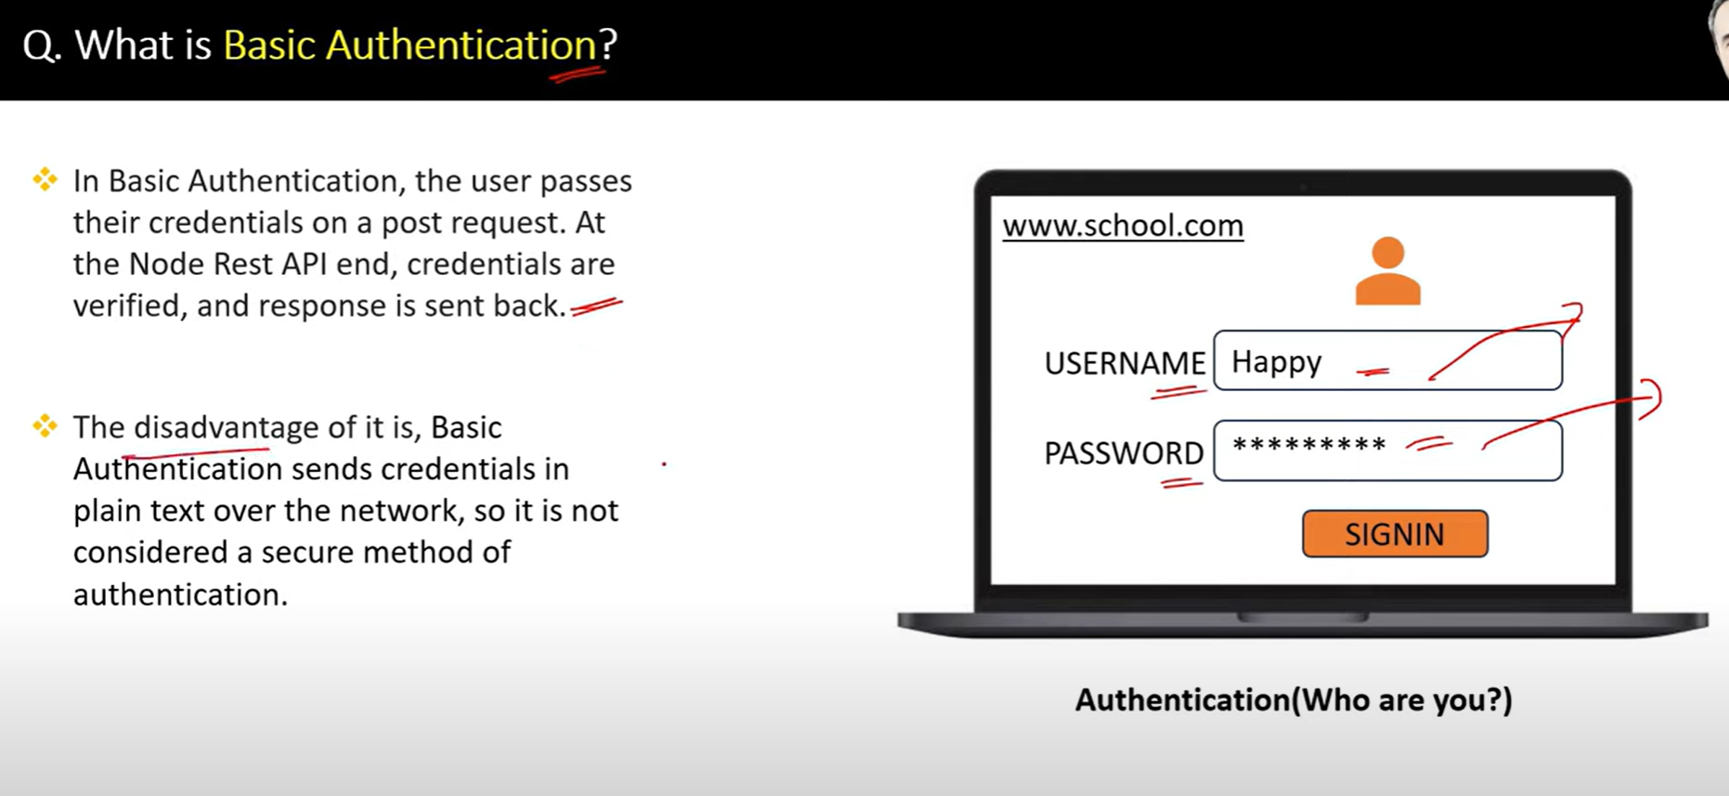

67.

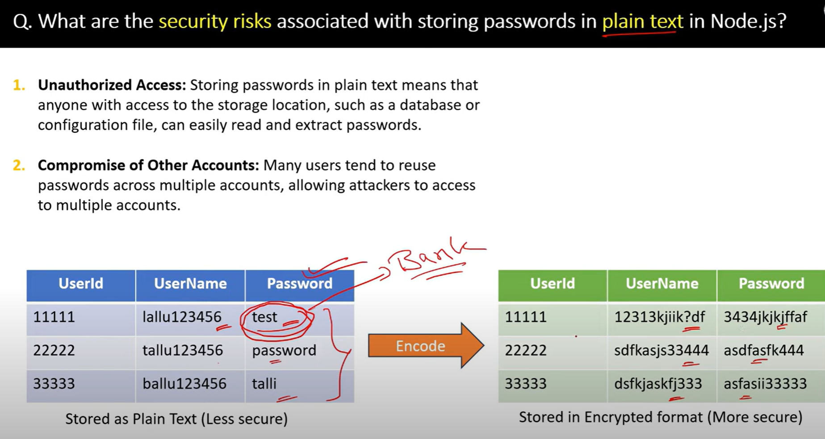

68.

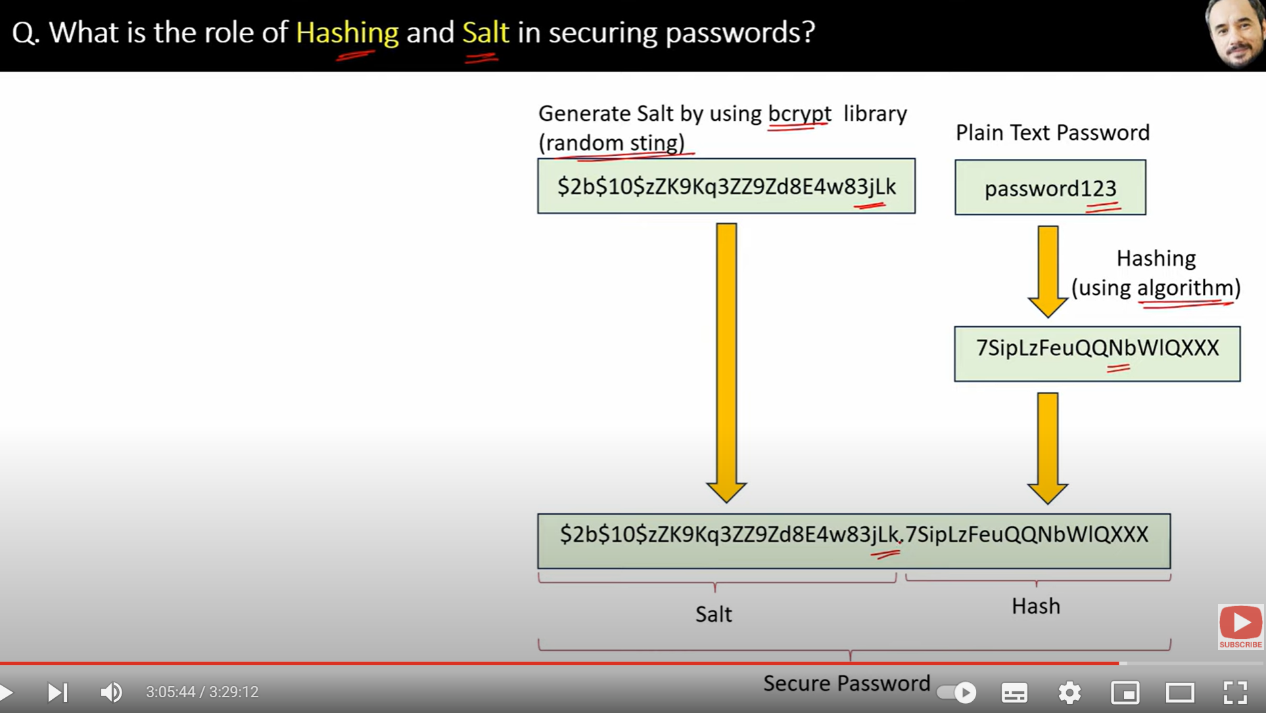

69.

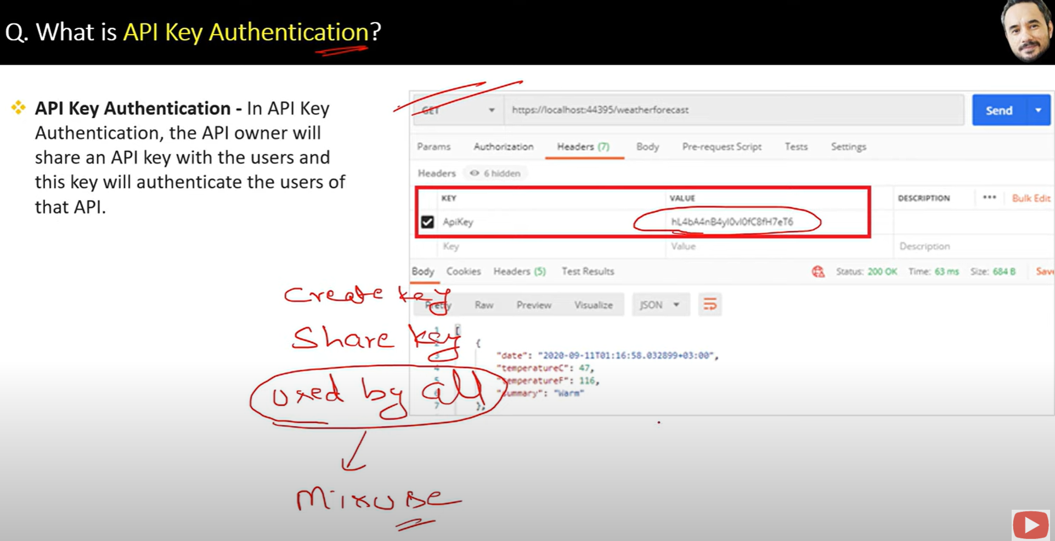

70.

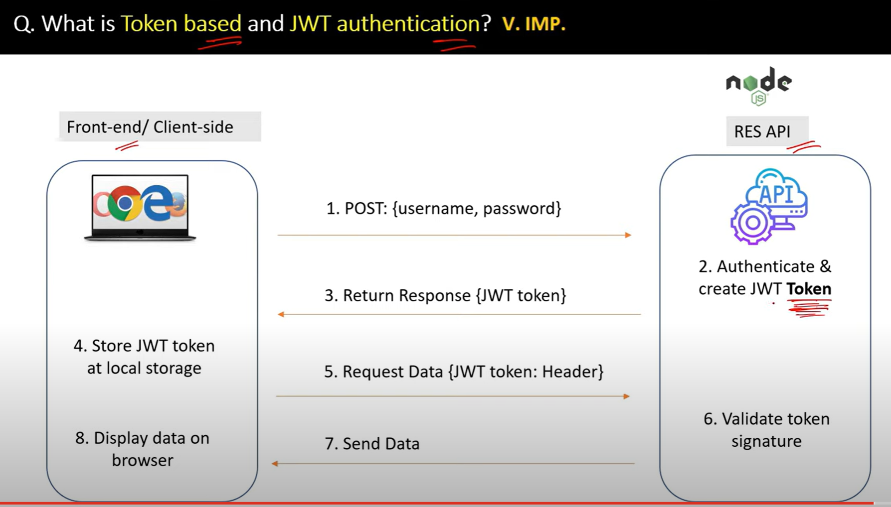

71.

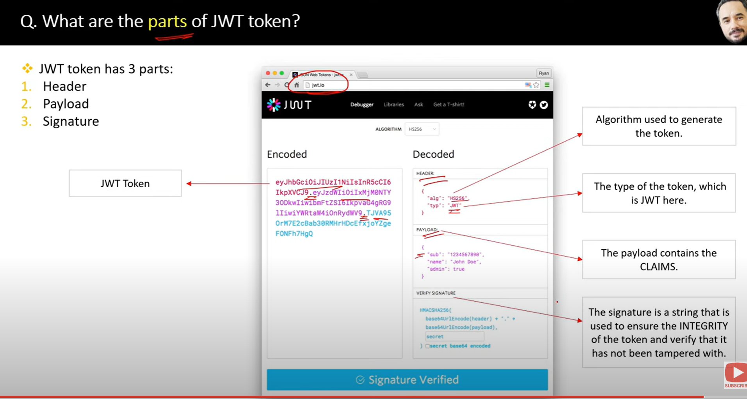

72.

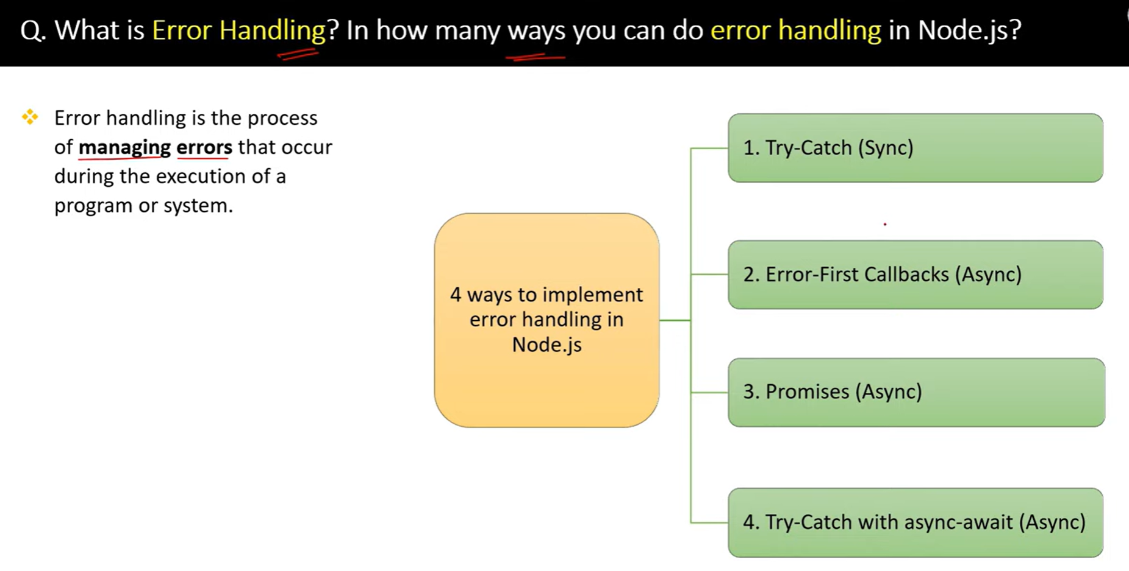

73.

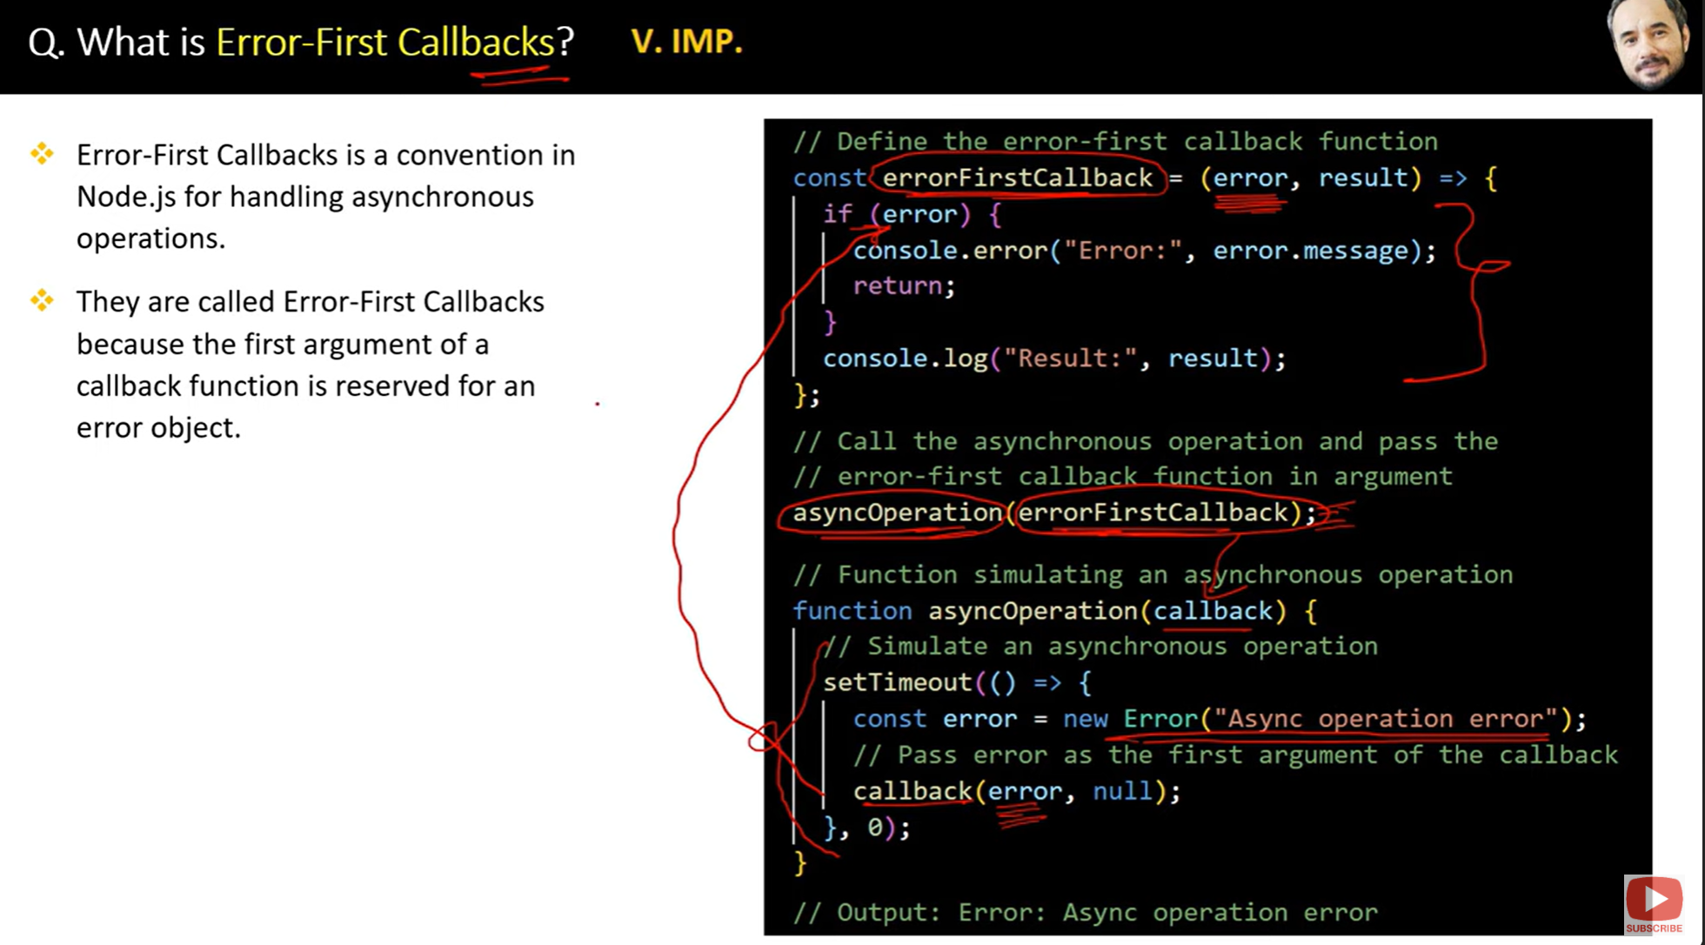

74.

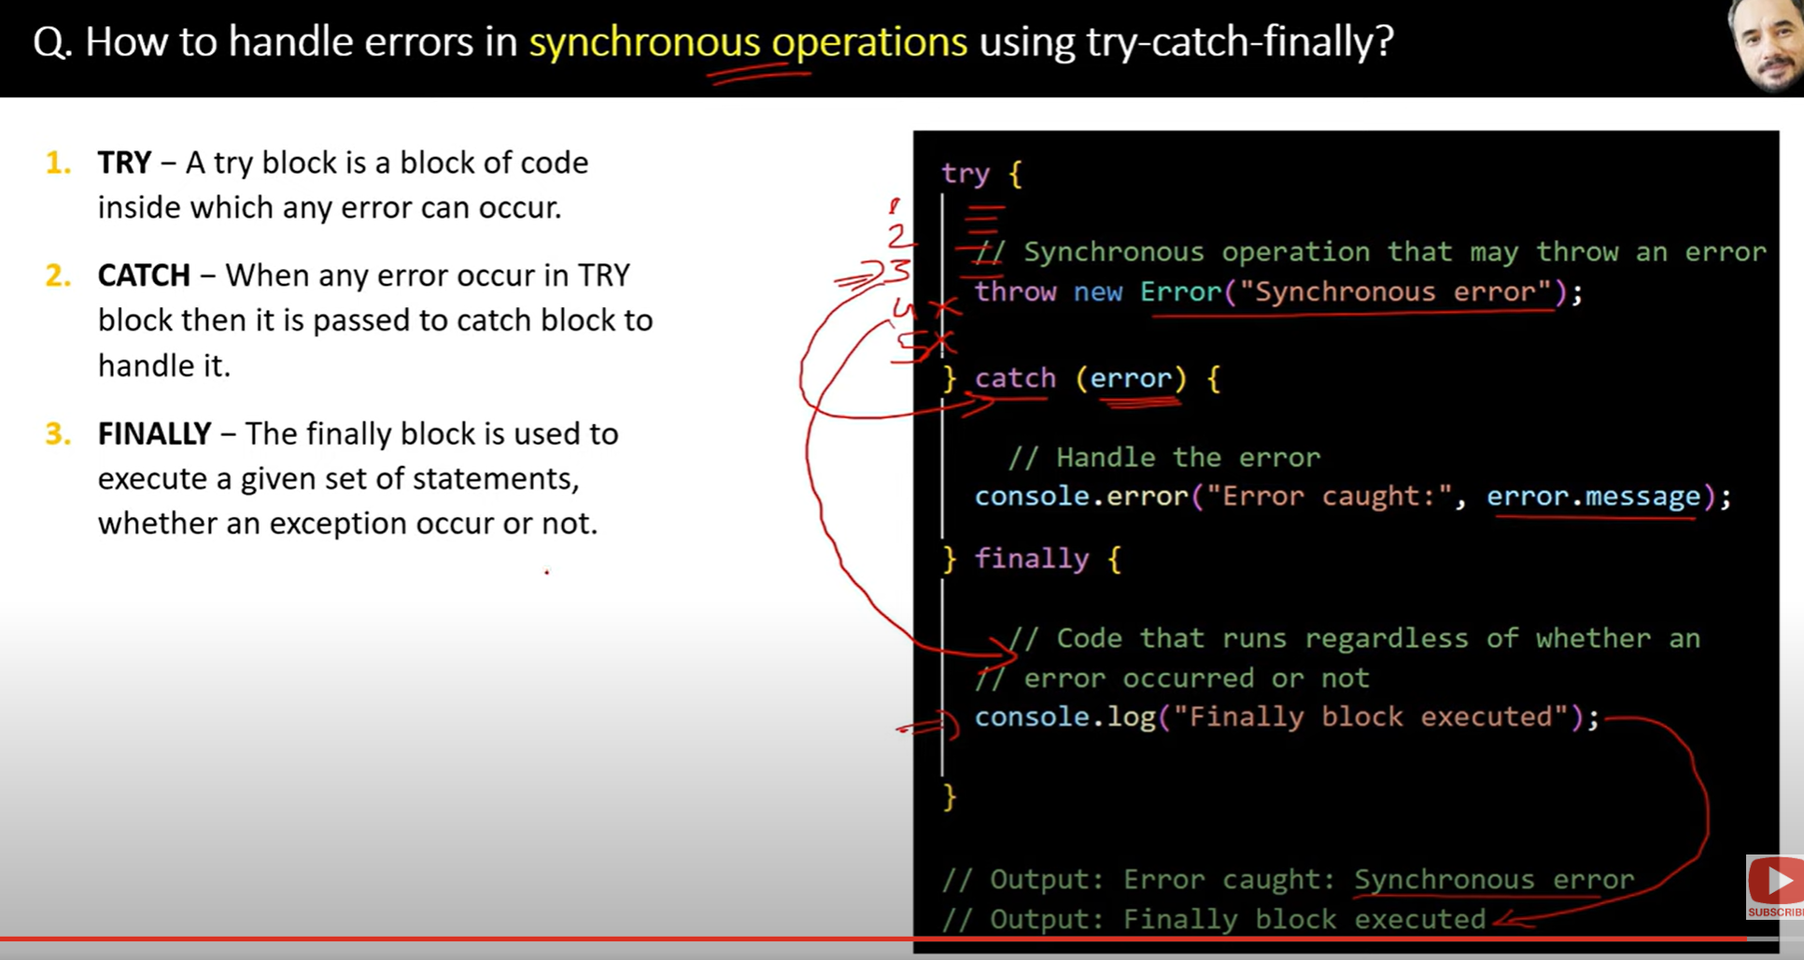

75.

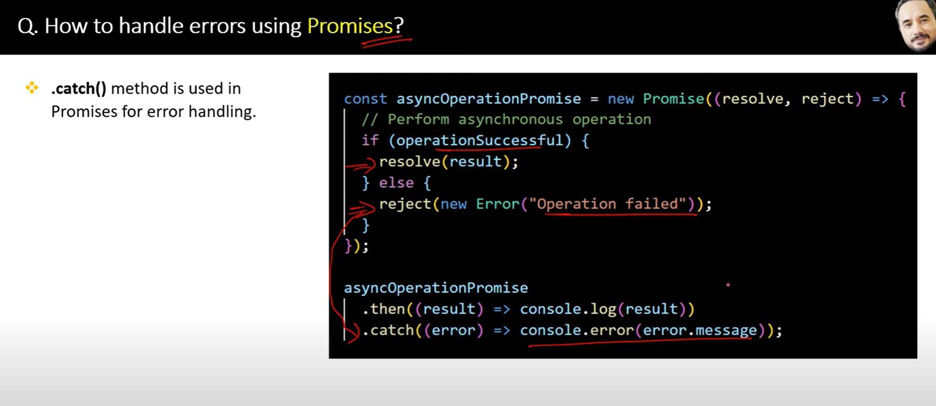

76.

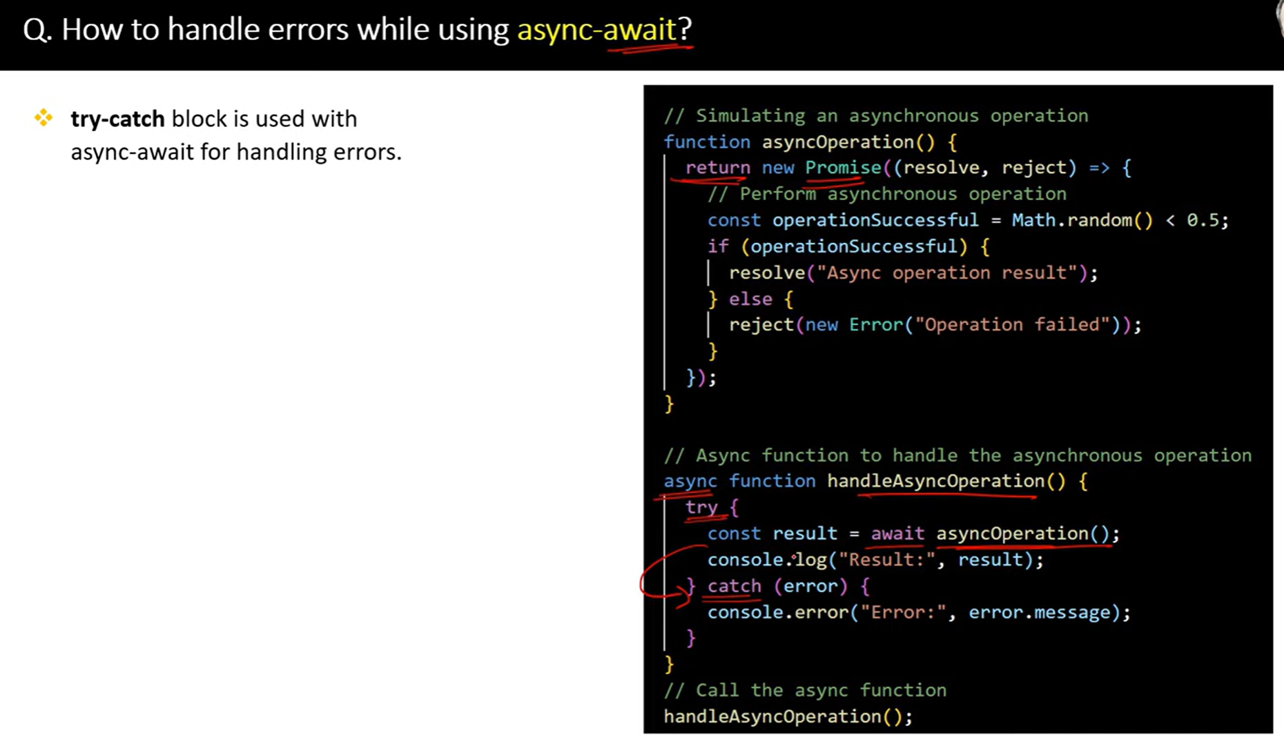

77.

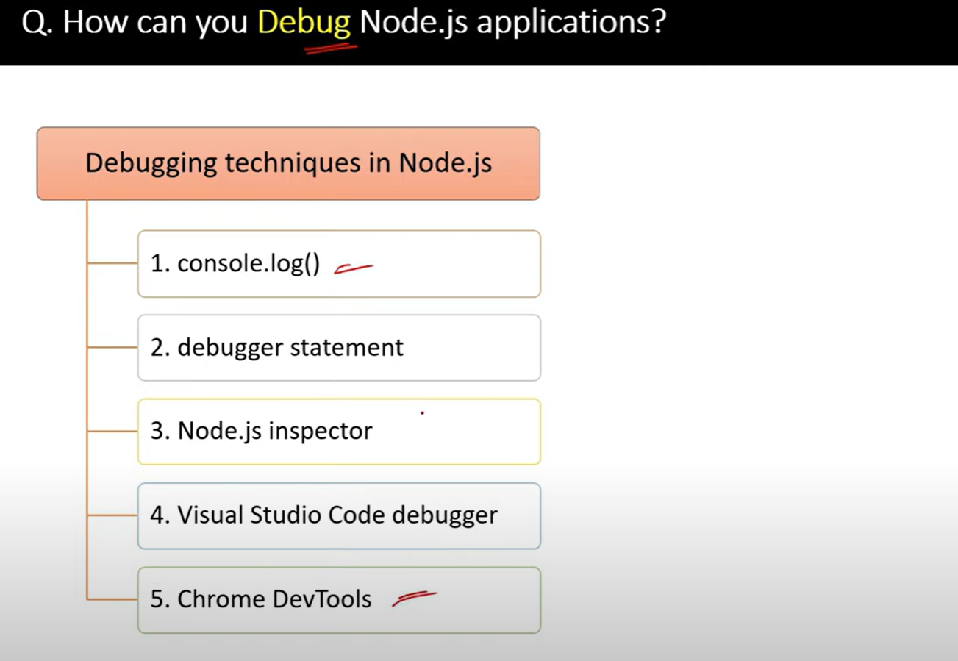

**🔄 WebSocket vs. Webhook: What's the Difference?**

While **WebSockets** and **Webhooks** both deal with communication between systems, they work very differently and are suited for different use cases. Let’s break it down:

**1. Communication Type 🗣️**

* **WebSocket**:
  + **Two-way** communication.
  + **Real-time**, bidirectional communication between client and server.
  + The client **and** the server can both **send messages** at any time after the connection is established.
* **Webhook**:
  + **One-way** communication.
  + A server sends data to another server (usually a specific endpoint) when a particular event happens.
  + The client **cannot** send messages back to the server via the same webhook.

**Purpose 🎯**

* **WebSocket**:
  + Used for **real-time applications** that need constant data exchange, such as:
    - **Chat apps** (messages appear instantly)
    - **Live data** feeds (sports scores, stock prices)
    - **Online games** (real-time multiplayer interactions)
* **Webhook**:
  + Used for **notifications** when something specific happens, such as:
    - **Payment notifications** (payment gateway tells your app when a payment is successful)
    - **Form submissions** (your server notifies an external service when a form is submitted)
    - **Event triggers** (sending data when a specific event happens in your system)

**🧠 Summary:**

| **Feature** | **WebSocket** | **Webhook** |
| --- | --- | --- |
| **Communication** | Two-way, real-time | One-way, event-based |
| **Connection** | Persistent, stays open | Temporary, closed after sending the data |
| **Use case** | Real-time applications (chat, live feeds) | Event notifications (payment, form submission) |
| **Data flow** | Continuous, can be sent at any time | One-time, triggered by events |
| **Setup** | Requires more infrastructure (long-lived connections) | Simpler, typically just an HTTP endpoint |

| **Feature** | **HTTP** | **HTTPS** |
| --- | --- | --- |
| **Security** | No encryption, data can be intercepted | Encrypted, data is secure |
| **Authentication** | No authentication | Website is authenticated with an SSL certificate |
| **Performance** | Faster, no encryption overhead | Slightly slower due to encryption |
| **Data Integrity** | No guarantee data hasn’t been altered | Data integrity is ensured (not tampered) |
| **SEO** | Lower ranking in search engines | Better ranking in search engines |
| **URL Prefix** | http:// | https:// |
| **Browser Indicators** | No padlock, warnings on sensitive data | Padlock symbol, safe connection |